Striped Skunk
Mephitis mephitis
Tracks and sign  Range: Throughout U.S., except some desert areas  Habitat: Forests, agricultural areas, woodlands, waterways  Size: 15-19 inch long body, with 7-10 inch long tail  Young: 3 to 8 born per year  Tracks: Five toes on front and five toes on hind foot. Long claws on front foot  Scat: .75 in. diameter, 2 to 5 inches L  Stride: 4-8 inches  Diet: Omnivorous, eats small mammals, eggs, insects, grubs, fruit, carrion | Narrative  The striped skunk is a boldly colored nocturnal animal whose defense is a very strong smelling spray. It has glands which hold about a tablespoon of musky smelling methyl mercaptan. This is enough to allow the skunk to spray five or six times. It stamps its feet, growls, hisses, turns its back, and raises its tail straight up when it is about to spray. It can spray up to 15 feet and the smell can carry a mile. If the spray gets in the eyes, it causes pain.  Skunk tracks show five toes on the front foot and five on the hind foot. The front tracks usually show claw marks farther ahead of the toe marks than the rear prints do. This is because the skunk has longer claws on the front feet to use in digging up roots and insects.  They forage by digging. Sometimes, you will find these small holes dug out by skunks. They will also get into garbage cans.  It has been said that skunks can be discouraged from visiting by scattering a few mothballs around on the ground. They are supposed to be repelled by the smell of camphor.  Three to eight young are born blind and are weaned at six to seven weeks.  Skunks are omnivorous, eating mice, eggs, insects, grubs, fruit, carrion, and shrews.  Great horned owls are predators that commonly eat skunks.  Skunks find shelter under buildings or in ground burrows taken over from other animals. Skunks are active year-round.

Striped Skunk Tracks and Sign
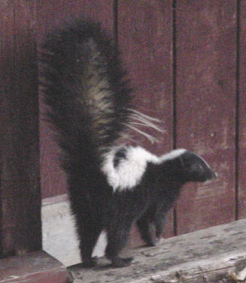 | 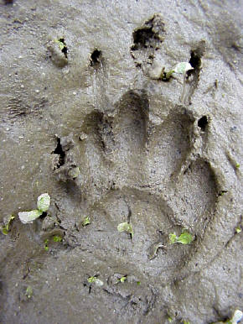
Striped skunk with tail raised in a warning posture. | Perfect striped skunk track in mud. This is the front foot, with its long digging claws.
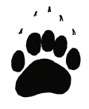  Front track  1.5 in. L x 1.25 in. W | 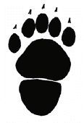  Hind track  2 in. L x 1.5 in. W
Striped skunk tracks. The long claws help the skunk dig. Skunk tracks resemble tiny bear tracks. The heel of the hind foot does not always show.
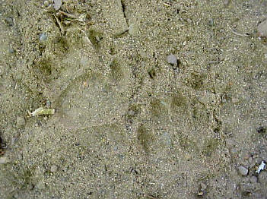
Pair of skunk tracks in sand. Toes are close together and do not splay outward, even in deep mud. | This skunk track was found on a dusty shelf. I used tape to "lift" the track from the shelf, then photographed it. It looks similar to the skunk tracks found on baited soot plates.
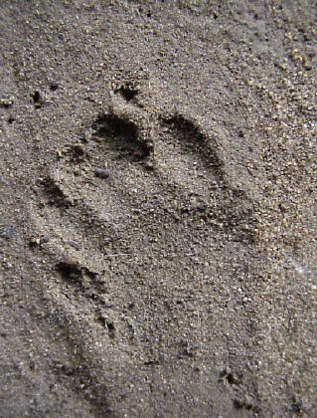 | 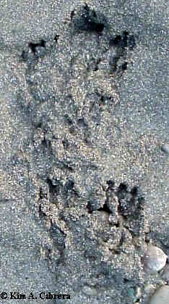
Skunk track in wet sand | Digging by a striped skunk. You can see the claw marks in this photo.
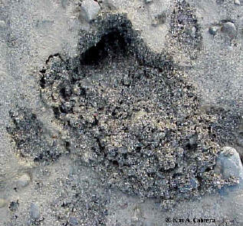 | 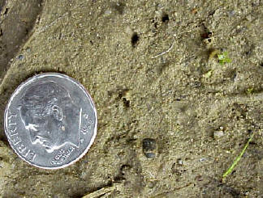
Skunk digging. Skunks usually dig small, somewhat round holes like this. | Skunk track with only the claw marks visible. The rest of the track barely registered.
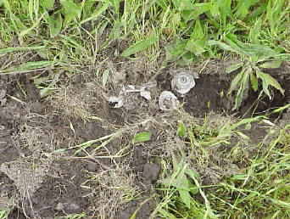 | 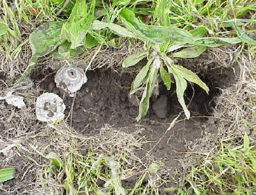
A skunk dug up this small underground wasp nest. All that is left is the papery part of the nest. Close-up on the right.
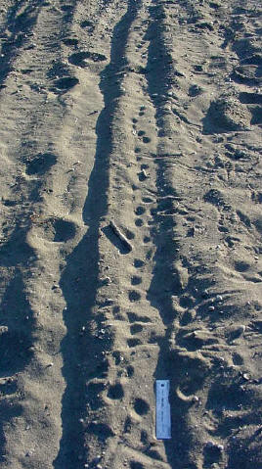 | 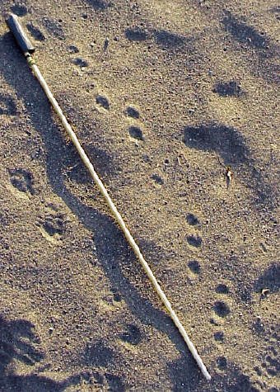
Skunk trails in sand. The trail on the left was found on a river shore. The one on the right was found on a coastal beach, not far from the wave slope.
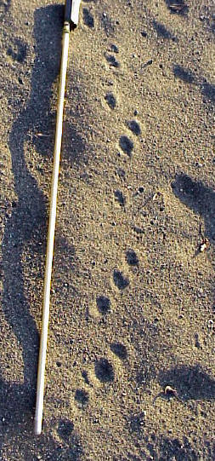 | 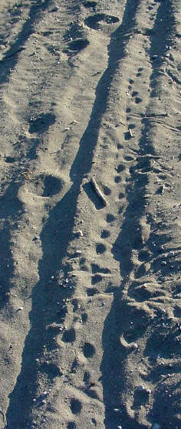
Sad may not hold perfectly detailed tracks, but the trail pattern is distinctively skunk. | Tiny skunk tracks in a tire track. The bird tracks belong to ravens. This scene was on a river bank popular with people. The skunk and ravens were searching for food scraps near where the people had been.
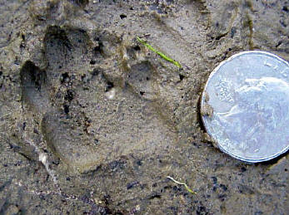 | 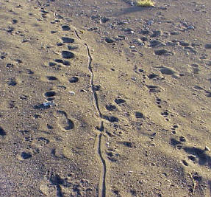
Skunk hind track in mud. | The skunk trail is clearly visible as a line of small dots to the right of the long drag mark in the sand.
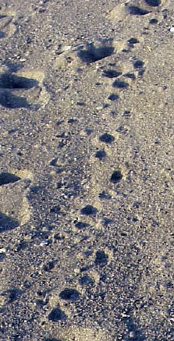 | 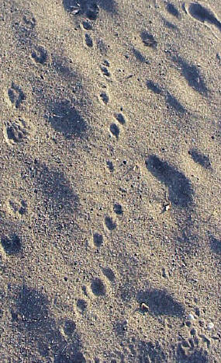
Skunk tracks in a loping trail pattern
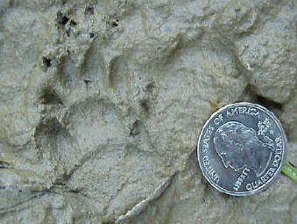 | 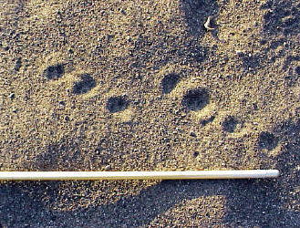
Doubled skunk track in mud | Skunk lope
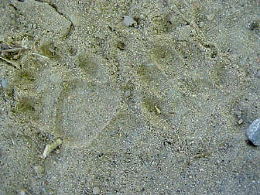 | 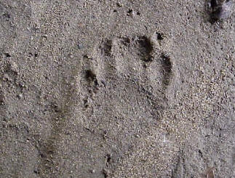
Clear pair of skunk tracks in dust. Front track on the right, hind track on the left. | Skunk track. This is the front foot as indicated by the small dots left by the claws way ahead of the toes.
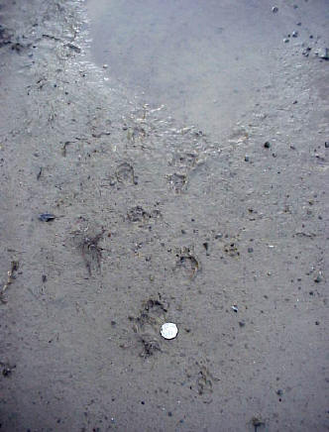 | 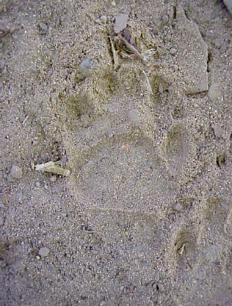
This skunk walked up to the puddle and took a drink. | Clear skunk hind track with partial heel showing
Copyright © Kim A. Cabrera 2004

