NAME: _____________________________________
Asia Study Guide
Test Friday, March 4th
Vocabulary:
- constitutional monarchy- government headed by a prime minister and a constitution with a king or queen for ceremonies (citizens have many rights and high civic participation)
- monarchy- government headed by a king or queen
(citizens have fewer rights than a democracy or constitutional monarchy and low civic participation)
- democracy- government where power is held by the people who vote for representatives to represent them in government (citizens have many rights and high civic participation)
- dictatorship- government run by a strict dictator who seizes power (citizens have few rights and low civic participation)
- urbanization- people moving from the countryside to the city for jobs
- urban = city
- rural = country
- market economy (aka capitalism)- private citizens can own big businesses, citizens make all business decisions, supply and demand determine price
- command economy (aka communism)- government controls business, production, supply and price; government makes major economic decisions
- mixed market economy (aka socialism)- government controls big business, citizens can own small businesses

Urbanization:
- Define “Urbanization”: moving from the country to the city
- Main Reason urbanization is happening in Asia: JOBS!!!!!!!!!!!!!!!!!!!
- A PUSH factor makes you want to move.
- A PULL factor is what draws you into a new place.

Examples of Push Factors | Examples of Pull Factors
Pollution  Overcrowding  Not safe  No jobs | Jobs  Education/ Opportunities  Healthcare

Map: Please label the countries on the map below.

- China B. India C. North Korea D. Japan E. South Korea
F. Bangladesh G. Thailand H. Phillipines
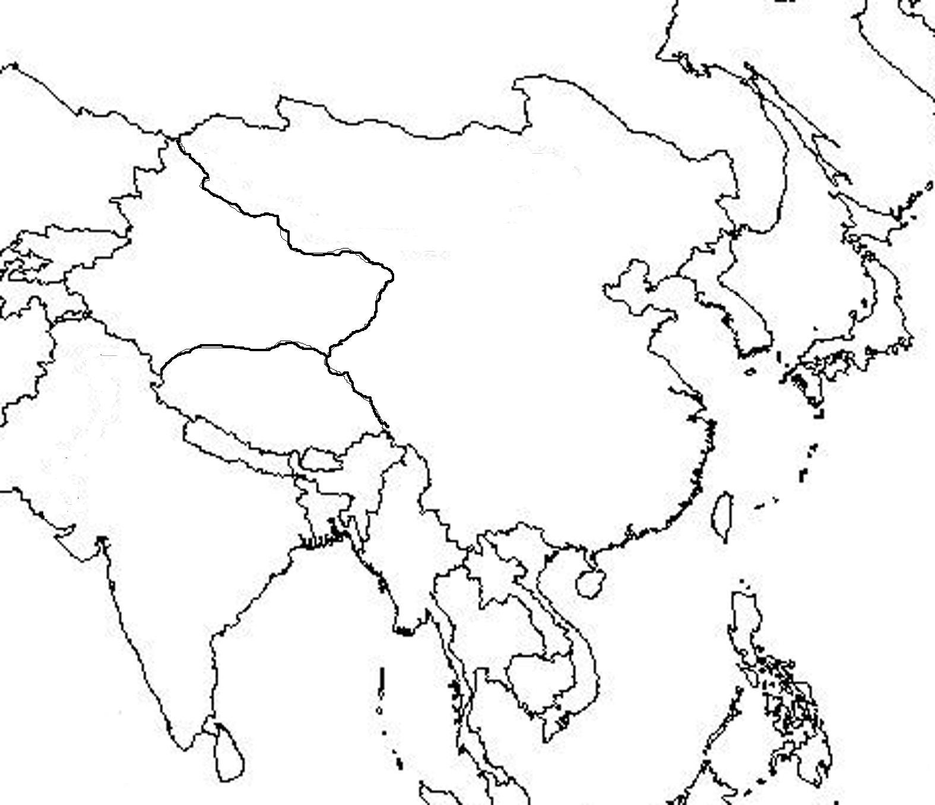

Types of Governments:

 | Democracy | Constitutional  Monarchy | Dictatorship | Monarchy | Communism
Citizen Rights  (write high or low) | High | High | Low | Low | LOW  Strict government limits rights
Civic Participation  (write high or low) | High | High | Low | Low | LOW  citizens can only vote for communist party
Leader is called... | President | Prime Minister/ Emperor or King (for ceremonial purposes) | President | King/Queen | COMMUNIST PARTY  1 party who elects a leader of that party
Which countries have we studied in Asia? | South Korea  India | Japan | North Korea |  | CHINA
Summarize what life is like in this type of government. | Many freedoms,  Many rights,  Citizens can vote,  Citizens can make economic decisions | Many freedoms,  Many rights,  Citizens can vote,  Citizens can make economic decisions | limited freedom  cannot speak out or go against government |  | limited freedom  cannot speak out or go against government  only one political party that makes all political and economic decisions

TYPES OF ECONOMIES:

 | Capitalism | Socialism | Communism
Another Name = | Market Economy | Mixed Market Economy | Command Economy
Who makes business decisions? | Citizens | Government | Government
Who controls production?  (what to make and how to make it) | Citizens | Government | Government
Who controls distribution? (how much of supplies or wealth people get) | Citizens | Government | Government
Who controls big business?  (i.e. steel making, construction, transportation) | Citizens | Government | Government
Who controls smaller/ private business?  (i.e. stores, restaurants etc.) | Citizens | Citizens | Government
Advantages: | Freedoms, Choices,  Can get as rich as you want | Some choices and freedoms with government guidance | Everyone is EQUAL,  Cannot make bad decisions.
Disadvantages: | Inequality,  Some very rich and others poor | Government controls big business and wealth | No freedoms, No choices,  Usually faced with poverty
Examples: | USA, Japan, South Korea | China | North Korea

