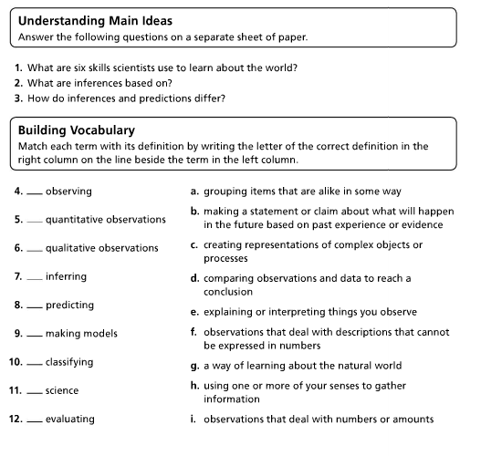
I CAN explain skills and attitudes scientists possess.

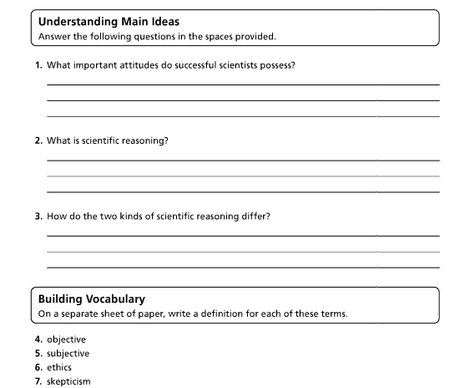

Directions: Determine whether the following are observations or inferences. Write “O” on the line if it is an observation. Write “I” on the line if it is an inference.

______The container is filled to the 350 mL mark.

______The clear liquid has a strong scent and a pH of 9. It is most likely ammonia.

______When the sun came out, it made the rain stop.

______The powder is white, fine grained, and reacts with vinegar.

I CAN use scientific inquiry to draw conclusions

Directions: Use the following testable question to complete the steps of scientific method below.

Testable question: Does a piece of paper folded in half fall faster than a piece of paper that is unfolded (crease pointing upward)?

Hypothesis: If ________________________________________________________________________,

then ________________________________________________________________________________

because______________________________________________________________________________.

Independent Variable __________________________________________________________________

Dependent Variable ____________________________________________________________________

Control Variables (2) ___________________________________________________________________

___________________________________________________________________

Possible Conclusion____________________________________________________________________

_____________________________________________________________________________________

_____________________________________________________________________________________

_____________________________________________________________________________________

I CAN use scientific inquiry to draw conclusions.

Directions: Using the graph below answer the following questions.
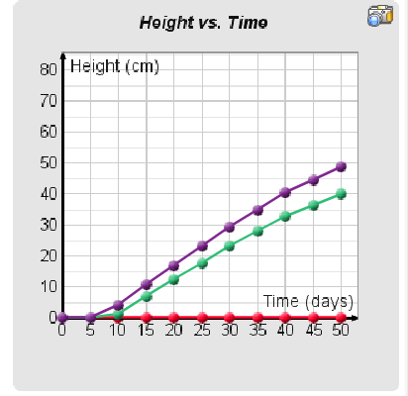
Identify the following…

- Independent Variable:_________

- Dependent variable: ___________

- Identify the relationship between variables _______________________________

_______________________________

_______________________________

_______________________________

