TEN MOST REVEALING PSYCHOLOGY EXPERIMENTS

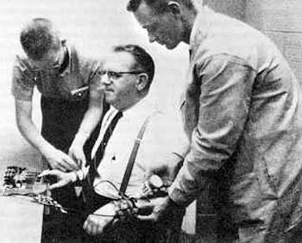
Read all these instructions carefully before beginning!
Go to the link about the Ten Most Revealing Psychology Experiments and read through the summaries of all ten of them.
Select one of the experiments that you think is interesting. Click on the link in the summary to start your research about that experiment. (the link to #3 is broken, but you can use this link to get started.) Read through the information and seek out other information online. There may be good YouTube videos or other sources you should investigate. You can also look up some of the experiments or the experimenters in your textbook.
Please do the following to complete the assignment:
1. Summarize the experiment. Include who did it, when they did it, where they did it, and what they did.
2. Explain the importance of the experiment to our understanding of human behavior. Why do you think the experiment is considered a valuable insight into the way people think and/or act?
3. Give one example of how the experiment can be applied to everyday life. You can use yourself or someone you know in the example, or make up an example that you think the experiment might apply to in normal life.
4. At the end of your post include all sources (full URLs, please)
Please print out your responses and turn them in by THURSDAY AUGUST 31, 2017.
Your response should be 3 to 5 paragraphs long and should demonstrate some original thinking on your part. Do not cut-and-paste or copy any text directly without properly citing.

1. 'Lord of the Flies': Social Identity Theory
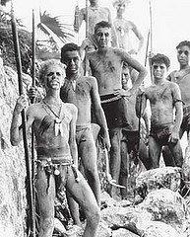
The Robbers Cave Experiment is a classic social psychology experiment conducted with two groups of 11-year old boys at a state park in Oklahoma, and demonstrates just how easily an exclusive group identity is adopted and how quickly the group can degenerate into prejudice and antagonism toward outsiders.
Researcher Muzafer Sherif actually conducted a series of 3 experiments. In the first, the groups banded together to gang up on a common enemy. In the second, the groups banded together to gang up on the researchers! By the third and final experiment, the researchers managed to turn the groups on each other.

2. The Stanford Prison Experiment: Power Corrupts
This infamous experiment to plumb the depths of evil in human hearts ended up affecting its lead researcher as much as its subjects. Psychologist Philip Zimbardo divided his participants into two groups labeled "prisoners" and "guards." It was conducted in a mock-up prison in a Stanford University basement. The prisoners were subjected to arrest, strip search, de-lousing, head shaving and other abuses. The guards were given clubs.
The prisoners rebelled on the second day, and the reaction of the guards was swift and brutal. Before long, the prisoners were behaving meekly and with blind obedience, while the guards fully embraced their roles by taunting and abusing their charges. This one might be scientific confirmation of the idea that humans harbor evil tendencies. The planned 14-day experiment was halted after only 6 days due to increasing levels of abuse.

3. Obedience to Authority: Human Capacity for Cruelty
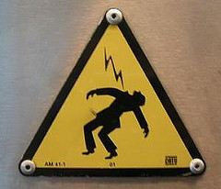
In 1963 psychologist Stanley Milgram set out to test people's propensity to obey authority when ordered to hurt another person. The world was still wondering what happened in Germany during WW-2 that caused so much horror. Milgram's subjects were told they were to be the 'teachers' of a 'learner' (who was secretly in on the experiment). They were to deliver electric shocks to the 'learner' if he or she got an answer wrong. Worse, they were told to increase the shock if the 'learner' continued to get the answers wrong.
Despite the screams and moans of pain from the unseen 'learner', the subjects continued to deliver ever more severe shocks if ordered to do so by the experimenter in the lab coat. They continued even when told they had rendered the 'learner' unconscious! The conclusion? Looks like we humans are quite easily able to set aside moral and ethical considerations when ordered by authority to violate them.

4. Conformity: Not Believing Your Lying Eyes
From social identity theory psychologists got a handle on group dynamics and prejudices, how natural it is for groups to elicit conformity among their members. In 1951 Solomon Asch set out to identify just how much individual judgment is affected by the group.
In a test environment in which undergrads were asked to render a judgment after other subjects gave deliberately wrong answers, 50% of people gave the same wrong answer when their turn came. Only 25% of test subjects refused to be swayed by the false judgment of the others, while 5% always went with the crowd. The finding was that a third of people will ignore what they know to be true and go with a falsehood if they're in a group that insists on the falsehood being true. What else will people do under influence of the group?

5. Lying to Ourselves: Cognitive Dissonance
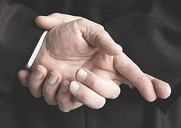
One might begin to suspect that people must be pretty good at either ignoring their own feelings, beliefs and desires, or flat out lying to themselves (and getting away with it). In a classic 1959 experiment psychologists designed an experiment with level upon level of deceit to see just how much a person will ignore their own experience, even to the point of helping to convince someone else of something they know is not true.
The human capacity for sustaining cognitive dissonance has since been confirmed in many other well-designed experiments. This capacity is linked closely with our desire to join and fit in with a group, adjusting our own values and beliefs about things to align with those of others. Perhaps, knowing about these propensities, we can learn to avoid believing our own lies too much.

6. Memory Manipulation: Do You Really Know What You Saw?
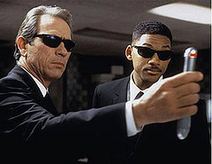
In 1974 researchers designed an experiment to test the reliability of memory, and whether it could be manipulated after the fact. 45 people watched a film of a car accident. Nine of those people were then asked to estimate how fast the cars were going when they "hit." Four other groups were asked an almost identical question, but the word "hit" was replaced with the words "smashed," "collided," "bumped" and "contacted."
Those whose questions included the word "smashed" estimated the cars were going 10 mph faster than those whose word was "contacted." A week later participants were asked about broken glass (indicative of more serious accident), and those whose trigger words were more forceful said they remembered broken glass even though the film had depicted none. Looks like something so subtle as a single descriptive word can manipulate memories of an event!

7. Magic Memory Number: 7
Psychologist George Miller wrote in 1956 that he was "persecuted" by the number 7, which kept intruding on his mind while contemplating data or reading journals. Sometimes it was slightly higher, sometimes slightly lower, but always it hovered around 7. Miller theorized that this 'magic' number represents the number of items we are able to hold in our short term memory at any given time. Plus or minus 2.
More recent studies have demonstrated that people are able to 'group' items in short term memory - thereby being able to hold more individual items - yet even there the total if groupings are considered units, the number comes out to 7. Plus or minus 2. Maybe this is why human cultural belief systems historically considered the number 7 to be especially important to the gods!

8. Anatomy of Mass Panic: War of the Worlds
Orson Wells broadcast an adaptation of H.G. Wells' War of the Worlds on radio in 1938, causing panic in nearly 3 million of the 6 million people who listened to the broadcast. Princeton psychologists later interviewed 135 New Jersey residents about their reactions to the broadcast.
A surprising number of frightened people never bothered to check out the validity of the broadcast, and some highly educated individuals believed it was true just because it was on the radio and thus "authoritative." We like to think we're more sophisticated today and wouldn't fall for such an obvious dramatization, but don't be too sure, Media manipulation of our emotions and desires is a regular art form these days. Just ask Madison Avenue!

9. The Bargaining Table: Threats Don't Work
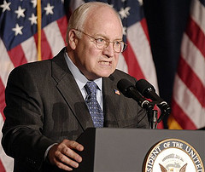
Luckily, the behavior of individuals is both less deceptive and less violent than the behavioral 'norms' of groups. In the area of diplomacy among individuals and groups, people attempt to get concessions they want or need from others. Usually without having to give up too much in exchange. Researchers Morgan Deutsch and Robert Krauss tested two factors involved in the crafting of agreements between humans in 1962: communication and threats.
This complicated economic experiment found that cooperative relationships between the bargainers are more beneficial to both parties than threats, either unilateral or bilateral. Not exactly a rousing endorsement of capitalistic winner-take-all competition, but in view of the current economic situation perhaps the results of this experiment should be kept in mind as we craft a recovery!

10. Risky Behavior: Prospect Theory
Speaking of the economy, researchers Daniel Kahneman and Amos Tversky studied decision-making in risky situations and developed a theory about it that garnered a Nobel Prize and has been used to develop predictive economic models and influence marketing campaigns.
Turns out that it's all about framing. People behaved differently depending on how the situation was presented. If considered in terms of losses, people were more likely to take risks. They were less likely to take a risk of the situation was presented in terms of what they stood to gain. This seems strangely opposite of what we'd tend to guess, so it's something to bear in mind next time you're trying to bluff at the poker table.

