The Floating Leaf Disk Assay for Investigating Photosynthesis
Name _____________________
Date __________________
Binder section_________
Brad Williamson

The biology behind the procedure:
Leaf disks float, normally. When the air spaces are infiltrated with solution, overall density of the leaf disk increases and it sinks. The infiltration solution includes Sodium bicarbonate (NaHCO₃) which serves as the carbon source for photosynthesis: 2NaHCO₃(aq) Na₂CO₃(aq) + CO₂(g) + H₂O(l). As photosynthesis proceeds, oxygen gas (O₂) is released into the interior of the leaf, changing its buoyancy and causing the disk to rise. Since cellular respiration is taking place at the same time, consuming O₂, the rate of disk rise is an indirect measurement of the net rate of photosynthesis: O₂ produced by photosynthesis minus O₂ used by cell respiration equals O₂ accumulating in the leaf disk.
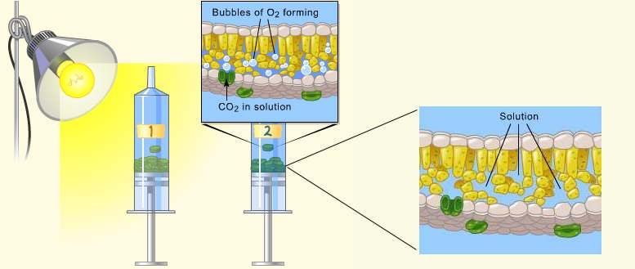
Stomata—air holes & guard cells that open & close them
Photosynthetic cells in the columnar & palisade mesophyll (center) of the leaf (note the chloroplasts in the cells. Note air spaces between the cells!
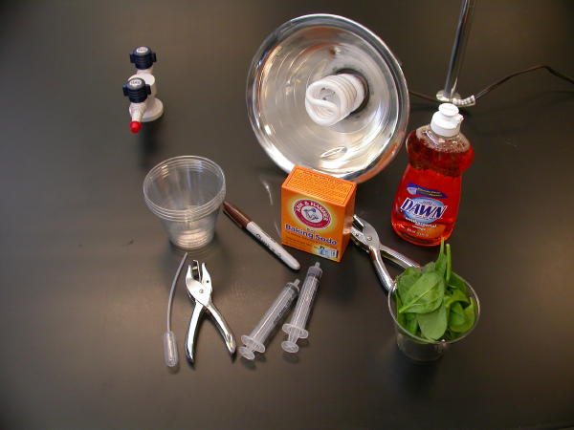
Materials:
- Sodium bicarbonate (Baking soda)
- Liquid Soap
- Plastic syringe (10 cc or larger) —remove any needle!
- Leaf material
- Hole punch
- Plastic cups
- Timer
- Light source

Procedure:
- (Teacher) Prepare 300 ml of bicarbonate solution for each trial.
  - The bicarbonate serves as an alternate dissolved source of carbon dioxide for photosynthesis. Prepare a 0.2% solution. (This is not very much it is only about 1/8 of a teaspoon of baking soda in 300 ml of water.)
  - Add 1 drop of dilute liquid soap to this solution. The soap wets the hydrophobic surface of the leaf allowing the solution to be drawn into the leaf. It’s difficult to quantify this since liquid soaps vary in concentration. Avoid suds. If your solution generates suds then dilute it with more bicarbonate solution.

- (Student) Cut 10 or more uniform leaf disks for each trial.
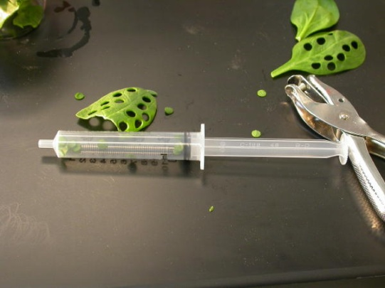
  - Single hole punches work well for this but stout plastic straws will work as well.
  - Avoid major veins.
- Infiltrate the leaf disks with sodium bicarbonate solution. READ THESE PROCEDURES THREE TIMES.
  - Remove the piston or plunger and place the leaf disks into the syringe barrel. Replace the plunger being careful not to crush the leaf disks. Push on the plunger until only a small volume of air and leaf disk remain in the barrel (< 10%).
  - Pull a small volume (~10ml) of sodium bicarbonate solution into the syringe. Tap the syringe to suspend the leaf disks in the solution.
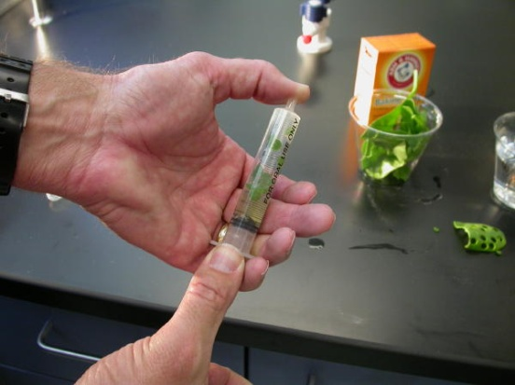
  - Holding a finger over the syringe-opening, draw back on the plunger to create a vacuum. Hold this vacuum for about 10 seconds. While holding the vacuum, swirl the leaf disks to suspend them in the solution. Let off the vacuum. The bicarbonate solution will infiltrate the air spaces in the leaf causing the disks to sink. You will probably have to repeat this procedure 2-3 times in order to get the disks to sink. If you have difficulty getting your disks to sink after about 3 evacuations, it is usually because there is not enough soap in the solution. Add a few more drops of soap.

- Pour the disks and solution into a clear plastic cup. Add bicarbonate solution to a depth of about 3 centimeters. Use the same depth for each trial. Shallower depths work just as well.
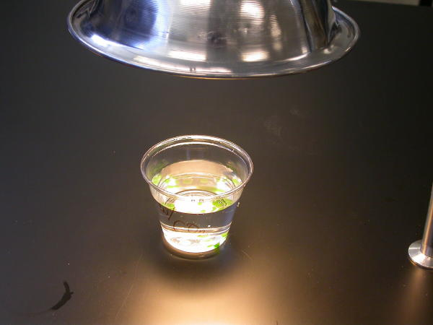
- For a control infiltrate leaf disks with a solution of only water with a drop of soap--no bicarbonate.
- Place under the light source and start the timer. At the end of each minute, record the number of floating disks. Then swirl the disks to dislodge any that are stuck against the sides of the cups. Continue until all of the disks are floating.
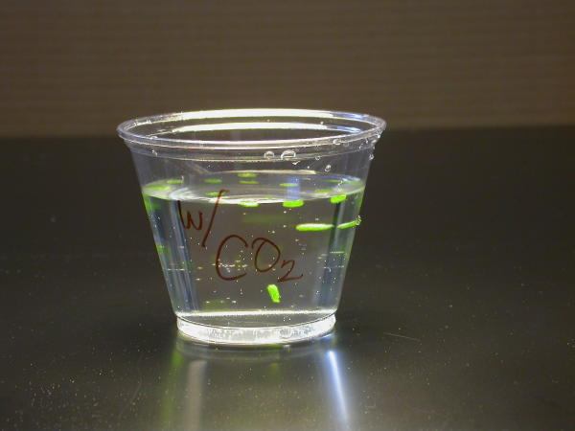
Data Collection and Analysis
These data are from an demonstration investigation using spinach leaf disks.
Time | Disks | Time | Disks | Graph of minutes (x) versus total number floating disk (y)
1 |  | 8
2 |  | 9
3 |  | 10
4 |  | 11
5 |  | 12
6 |  | 13
7  Not Under light |  | 14
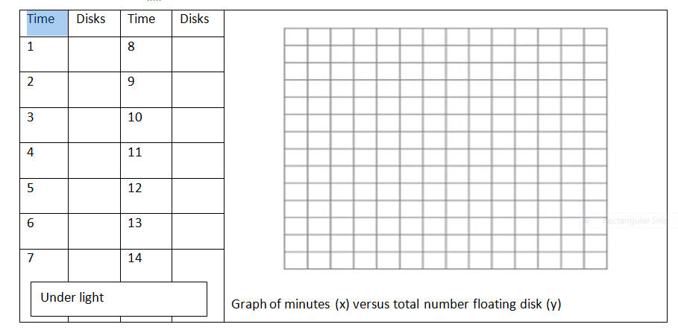
Extension:
In this graph, the light was turned off at 14 minutes and the cups with their floating disks (grape ivy) were placed in the dark. Every minute, the dark cover was removed and disks still floating were counted. Then, the disk were stirred to raise them to the top, but after a while the disks begin to sink again. Why? Cellular respiration removed the O₂ from the cell spaces. The rate that the disks sunk was an indirect measure of the rate of cellular respiration. Can you think of a way to how you might measure the gross rate of photosynthesis with this technique?

Print and Web Resources:
Wickliff, J.L. and Chasson, R.M. 1964. Measurement of photosynthesis in plant tissues using bicarbonate solutions. Bioscience, 14: 32-33.
Steucek, Guy L. Robert J. Hill and Class/Summer 1982. 1985. Photosynthesis I: An Assay Utilizing Leaf Disks. The American Biology Teacher, 47(2):96-99.
Tatina, Robert E. 1986. Improvements to the Steucek and Hill Assay of Photosynthesis. The American Biology Teacher, 48(6): 364-366.
Juliao, Fernando and Henry C. Butcher IV. 1989. Further Improvements to the Steucek and Hill Assay of Photosynthesis. The American Biology Teacher, 51(3): 174-176.
Armstrong, Joeseph E. 1995. Investigation of Photosynthesis using the Floating Leaf Disk Assy. http://www.bio.ilstu.edu/Armstrong/biolab/cellbio/psynex1.htm
Rukes, Kari L. and Timothy J.Mulkey. 1994. Measurement on the Effects of Light Quality and Other Factors on the Rate of Photosynthesis. Bioscene, 20(3): 7-11. http://www.acube.org/volume_20/v20-3p7-11.pdf
Greenler, John. 1990. Exploring Photosynthesis with Fast Plants. WisconsinFast Plant Notes, 4(1): 4-5. http://www.fastplants.org/pdf/activities/exploring_photosynthesis.pdf
BioPi listserv archives. http://listserv.ksu.edu/archives/biopi-l.html
Enter the "Leaf Disks" for a search to review a thread on the technique. Dan Mott attached a copy of his lab using this technique to one of his postings.
Richard, David S. Measure of Photosynthetic Rate In Spinach Leaf Disks http://www.susqu.edu/FacStaff/r/richard/photosynthlab.html

Prelab
      - Write the balanced chemical equation for photosynthesis. ______________________________________________________________________________
      - Identify reactants. _______________________________________
      - Identify products. ________________________________________
      - Identify source of energy. _________________________________
      - Sketch a section of a leaf, labeling three stomata and guard cells, 3 columnar cells with chlorophlasts in them, 3 palisade mesophyll cells with chloroplasts in them, air spaces, and the upper and lower epidermal (covering sheet) cells.

6. Why are the photosynthetic cells at the top side of the leaf? __________________________________________________________________________________________________________________________________________________________________________________
7. Why is their space in the “spongy” palisade mesophyll? __________________________________________________________________________________________________________________________________________________________________________________

8. Leaves also contain veins that have extended from the root up to the leaf; these veins are called xylem. Why do leaves need xylem? _________________________________________________________________________________________
9. Leaves also contain veins that extend out of the leaves to carry sugar solutions out of the leaf and to the rest of the plant; these veins are called phloem. Why do leaves need phloem? __________________________________________________________________________________________________________________________________________________________________________________
10. What gas will be removed from the leaf spaces by photosynthesis? _________________________
11. What gas will be added to the spaces by photosynthesis? _________________________________
12. What gas will be removed from the leaf by cell respiration? ________ Added by cell respiration? ______
13. Independent Variable in the experiment? ____________________________________________
14. Dependent variable in the experiment? ______________________________________________
15. Hypothesis: Rate of leaf disk rise will be ______________ in cups under lights than cups not under lights.

