World Lit and Comp Honors – McBride Name__________________________
Tone and Mood station rotation

LG - Analyze the cumulative impact of specific word choices on meaning and tone (e.g., how the language evokes a sense of time and place; how it sets a formal or informal tone).
Directions: During our reading of Ishmael, we dipped our toes in the mood/tone pool and now it’s time to dive in head first (get your water wings ready). You and your group will be navigating through each station to see how people craft a mood and or a tone in a particular piece. You will be encouraged to think about the creator’s intended audience and purpose. You will have approx. 7 min. at each station, so don’t delay!
HAVE YOUR MOOD/TONE WORD SHEETS OUT FOR THE WHOLE PROCESS!
STATION ONE
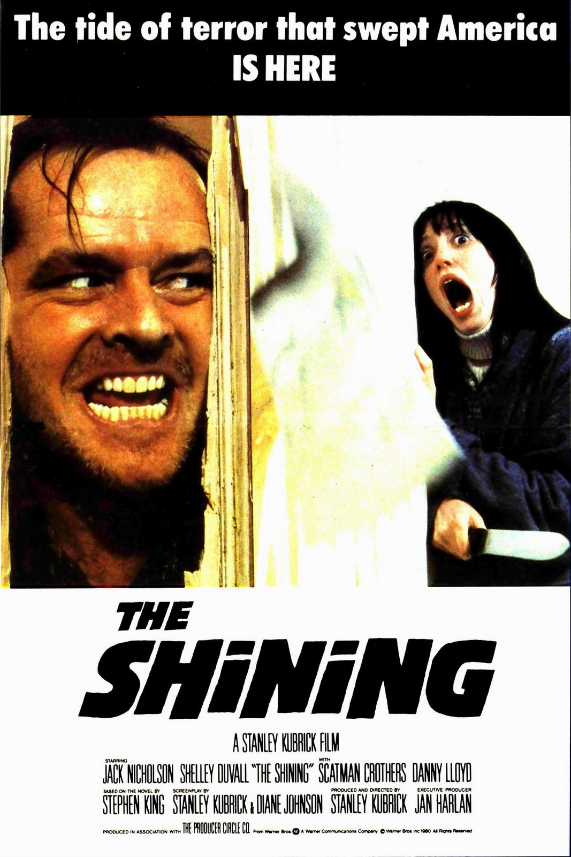
Directions: Carefully watch each movie trailer and take note of particular elements that create a mood. Jot them down below. With your group, decide on a mood word that best describes each clip.
CLIP 1: https://www.youtube.com/watch?v=1G7Ju035-8U
CLIP 2: https://www.youtube.com/watch?v=Os6raCCmAFk
- What is the mood created in the first version? How is it created (think visual, audio, word choices)?

- How is the mood changed in the second version? Provide specific details.

STATION TWO
Directions: Carefully read excerpt from Night, by Elie Wiesel then answer the following questions.
- What is the central idea of this passage?

- What is Wiesel’s attitude toward this idea? Use specific word choices to support you choice.

- List the specific words that he uses to create this tone.

STATION THREE
Directions: There are two jars on the table. As a group, choose ONE slip out of the PHRASE jar. Then, each individual should select ONE slip out of the TONE jar. Now, rewrite the phrase so that it reflects the tone word you selected, paying close attention to punctuation and word choice. Then share them aloud and have some fun!

STATION FOUR
Directions: Carefully listen to the following slam poem. As you watch and listen, write down specific words and/or gestures that are most poignant. Then answer the questions.
https://www.youtube.com/watch?v=UCUz2b050lE&list=PLCaGXb8nbr9O7nieIapgfyD7ZH1Y71dWU
- What words/gestures are most poignant?

- Who is their intended audience? What is their intended purpose?

- In what ways are their words effective in conveying their message to the audience?

STATION FIVE
Directions: Listen to the first minute or so of each song.
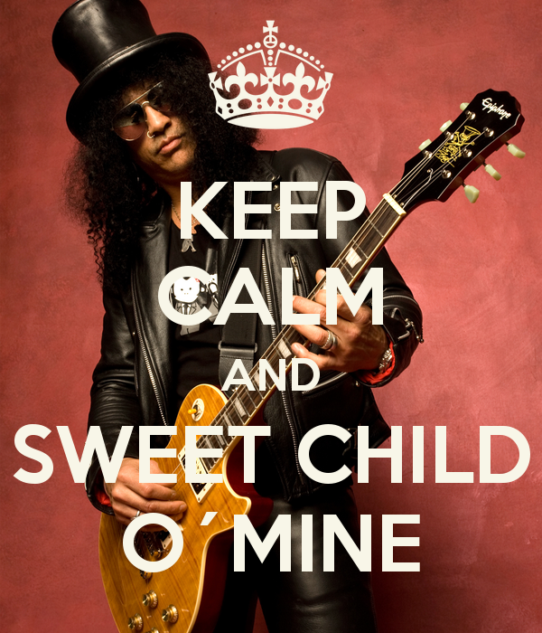
https://www.youtube.com/watch?v=P-AYAv0IoWI
https://www.youtube.com/watch?v=tm2Jy64b0dI
1. How has the mood has been altered? Provide specific details from each video.

