Math 4 Name ________________________

U1 L1 I2 *It’s All in the Family* Date ______________________

*How do the parameters in the basic function families provide tools for matching function models to specific problem conditions, data patterns, & graphs?*



Use the following function to answer the questions below:

1. What is the domain? (use ***interval notation***) 2. What is the range? (use ***interval notation***)
2. Complete the following table of values.

|  |  |  |  |  |  |  |  |  |  |
| --- | --- | --- | --- | --- | --- | --- | --- | --- | --- |
| *x* | -10,000 | -1000 | -100 | -10 | 0 | 10 | 100 | 1000 | 10,000 |
| *f(x)* |  |  |  |  |  |  |  |  |  |

1. As the value of *x* decreases, what value does *f(x)* appear to approach? __________
2. As the value of *x* increases, what value does *f(x)* appear to approach? __________

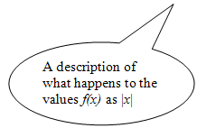Description of the *end behavior* of *f*:  = _____  = _____

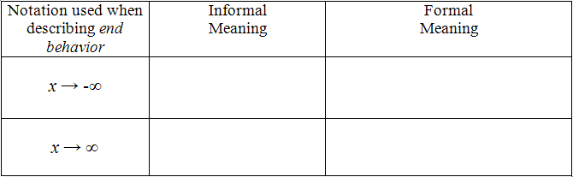

Symmetry:

OVER 🡪

**p. 10**



**I. Linear Functions**

General Rule:

*y*

Domain:

Range:

*x*

Symmetries (if any):

Even, Odd, Neither

Asymptotes (if any):

End Behavior:

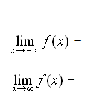



**II. Exponential Functions**

General Rule:

*y*

Domain:

Range:

*x*

Symmetries (if any):

Even, Odd, Neither

Asymptotes (if any):

End Behavior:



**III. Power Functions**

General Rule:

*y*

Domain:

Range:

*x*

Symmetries (if any):

Even, Odd, Neither

Asymptotes (if any):

End Behavior:



**IV. Inverse Variation Functions**

General Rule:

*y*

Domain:

Range:

*x*

Symmetries (if any):

Even, Odd, Neither

Asymptotes (if any):

End Behavior:

OVER 🡪



**V. Quadratic Functions**

General Rule:

*y*

Domain:

Range:

*x*

Symmetries (if any):

Even, Odd, Neither

Asymptotes (if any):

End Behavior:



**VI. Sine, Cosine & Tangent Functions**

General Rule:

*y*

Domain:

Range:

*x*

Symmetries (if any):

Even, Odd, Neither

Asymptotes (if any):

End Behavior:

General Rule:

*y*

Domain:

Range:

*x*

Symmetries (if any):

Even, Odd, Neither

Asymptotes (if any):

End Behavior:

General Rule:

*y*

Domain:

Range:

*x*

Symmetries (if any):

Even, Odd, Neither

Asymptotes (if any):

End Behavior:

2. a. *NEXT-NOW Rules* b. *Recursive Rules*

OVER 🡪

**Practice:**

1. Describe what happens to *f(x)* as |*x*| grows larger and larger in magnitude. In other words, use limit

notation to describe the end behavior of each function. If the limit does not exist, write *d.n.e.*

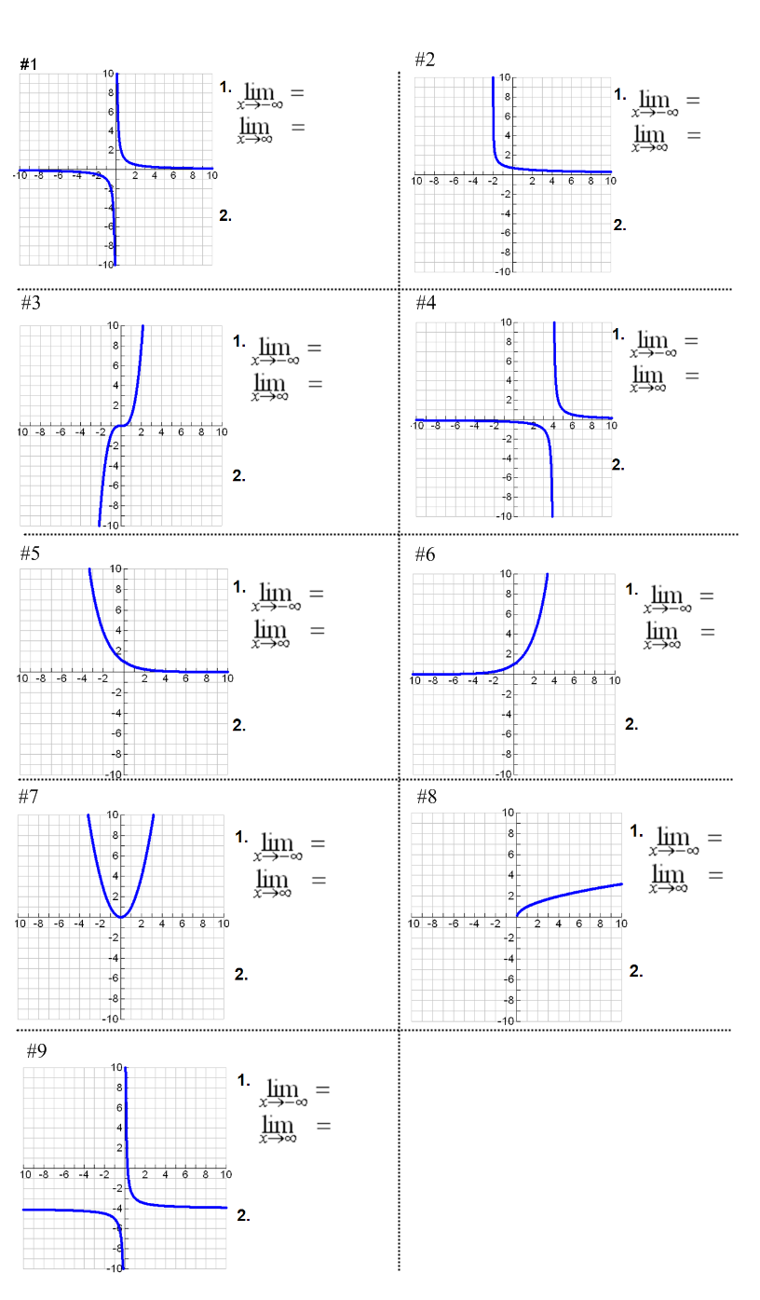2. State whether the function is *even, odd* or *neither*.