Math 3  Name _________________  
Unit 1 Extra Practice Problems

1. 

a. The inverse of this function exists. Find the inverse of the function algebraically. Show your work.

b. Find *f*(-5).

c. Find *x* when *f(x)* = 12

d. Find 

e. Find *x* when 

f. Graph both the function and the inverse on the coordinate plane.

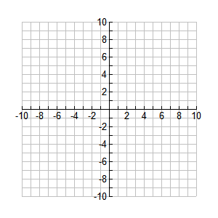

2. 

The inverse of this function exists. Find the inverse of the function algebraically. Show your work.

3. 

The inverse of this function exists. Find the inverse of the function algebraically. Show your work.

4. The table below is for a function *g*. The inverse of the function exists.

|  |  |  |  |  |  |
| --- | --- | --- | --- | --- | --- |
| *x* | -2 | -1 | 0 | 1 | 2 |
| *g(x)* | 5 | 2 | -1 | -4 | -7 |

Find 

5. If *h*(x) = 3x – 1, evaluate .

6. Give the domain and range of .

7. Find the inverse of 

8. True or False. NO CALCULATOR. The following logarithms are in order from least to greatest.

   