Math 4 Honors Name ___________________________ #____

Group Problem Solving Activity Date ____________________________

Please show your work for all problems.

You must do one problem at a time, together.

**Problem #1: Piecewise Functions**

Carefully graph each of the following. Identify whether or not he graph is a function. Then, evaluate the graph at any specified domain value. You may use your calculators to help you graph, but you must sketch it carefully on the grid! (*Remember:* ○ for > or < and ● for > or < )

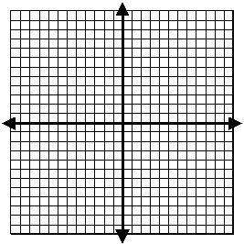1. 

Function? Yes or No



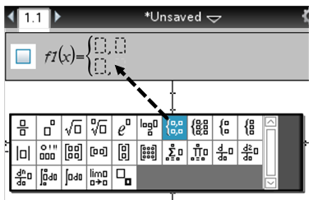 Calculator Tip:

2. 

Function? Yes or No



OVER 🡪

Page 2

3. Your favorite dog groomer charges according to your dog’s weight. If your dog is 15 pounds and under, the groomer charges $35. If your dog is between 15 and 40 pounds (inclusive), she charges $40. If your dog is over 40 pounds, she charges $40, plus an additional $2 for each pound.

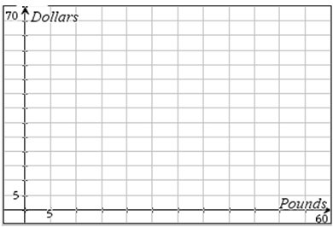(a.) Write a piecewise function that describes what your dog groomer charges.  
(b.) Carefully graph the function.  
(c.) What would the groomer charge if your cute dog weighs 60 pounds?

**Problem #2: Parametric Golfing**

Suppose a pro golfer drives a golf ball 315 yards, which includes 50 yards of roll after it hits the ground. He hits the ball so that its direction makes a 27° angle with the horizontal.

1. What is the initial velocity of the ball when it leaves the club? *Round to the nearest 100th ft/sec.*

*\*\*\*Hints: Convert yards into feet; Substitute known quantities into the parametric equations; You*

*will have to solve a system of equations by the substitution method.*

Use your answer from part (a) and the TRACE function of your calculator to answer (b) & (c).

1. What is the maximum height that the ball reaches? At what time is it reached? *Round to the nearest*

*100th of a second.*

(c.) How long is the ball in the air? *Round to the nearest 100th of a second.*

WORK AND ANSWERS:

Page 3

**Problem #3: Building a Quadratic Equation through Function Composition**

* Let *f*  be the function defined by *f*(*x*) = 2*x*2 + 4*x* – 16 .
* Let *g* be the function defined by *g*(*x*) = 2(*x* + 1)2 – 18.

1. Verify algebraically that *f*(*x*) = *g*(*x*) for all *x* .

2. Consider the functions *h*, *l,* *m*, and *n* given by

*h*(*x*) = *x*2 *l*(*x*) = *x* + 1 *m*(*x*) = *x* – 9  *n*(*x*) = 2*x*

Show that *f(x*) is a composition, in some order, of the functions *h*, *l,* *m*, and *n*.

3. Using transformation vocabulary, explain the impact each of the functions *l,* *m*, and *n* has on the **graph**

of the composition. *\*\*\*Use complete sentences for your explanation.*

**Problem #4: Bacteria Count**

The number *N* of bacteria in a refrigerated food is given by *N*(*T*) = 20*T* 2 – 80*T* + 500, 2 < *T* < 14 where *T* is the temperature of the food in degrees Celsius. When the food is removed from refrigeration, the temperature of the food is given by *T*(*t*) = 4*t* + 2, 0 < *t* < 3 where *t* is the time in hours.

1. Find the composition *N*(*T*(*t*)) and interpret its meaning in context. *Write your equation in standard*

*polynomial form.*

(b) Find the time when the bacteria count reaches 2000. *Round to the nearest 100th*

OVER 🡪

Page 4

**Problem #5: Combining Functions**

Suppose that *f*(*x*) = 5*x*, *g*(*x*) = sin *x*, and *h*(*x*) = *x* + 3. Use these functions to evaluate or find rules for:



WORK & ANSWERS:

|  |  |  |  |  |
| --- | --- | --- | --- | --- |
| **CATEGORY** | **20** | **16** | **12** | **8** |
| **Mathematical concepts** | Work and/or explanations show complete understanding of the mathematical concepts used to solve the problem(s). | Work and/or explanations show substantial understanding of the mathematical concepts used to solve the problem(s). | Work and/or explanations show some understanding of the mathematical concepts needed to solve the problem(s). | Work and/or explanations show very limited understanding of the underlying concepts needed to solve the problem(s) OR is not written. |
|  | **10** | **8** | **6** | **4** |
| **Mathematical errors** | 90-100% of the steps and solutions have no mathematical errors. | Almost all (85-89%) of the steps and solutions have no mathematical errors. | Most (75-84%) of the steps and solutions have no mathematical errors. | More than 75% of the steps and solutions have mathematical errors. |
|  |  |  | **5** | **3** |
| **Answers are labeled with appropriate units** |  |  | Completely | Partially |
|  |  |  | **5** | **3** |
| **Directions were followed** |  |  | Completely | Partially |

Total: _______/40