Math 4 Name_________________________

**Unit 1 Review**  **Non-graphing calculator permitted on test!!** Date________

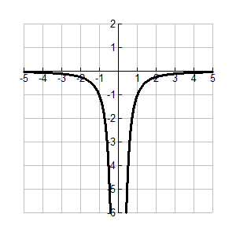

1. **Function Families**

Given a function or graph, find the domain, range, symmetries, degree and type of function family.

Domain: Range:

Symmetry: Type of function:

2. **Absolute Value Functions**

Solve equations and inequalities involving absolute value.



3. **Function Operations**

Given two functions, calculate arithmetic operations and the composition of the functions.

 

Calculate the following:

 

 

4. **Parametric Equations**

Use parametric equation to construct a graph. Convert parametric equations to rectangular form.



Graph the equations over the interval  then convert the equations to rectangular form & simplify.

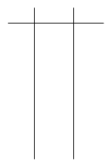

5. **Chunking/*u*-substitution**

Solve for *x*.

 *n*10 – 5*n*6 + 4*n*2 = 0

6. **Number Line Analysis**

Solve the inequality below.



7. **Arithmetic and Geometric Sequences and Series including Sigma Notation.**

Study your 1-6, 1-7 and 1-8 materials as well!