Math 1 Name_________________________

**Unit 1 Review** Date________

Label each phrase with either dependent variable or independent variable.

1. the number of pints of ice cream sold at Dairy Mart

the temperature outside

______________________________________________________________________________

2. the number of games played at Chucky Cheese

the number of tickets earned for prizes at Chucky Cheese

______________________________________________________________________________

3. the number of pear trees that have been planted in the orchard

the number of barrels of pears the orchard will produce

______________________________________________________________________________

4. the number of dogs at an animal shelter

the number of pounds of dog food purchased each month

______________________________________________________________________________

5. Brook’s grade on a test

the number of hours Brook spent studying for the test

______________________________________________________________________________

6. the amount left for a tip

the bill for dinner at a restaurant

______________________________________________________________________________

7. the age of a car

the value of a car

______________________________________________________________________________

8. the loudness of fans inside a football stadium

the number of people in attendance at the football game

**For #9 & 10, solve the equations.**

9.  10. 

11. For the equation  solve for  12. For the equation  solve for 

13. For the equation  solve for 

**Solve each equation or formula for the variable specified.**

14. 3*x* – 4*y* = 7, for *y*. 15. *d = rt*, for *t*.

16. , for *x*. 17. *y* + *a* = *b*, for *y*.

18. *y* = *mx* + *b*, for *x*. 19. , for *y*.

20. , for *R*. 21. *kmx* = 6*y*, for *m*.

22.  *p*(*t* + 3) = -4, for *t*. 23. , for *x*.

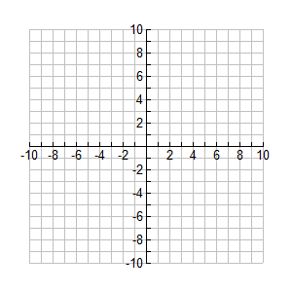24. Sketch a graph that matches the characteristics of the average rate of change given:

Between points A and B: large, positive rate

Between points B and C: small, negative rate

Between points C and D: large, negative rate

Between points D and E: No change

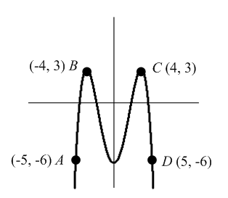25. Use the graph below to answer the following questions.

1. Calculate the average rate of change from point *A* to point *B*.
2. Calculate the average rate of change from point *B* to point *C*.
3. Calculate the average rate of change from point *C* to point *D*.
4. Describe the relationship that exists between the average rate of change and the pattern of the graph between points *A* and *B*.
5. Describe the relationship that exists between the average rate of change and the pattern of the graph between points *B* and *C*.
6. Describe the relationship that exists between the average rate of change and the pattern of the graph between points *C* and *D*.