Math 4 Name_______________________________

**Unit 2 Review** Date________

1. Let  and  Without your calculator, find the following:

a.  c. 

b.  d. 

2. Solve for *a* and *b*: 

3. Suppose that matrix *A* has dimensions  and matrix *B* has dimensions  Which of the following statements is **true**?

(A) The product *AB* exists and has dimensions 

(B) The product *BA* exists and has dimensions 

(C) The product *BA* exists and has dimensions 

(D) The product *AB* exists and has dimensions 

4. If  what are the dimensions of matrix *A*?

5. The average number of gallons of unleaded gas sold daily at three different gas stations is given in the matrix below.

Regular Super Premium

 

The selling prices for regular, super, and premium are $3.79, $3.89, $4.02, respectively. Use a product of **2** matrices to find the gas revenue for each station. **Be sure to show the product of the matrices you use to arrive at your answer.**

Jack's _______________

Karen's _______________

Carl's ________________

6. Let  and 

If *A* = *B*, find the values of *x*, *y* and *z*.

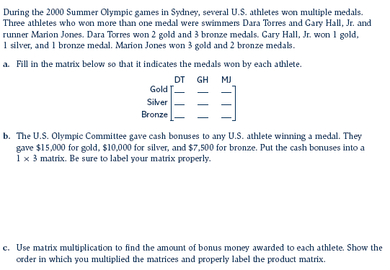7.

8. Let *B* =  What is the additive inverse of matrix *B*?

a.  b.  c. 

d.  e. there is no additive inverse of matrix *B.*

9. Without using a calculator, find the following:

**In numbers 10 - 12, solve the following systems using matrices. Make sure to write your matrix equation as well as the solution matrix.**

10. 

11. 

12. 