Math 4 Honors Name _________________________________

Unit 3 Critical Skills Review Date ______________________________

Unit 3 is all about Rational Functions! The following problems are to help you review some algebraic skills you will need to apply in order to be successful in this unit. Make Mr. Shirey proud!!!!

1. Simplify each rational expression completely. Then state the domain using set builder notation.

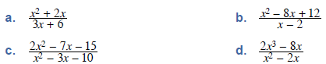





e. f.

2. Find . Simplify each expression as much as possible.

OVER 🡪

3. Solve for *x*.



1. b.



 c. d.

4. Solve the following inequalities using NLA. Write your solutions in interval notation.

(OK, this is happy Heinl memories!)

***Note: Rational inequalities have additional critical values. *Hint:* Think vertical asymptotes . . . .



a.





