Math 4 Honors Unit 3 Test Review

**Station #1: SAT Subject Test Math Questions**

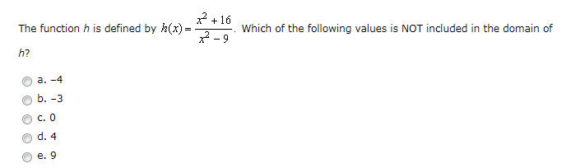

1.

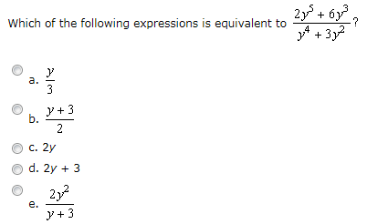

2.

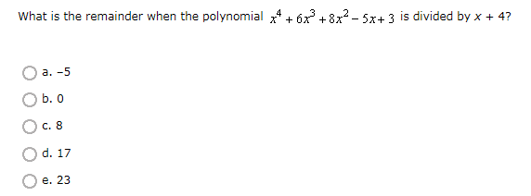

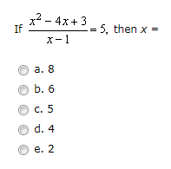

3.

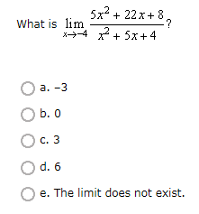

4.

Math 4 Honors Unit 3 Test Review

**Station #2: Rational Function Concept Map (or some other graphic organizer)**

Make a concept map (or some other graphic organizer) for *rational functions* and the vocabulary associated with them.

Vertical asymptote, horizontal asymptote, oblique asymptote, local behavior, end behavior, hole, numerator, denominator, essential discontinuity, removable discontinuity, zero(s), division, quotient, identical factors

Math 4 Honors Unit 3 Test Review

**Station #3: Partial Fraction Decomposition**

1. Draw lines to match the rational expression with the form of its decomposition.



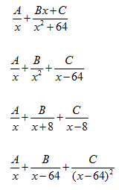

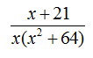

2. Find the partial fraction decompostion of .

Math 4 Honors Unit 3 Test Review

**Station #4: Solving Inequalities Using NLA**

Solve the following inequalities. Write your answers in interval notation.

1. 

2. 

3. 

Math 4 Honors Unit 3 Test Review

**Station #5: Analyzing Functions *without* a Graphing Calculator**

Match each function rule with ALL properties that apply to that function.

*Some may be used more than once.*

**Functions Properties**

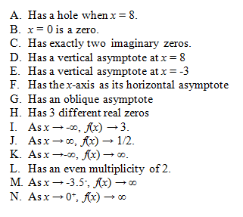1. _______________ 

2. _______________ 

3. _______________ 

4. _______________ 