Math 4 Honors Name ___________________________

Unit 4 Pre-requisites: *The Unit Circle & Trig. Functions* Date _________________________



Equation for the **Unit Circle**:

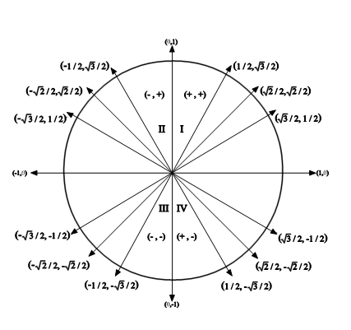 What is the radius of the unit circle? _____ What are the coordinates of its center? ________

* Which coordinate is used to

evaluate an angle’s cosine?

* Which coordinate is used to evaluate an angle’s sine?
* How are an angle’s sine & cosine used to evaluate its tangent?

Fill in the blanks in the graph above with the appropriate radian measure for each angle. Then, complete the table below (exact values only):

|  |  |  |  |  |  |
| --- | --- | --- | --- | --- | --- |
| θ | 0° = | 30° = | 45° = | 60° = | 90° = |
| sin θ |  |  |  |  |  |
| cos θ |  |  |  |  |  |
| tan θ |  |  |  |  |  |

Evaluate the following (exact values only):





OVER 🡪

**Graphical analysis of trigonometric functions.**

Consider the three functions graphed below on the interval [-2π, 2π]. For each function identify the following:

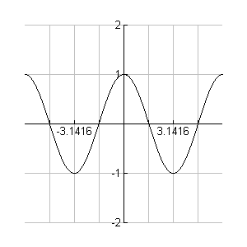***Use exact values.***

1. Name

Period:

Even or Odd?

2. Domain

3. Range

4. Where the function is increasing and decreasing

5. Relative max/min values and where they occur

6. End behavior

7. Zeros

8. *y*-intercept

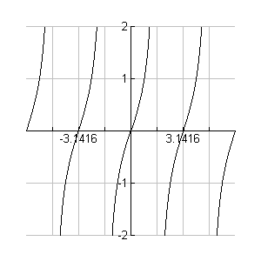1. Name

2. Domain

Period:

Even or Odd?

3. Range

4. Where the function is increasing and decreasing

5. Relative max/min values and where they occur

6. End behavior

7. Zeros

8. *y*-intercept

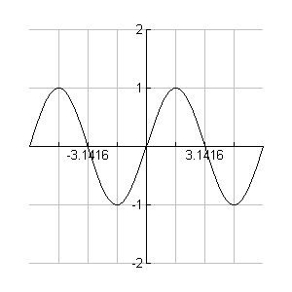1. Name

Period:

Even or Odd?

2. Domain

3. Range

4. Where the function is increasing and decreasing

5. Relative max/min values and where they occur

6. End behavior

7. Zeros

8. *y*-intercept