Math 1 Name_______________________________

**Unit 4 Review** Date________

**For numbers 1-2, write an explicit and a recursive equation and then answer the question.**

1. The value of a stock when purchased was $20 a share. The stock grew at a yearly [rate](javascript:def('/Glossary/glossaryterm.aspx?word=Rate',%20500,%20500);) of 8%.  What is the value of the stock after 15 years?

*f(x)* = _____________________ Value of stock after 15 years __________________

*Recursive:*

1. The value of a stock when purchased is $55 a share. The stock decreased at a [rate](javascript:def('/Glossary/glossaryterm.aspx?word=Rate',%20500,%20500);) of 4%

yearly.  How many years did it take for the stock to be worth $20.65?

*f(x)* = _____________________ Number of years until the stock reaches $20.65 _________

*Recursive:*

1. Coffee, tea, and some soft drinks contain the drug caffeine. One hour after ingestion, 65% of the original amount of caffeine remains. At the end of each hour after that, 65% of the amount at the beginning of the hour remains. Suppose a person consumes 30 milligrams of caffeine.

The equation represents this situation.

1. How much caffeine would remain after 2.5 hours?

*Amount of caffeine remaining: =* __________________________

1. Estimate when 6 mg of caffeine remains.

*Time when 6 mg of caffeine remain: _________________________*

1. Set up and solve an equation to find the half-life of the drug caffeine.

1. Describe the possible domain and range of this situation.

Domain –

Range –

1. 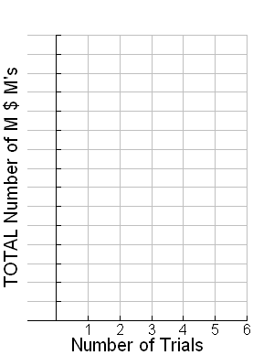Geoff and his friend Sandra were completing an M&M activity in Math 1 class where they were collecting data by counting the remaining M&M’s. **Graph** their data that is listed in the below chart:

|  |  |
| --- | --- |
| **Trial Number** | **Number of M&M’s** |
| 0 | 3 |
| 1 | 5 |
| 2 | 9 |
| 3 | 15 |
| 4 | 19 |
| 5 | 32 |
| 6 | 45 |

1. Find the **linear regression equation** the models Geoff and Sandra’s data. ***Round to the nearest hundredth.***

*y* = _____________________________

1. Using your linear regression, predict the number of M&M’s you would have after 12 trials.
2. Find the **exponential regression equation** the models Geoff and Sandra’s data. ***Round to the nearest hundredth*.**

*y* = _____________________________

1. Using your exponential regression, predict the number of M&M’s you would have after 12 trials.
2. Will your prediction using the **linear regression equation** or the **exponential regression equation** be a better representation of the number of M&M’s after 12 trials? *Explain why!!!*
3. 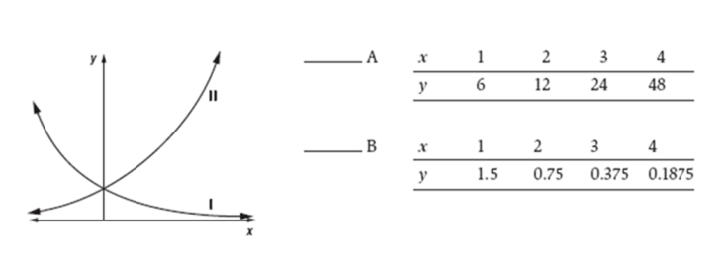Two exponential growth and decay situation are represented by Graphs I and II and also by Tables A and B. For each graph, there is a matching table.
4. Write the number of the graph beside its corresponding table.
5. The rule for Graph I in Part *a* is of the form *y = a(b)x.* Will *b* be less than 1 or greater than 1? *Explain your answer.*

*Circle your answer*: Greater than 1 or Less than 1

*Explanation*:

1. Stan can figure out how much money he has in the bank by using the following formula. (*x* stands for years and *M* stands for money)
   * 1. How much money did Stan initially deposit in the bank?
     2. What is the interest rate of the account?
     3. How much money will Stan have in 20 years?
     4. When will Stan’s bank account reach about $10,050?
     5. Describe the possible domain and range of this situation.

Domain –

Range –

1. What is the percent of decay modeled by the equation: 

*Percent of decay: _________________*

1. What is the percent of growth modeled by the equation: 

*Percent of growth: _________________*

1. Label the following equations with the terms ***Exponential Growth****,* ***Exponential Decay****,* or ***Linear****.*

  

_______________ _______________ _______________



1. Which graph matches the equation:



*Circle your answer:*

Graph 1 Graph 2 Graph 3

_____________________________________________________________________________

1. Which equation matches Graph 2:

*Circle your answer:*

  