Math 4 Honors Name _________________________________

Unit 6 Test Prep Date _____________________________

**Station 1**

The function on the **left** is. Which graph on the **righ**t is a possible graph of?

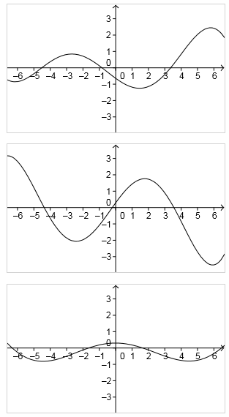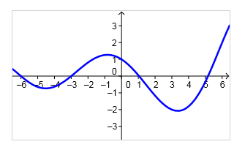

*In complete sentences, explain your choice using concepts and vocabulary from Unit 6.*

A.

B.

C.

FYI: There is a link for more practice

on my teacher website.

**Station 2**

Use the function below to answer the following. ***(Show algebraic work to support your answers)***  

1. Calculate 

1. For what values of *x* is *f* concave up? *Use interval notation.*

For what values of *x* is *f* concave down? *Use interval notation.*

Up:

Down:

**Station 3**

1. The relative minimum of  on the interval [-1, 2] is at *x* = ______.
2. -1 B.) -1/2 C.) 4/3 D.) 5/3 E.) 2
3. What is the slope of the tangent line for the function  when *x* = -6?
4. -21 B.) -4 C.) 0 D.) 27 E.) 527
5. A particle moves along a horizontal line and its position at time *t* is .

The velocity, *v*, is increasing when

1. *t* > 1 B.) 1 < *t* < 2 C.) *t* < 2 D.) *t <* 1or *t* > 2 E.) *t* > 0

**Station 4**

Identify the Function, First and Second Derivatives.

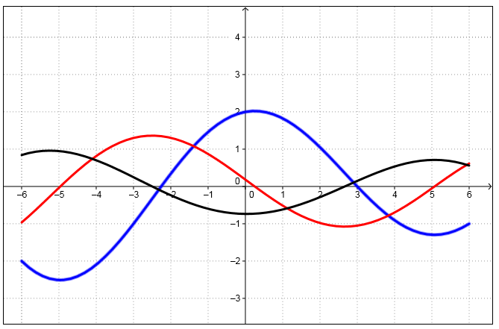

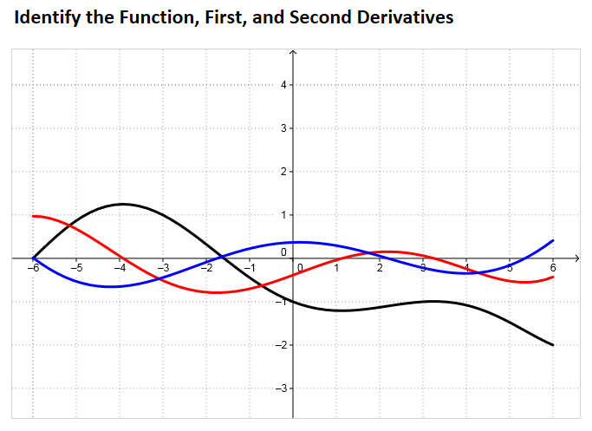1. 2.

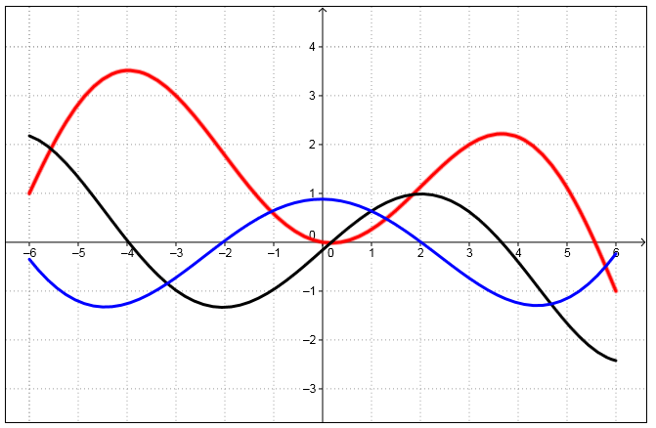3.

FYI: There is a link for more practice

on my teacher website.

**Station 5**



A graph of  is given at the right.

1. On what interval(s) is  increasing?

Decreasing? Explain.

1. On what interval(s) is  increasing?

Decreasing? Explain.

1. On what interval(s) is  concave up? Concave down? Explain.

**Station 5**



A graph of  is given at the right.

1. On what interval(s) is  increasing?

Decreasing? Explain.

1. On what interval(s) is  increasing?

Decreasing? Explain.

1. On what interval(s) is  concave up? Concave down? Explain.