UNIT 8: MOTIVATION AND EMOTION

8A: MOTIVATION

INSTINCTS

DRIVES AND INCENTIVES

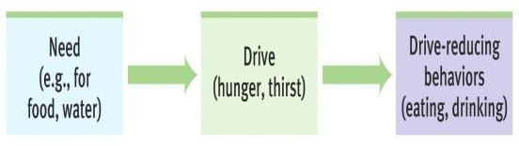drive reduction theory

homeostasis

incentives

HIERARCHY OF NEEDS (MASLOW)

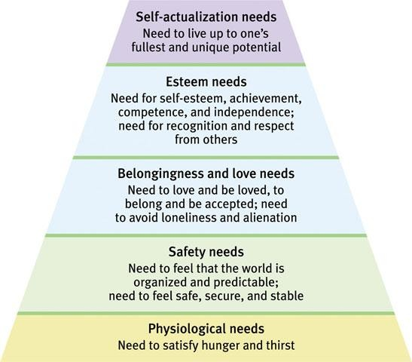

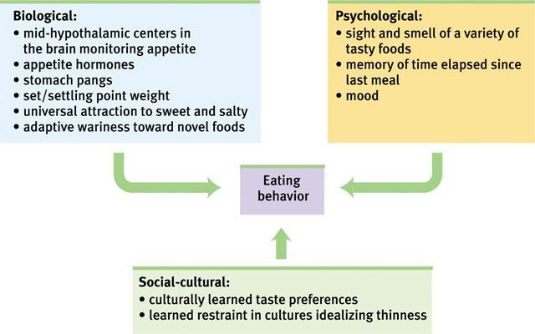HUNGER AND THE HYPOTHALAMUS

HORMONE | TISSUE | RESPONSE
Orexin increase
Ghrelin increase
Insulin increase
Leptin increase
PPY increase

1: From what perspectives do psychologists view motivated behavior?

2: What physiological factors produce hunger?

3: What psychological and cultural factors influence hunger?

4: How do eating disorders demonstrate the influence of psychological forces on physiologically motivated behaviors?

5: What factors predispose some people to become and remain obese?

6: What stages mark the human sexual response cycle?

7: Do hormones influence human sexual motivation?

8: How do internal and external stimuli influence sexual motivation?

9: What factors influence teen pregnancy and risk of sexually transmitted infections?

10: What has research taught us about sexual orientation?

11: Is scientific research on sexual motivation value free?

12: What evidence points to our human need to belong?

1. Motivation is best understood as a state that:
a. reduces a drive.
b. aims at satisfying a biological need. c. energizes an organism to act.
d. energizes and directs behavior.

2. Which of the following is a difference between a drive and a need?
a. Needs are learned; drives are inherited.
b. Needs are physiological states; drives are
psychological states.
c. Drives are generally stronger than needs.
d. Needs are generally stronger than drives.

3. One problem with the idea of motivation as drive reduction is that:
a. because some motivated behaviors do not seem to be based on physiological
needs, they cannot be explained in terms of drive reduction.
b. it fails to explain any human motivation. c. it cannot account for homeostasis.
d. it does not explain the hunger drive.

4. Some scientific evidence makes a preliminary link between homosexuality and
a. late sexual maturation.
b. the age of an individual’s first erotic experience.
c. atypical prenatal hormones.
d. early problems in relationships with
parents.

5. Electrical stimulation of the lateral hypothalamus will cause an animal to:
a. begin eating. b. stop eating.
c. become obese.
d. begin copulating.
6. Instinct theory and drive-reduction theory both emphasize factors in motivation.
a. environmental b. cognitive
c. psychological d. biological

7. The correct order of the stages of Masters and
Johnson’s sexual response cycle is:
a. plateau; excitement; orgasm; resolution.
b. excitement; plateau; orgasm; resolution. c. excitement; orgasm; resolution;
refractory.
d. plateau; excitement; orgasm; refractory.

8. Bulimia nervosa involves:
a. binging. b. purging.
c. dramatic weight loss. d. a and b

9. Castration of male rats results in:
a. reduced testosterone and sexual interest. b. reduced testosterone, but no change in
sexual interest.
c. reduced estrogen and sexual interest.
d. reduced estrogen, but no change in sexual interest.

10. In his study of men on a semistarvation diet, Keys found that:
a. the metabolic rate of the subjects increased.
b. the subjects eventually lost interest in food.
c. the subjects became obsessed with food. d. the subjects’ behavior directly
contradicted predictions made by
Maslow’s hierarchy of needs.

TRUE/FALSE ITEMS

1. When body weight rises above set point, hunger increases.

2. According to Masters and Johnson, only males experience a plateau period in the cycle of sexual arousal.

3. Testosterone affects the sexual arousal of the male only.

4. Unlike men, women tend not to be aroused by sexually explicit material.

5. All taste preferences are conditioned.

6. Married people are less at risk for depression than are unattached people.

7. An increase in insulin increases blood glucose levels and triggers hunger.

8. One’s sexual orientation is not voluntarily chosen.
UNIT 8B: EMOTION

James-Lange theory Canon-Bard theory two-factor theory

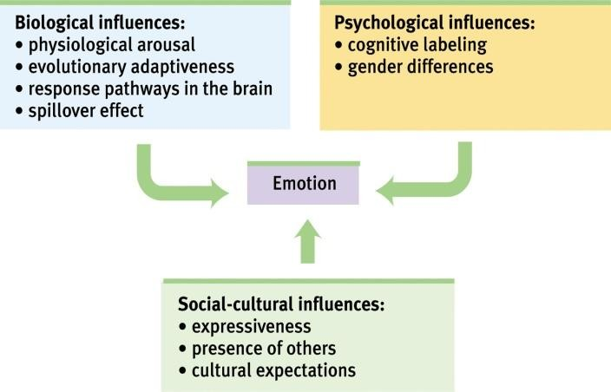EMBODIED EMOTION

Autonomic nervous system Physiological effects of emotions The role of cognition

EXPRESSED EMOTION Nonverbal communication

Detecting Emotion

Facial Expressions

EXPERIENCED EMOTION

Fear Anger Happiness

Adaptation and Comparison
KEY QUESTIONS FROM 8B: EMOTIONS, STRESS AND HEALTH

1: What are the components of an emotion?

2: What is the link between arousal and the autonomic nervous system?

3: Do different emotions activate different physiological and brain-pattern responses?

4: To experience emotions, must we consciously interpret and label them?

5: How do we communicate nonverbally?

6: Are nonverbal expressions of emotion universally understood?

7: Do our facial expressions influence our feelings?

8: What is the function of fear and how do we learn fears?

9: What are the causes and consequences of anger?

10: What are the causes and consequences of happiness?

11: What is stress?

12: What events provoke stress responses?

13: Why are some of us more prone than others to coronary heart disease?

14: How does stress make us more vulnerable to disease?

15: What factors affect our ability to cope with stress?

16: What tactics can we use to manage stress and reduce stress-related ailments?

