Math 1 Name __________________________________

**AIR Test Review** Date_________

Round the following numbers to the nearest thousandth:

1.  2. 

___________ ____________

Solve the following for *x* and round to the nearest thousandth. Circle your final answer.   
3.  4. 

5.  6. 

7. If I were writing a word problem where the independent variable is how often you work out, what is an example of something that could be a dependent variable?

8. Find the average rate of change between x = -2 and x = 7

|  |  |  |  |  |  |  |
| --- | --- | --- | --- | --- | --- | --- |
| x | -2 | 0.5 | 2.5 | 3 | 4.5 | 7 |
| y | -5 | -8 | -9.3 | -14 | -21.7 | 33 |

9. Find AROC for the points (13, 4) and (-8, 12.6). Round your answer to the nearest thousandth.

Write the explicit formula and the recursive formula for the following sequence.

10. {8, 5, 2, -1, …} 

Recursive Formula Explicit Formula

11. Find the missing terms of the following arithmetic sequence.

19, __________, __________, __________, 5.5

12. Key Club decided to sell cupcakes in hopes to raise money. The following function represents the Profit, *P* in dollars*,* in terms of how many cupcakes they sell, *n.*



a. What is the rate of change and what does it mean in the context of the situation?

b. What is the *y*-intercept and what does it mean in the context of the situation?

c. If Key Club sells 220 cupcakes, what will their profit be? *Show your work.*

d. Key Club ended up making a profit of $226, how many cupcakes did they end up selling? *Show your work.*

e. Give the practical domain of the situation.

f. Give the practical range of the situation.

13. Match the following correlation coefficients to the scatter plots below:

a. r = -0.87 b. r = 0.79 c. r = 0.91 d. r = -0.15

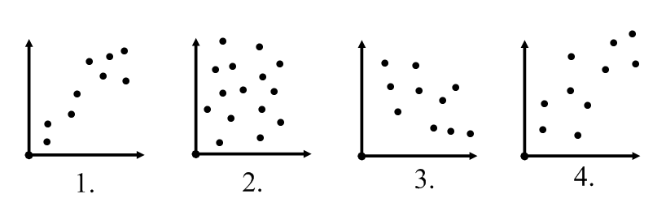 _________ _________ _________ _________

14. Find the equation in point-slope form that would pass through the coordinates (-2, 8) and (5, -6).

15. For the following 2 scenarios tell whether the situation is a correlation or causation. Explain your answer. Be sure to include a lurking variable if appropriate.

a. The amount you brush your teeth and the number of cavities you have.

b. The number of snow days and the number of eggs sold at Marcs

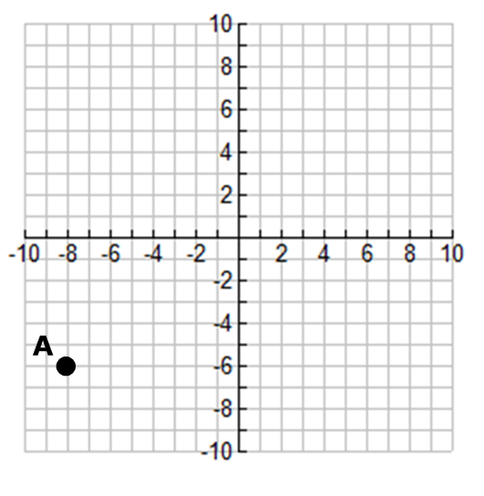16. Sketch a graph that matches the characteristics of the average rate of change given:

Between points A and B: small, negative rate

Between points B and C: large, positive rate

Between points C and D: large, negative rate

Between points D and E: no change

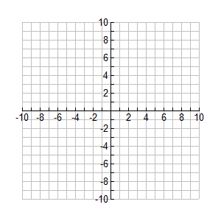17. Graph the following on the coordinate plane.



What is the solution to the system? ____________________

For 18 and 19, use the substitution or elimination method to solve the following:

18.  19. 

20. Suppose a population of 3000 armadillos is growing by 2.6% every year. Write an explicit equation to model the growth of this population.

21. In approximately how many years will the population be at 5700 armadillos?