AP Calculus AB Name__________________________________

“Up Through” Lesson 3-2 Learning Check Date ________________________________

**NO CALCULATOR**

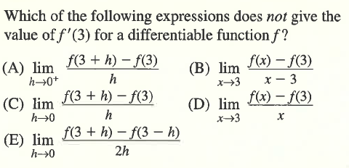

1.

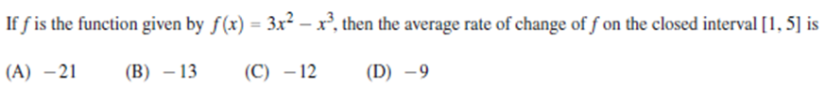

2.

***From 2017 exam



3.

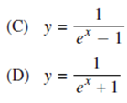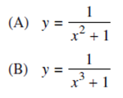

***From 2017 exam

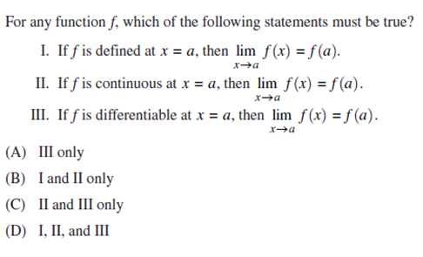

4.

***From 2017 exam

OVER 🡪

**CALCULATOR ACTIVE**

5. If then

(A) is not continuous at .

1. is continuous at but does not exist.

(C) exists and equals 1.

(D) .

1. does not exist.

6. Where is the function  nondifferentiable? Why is it nondifferentiable at that point?

7. Let . Find .

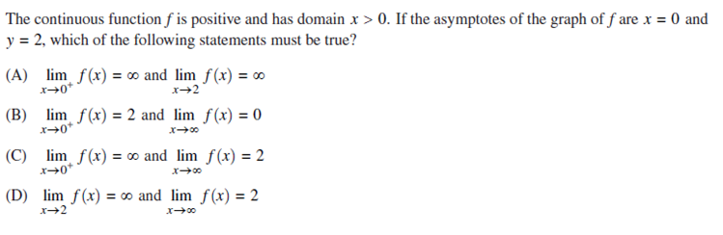

8.

***From 2017 exam