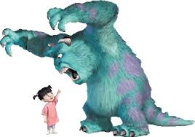
Weekly Agenda 10/10 – 10/13
World Lit and Comp Honors – McBride

Mon 10
- SAT QOTD / Collect papers
- SQUAD UP! Pair Share – Develop Monster Squad Claim (PE)
- HW – Prepare for Tag Team Seminar Tomorrow!
Tues. 11
- SAT QOTD / Collect papers
- Tag Team Seminar – What do monsters tell us about human nature?
- HW – Read Ch. 1-2 – Track Monsters Traits
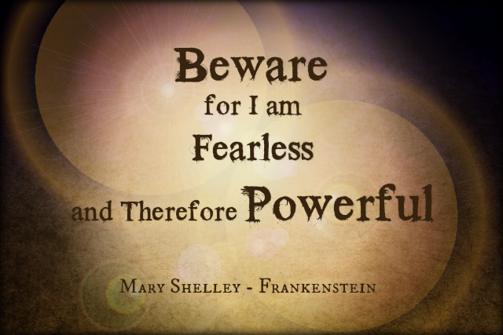
Wed.12 – No School – Yom Kippur
- HW – Read Ch. 3-4 Track Monster Traits
  - Complete Ch. 1-4 Pretest
Thurs. 13 – Conferences - Shortened Periods
- Review Ch. 1-4 Quiz (pre-test – 0 weight)
- Close reading strategy – filter characterization/Monster Traits.
- HW – Read LOTF Ch. 5-8 by Monday! (Monster Tracker!)
  - Read Polyphemus in Mythology - Enjoy your long weekend!
Learning Goals:
RL10.1 Cite strong and thorough textual evidence to support analysis of what the text says explicitly as well as inferences drawn from the text.
RL.10.2 Determine a theme or central idea of a text and analyze in detail its development over the course of the text, including how it emerges and is shaped and refined by specific details; provide an objective summary of the text.
RL.10.3 Analyze how complex characters (e.g., those with multiple or conflicting motivations) develop over the course of a text, interact with other characters, and advance the plot or develop the theme.

Weekly Agenda 10/10 – 10/13
World Lit and Comp Honors – McBride

Mon 10
- SAT QOTD / Collect papers
- SQUAD UP! Pair Share – Develop Monster Squad Claim (PE)
- HW – Prepare for Tag Team Seminar Tomorrow!
Tues. 11
- SAT QOTD / Collect papers
- Tag Team Seminar – What do monsters tell us about human nature?
- HW – Read Ch. 1-2 – Track Monsters Traits
Wed.12 – No School – Yom Kippur
- HW – Read Ch. 3-4 Track Monster Traits
  - Complete Ch. 1-4 Pretest
Thurs. 13 – Conferences - Shortened Periods
- Review Ch. 1-4 Quiz (pre-test – 0 weight)
- Close reading strategy – filter characterization/Monster Traits.
- HW – Read LOTF Ch. 5-8 by Monday! (Monster Tracker!)
  - Read Polyphemus in Mythology - Enjoy your long weekend!
Learning Goals:
RL10.1 Cite strong and thorough textual evidence to support analysis of what the text says explicitly as well as inferences drawn from the text.
RL.10.2 Determine a theme or central idea of a text and analyze in detail its development over the course of the text, including how it emerges and is shaped and refined by specific details; provide an objective summary of the text.
RL.10.3 Analyze how complex characters (e.g., those with multiple or conflicting motivations) develop over the course of a text, interact with other characters, and advance the plot or develop the theme.

