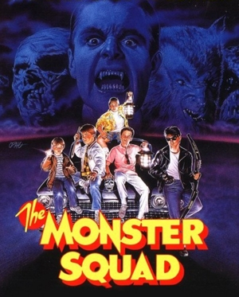
Weekly Agenda 10/31 – 11/4
World Lit and Comp Honors – McBride

Get Persepolis: The Story of a Childhood by Nov. 7th!
REDUCTIONS DUE MONDAY!

Monday 31 – Happy Halloween!
- Allusions: 3am! Muwahahaha!
- Are you ready for the Monstrous Mile??
- HW – Prototype Presentations and papers due tomorrow and Friday!
Tuesday 1 – Report to IC Amphitheater!
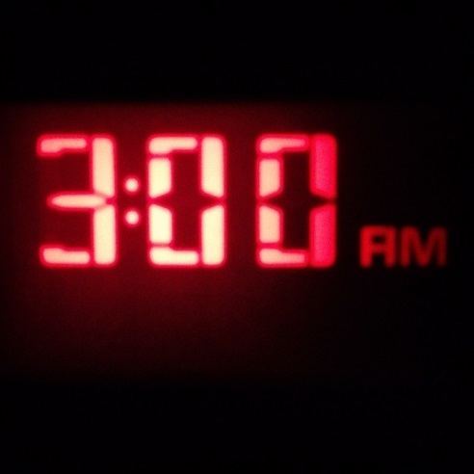
- Prototype presentations in Innovation Center Amphitheater
Wednesday 2
- Tune “Tuesday”
- Review Post Test 2 and 9-12 Summative
- HW – Presentations/Papers due Fri! Get Persepolis!
Thursday 3
- Silent reading day, Genetics Conference
- HW – Prototype presentations tomorrow!
Friday 4 - Report to IC Amphitheater!
- Prototype Presentations in Innovation Center Amphitheater
- Sentence Diagrams!
- HW – LOTF Reductions due Monday! Do you have Persepolis Yet?

Weekly Agenda 10/31 – 11/4
World Lit and Comp Honors – McBride

Get Persepolis: The Story of a Childhood by Nov. 7th!
REDUCTIONS DUE MONDAY!

Monday 31 – Happy Halloween!
- Allusions: 3am! Muwahahaha!
- Are you ready for the Monstrous Mile??
- HW – Prototype Presentations and papers due tomorrow and Friday!
Tuesday 1- Report to IC Amphitheater!
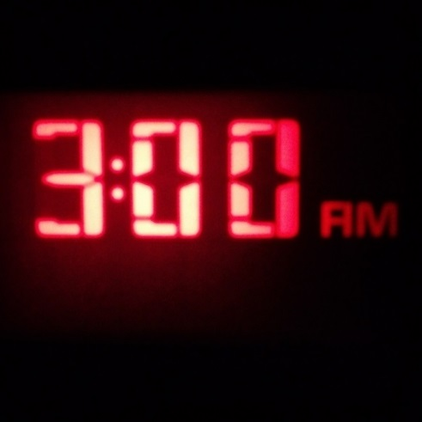
- Prototype presentations in Innovation Center Amphitheater
Wednesday 2
- Tune “Tuesday”
- Review Post Test 2 and 9-12 Summative
- HW – Presentations/Papers due Fri! Get Persepolis!
Thursday 3
- Silent reading day, Genetics Conference
- HW – Prototype presentations tomorrow!
Friday 4- Report to IC Amphitheater!
- Prototype Presentations in Innovation Center Amphitheater
- Sentence Diagrams!
- HW – LOTF Reductions due Monday! Do you have Persepolis Yet?

