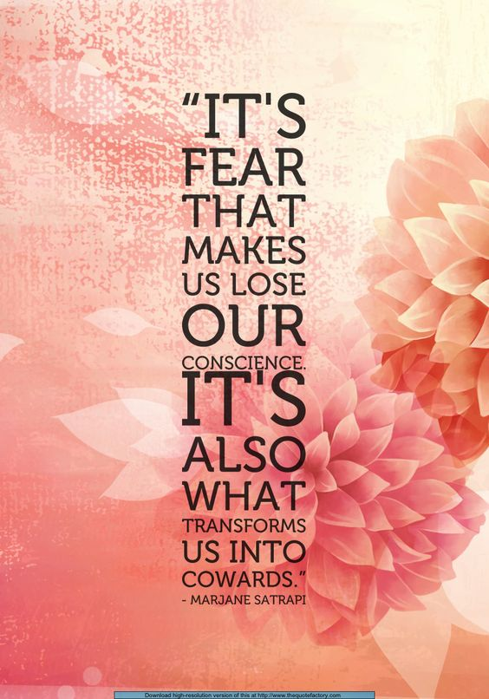
Weekly Agenda – 11/14 – 11/18
World Lit and Comp Honors – McBride
Monday 14 – Report to the Innovation Center!
- Socratic Seminar
- HW – Develop claim and organize sources for On-demand essay
Tuesday 15 – 2nd to Rm. 260, 3rd and 7th to rm. 217
- On-demand essay
- HW – Log onto google classroom and visit the Persepolis Prep Blendspace link. View at least 4 of the 6 and take thorough notes. https://www.tes.com/lessons/dN1ZKvWXkFqCgw/preppin-persepolis
Wednesday 16
- Review Blendspace Content – Check notes
- Silent Reading Day - The Veil, The Bicycle, The Water Cell, Persepolis
- HW – The Letter, The Party, The Heroes and Moscow
Thursday 17
- Review pre-Test Ques.
- How does Persepolis Support your working claim?
  - Finding specific TE to support or refute original claim
- HW – Read The Sheep, The Trip, The F-14s, The Jewels
Friday 18 – Report to 217
- Practice Active vs. passive voice (writing folders)
- Revise / edit on-demand essay
- HW – Read The Key, The Wine, The Cigarette, The Passport
Learning Goals:
- I can determine the meaning of words and phrases as they are used in the text, including figurative and connotative meanings; analyze the cumulative impact of specific word choices on meaning and tone (e.g. how the language evokes a sense of time and place; how it sets a formal or informal tone).
- I can determine an author’s point of view or purpose in a text and analyze how an author uses rhetoric to advance that point of view or purpose.
- I can analyze a particular point of view or cultural experience reflected in a work of literature from outside the United States, drawing on a wide reading of world literature.
- I can participate in collegial discussions.
- I can write for a variety of purposes.

Weekly Agenda – 11/14 – 11/18
World Lit and Comp Honors – McBride
Monday 14 – Report to the Innovation Center!
- Socratic Seminar
- HW – Develop claim and organize sources for On-demand essay
Tuesday 15 – 2nd to Rm. 260, 3rd and 7th to rm. 217
- On-demand essay
- HW – Log onto google classroom and visit the Persepolis Prep Blendspace link. View at least 4 of the 6 and take thorough notes. https://www.tes.com/lessons/dN1ZKvWXkFqCgw/preppin-persepolis
Wednesday 16
- Review Blendspace Content – Check notes
- Silent Reading Day - The Veil, The Bicycle, The Water Cell, Persepolis
- HW – The Letter, The Party, The Heroes and Moscow
Thursday 17
- Review pre-Test Ques.
- How does Persepolis Support your working claim?
  - Finding specific TE to support or refute original claim
- HW – Read The Sheep, The Trip, The F-14s, The Jewels
Friday 18 – Report to 217
- Practice Active vs. passive voice (writing folders)
- Revise / edit on-demand essay
- HW – Read The Key, The Wine, The Cigarette, The Passport
Learning Goals:
- I can determine the meaning of words and phrases as they are used in the text, including figurative and connotative meanings; analyze the cumulative impact of specific word choices on meaning and tone (e.g. how the language evokes a sense of time and place; how it sets a formal or informal tone).
- I can determine an author’s point of view or purpose in a text and analyze how an author uses rhetoric to advance that point of view or purpose.
- I can analyze a particular point of view or cultural experience reflected in a work of literature from outside the United States, drawing on a wide reading of world literature.
- I can participate in collegial discussions.
- I can write for a variety of purposes.

