Weekly Agenda 8/29 – 9/2
Books to purchase 1st Quarter:
Ishmael by Daniel Quinn,
Mythology by Edith Hamilton

World Lit and Comp Honors – McBride
Mon. 29
- Tag Team Seminar
- HW- Read Finding Your Voice Article,
Tues. 30 – Picture Day!
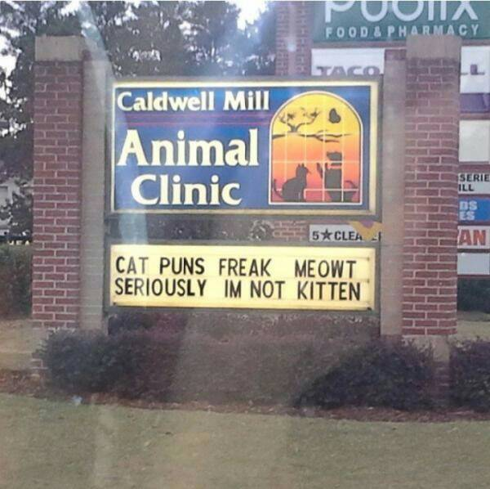
- Tune Tues
- Tag Team Reflection
- Prep for on-demand – Rubric and Close Reading/Text Evidence
- HW – prep for essay
Wed. 31 – 2nd and 3rd – LMC, 7th - 260
- Passion On-Demand Essay
- HW – Bring multiple copies of your paper (3-4)
Thurs. 1
- ACT/SAT
- PSW Training (obligatory )
- Writing Workshop – Revision –Focus on Claim/Evidence
- HW – Revise passion argument paper, Bring Ishmael tomorrow!
Fri. 2
- ACT/SAT
- Collect Revised Passion Argument paper
- Intro to Ishmael – Practice with Purposeful questioning
- HW – Read a creation myth of your choice in Mythology.
CCSS.ELA-LITERACY.SL.9-10.1.A
Come to discussions prepared, having read and researched material under study; explicitly draw on that preparation by referring to evidence from texts and other research on the topic or issue to stimulate a thoughtful, well-reasoned exchange of ideas.
CCSS.ELA-LITERACY.SL.9-10.1.B
Work with peers to set rules for collegial discussions and decision-making (e.g., informal consensus, taking votes on key issues, presentation of alternate views), clear goals and deadlines, and individual roles as needed.
CCSS.ELA-LITERACY.W.9-10.4
Produce clear and coherent writing in which the development, organization, and style are appropriate to task, purpose, and audience. (Grade-specific expectations for writing types are defined in standards 1-3 above.)

Weekly Agenda 8/29 – 9/2
Books to purchase 1st Quarter:
Ishmael by Daniel Quinn,
Mythology by Edith Hamilton

World Lit and Comp Honors – McBride
Mon. 29
- Tag Team Seminar
- HW- Read Finding Your Voice Article,
Tues. 30 – Picture Day!
- Tune Tues
- Tag Team Reflection
- Prep for on-demand – Rubric and Close Reading/Text Evidence
- HW – prep for essay
Wed. 31 – 2nd and 3rd – LMC, 7th - 260
- Passion On-Demand Essay
- HW – Bring multiple copies of your paper (3-4)
Thurs. 1
- ACT/SAT
- PSW Training (obligatory )
- Writing Workshop – Revision –Focus on Claim/Evidence
- HW – Revise passion argument paper, Bring Ishmael tomorrow!
Fri. 2
- ACT/SAT
- Collect Revised Passion Argument paper
- Intro to Ishmael – Practice with Purposeful questioning
- HW – Read a creation myth of your choice in Mythology.
CCSS.ELA-LITERACY.SL.9-10.1.A
Come to discussions prepared, having read and researched material under study; explicitly draw on that preparation by referring to evidence from texts and other research on the topic or issue to stimulate a thoughtful, well-reasoned exchange of ideas.
CCSS.ELA-LITERACY.SL.9-10.1.B
Work with peers to set rules for collegial discussions and decision-making (e.g., informal consensus, taking votes on key issues, presentation of alternate views), clear goals and deadlines, and individual roles as needed.
CCSS.ELA-LITERACY.W.9-10.4
Produce clear and coherent writing in which the development, organization, and style are appropriate to task, purpose, and audience. (Grade-specific expectations for writing types are defined in standards 1-3 above.)

