Weekly Agenda 9/26 – 9/30
World Lit and Comp Honors – McBride

MEET IN THE LMC ALL WEEK! – Remember to schedule a time to conference if you so desire!

Mon. 26
- SAT QOTD – Pass out rubrics/trans words/review
- Cont. Research / Conference
- HW- Develop claim based on your Research Tracker info.
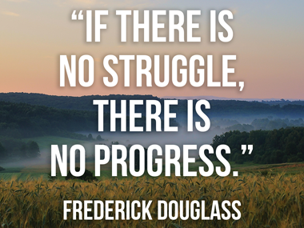
Tues. 27
- SAT QOTD
- Mrs. Bourdakos/Khan Academy/PSAT info…
- Begin outlining (see packet from McBride or use Noodletools)
- HW – Cont. Outlining
Wed. 28
- Cont. Outlining
- Begin drafting
- HW – Work on paper!
Thurs. 29
- ACT/SAT
- Drafting/Conferences
- HW – work on paper!
Fri. 30–
- Sent Diagramming
- Last day to draft/conference in lab
- HW – Writing Workshop is Wed., Oct. 5th! You must have a COMPLETE draft by then.
Research Learning Goals:
- I can focus research around a self-generated question I have determined.
- I can evaluate the credibility and usefulness of a source
- I can synthesize my information to answer my question.

Weekly Agenda 9/26 – 9/30
World Lit and Comp Honors – McBride

MEET IN THE LMC ALL WEEK! – Remember to schedule a time to conference if you so desire!

Mon. 26
- SAT QOTD – Pass out Rubrics/Trans words/Review
- Cont. Research / Conference
- HW- Develop claim based on your Research Tracker info.
Tues. 27
- SAT QOTD
- Mrs. Bourdakos/Khan Academy/PSAT info…
- Begin outlining (see packet from McBride or use Noodletools)
- HW – Cont. Outlining
Wed. 28
- Cont. Outlining
- Begin drafting
- HW – Work on paper!
Thurs. 29
- ACT/SAT
- Drafting/Conferences
- HW – work on paper!
Fri. 30–
- Sent Diagramming
- Last day to draft/conference in lab
- HW – Writing Workshop is Wed., Oct. 5th! You must have a COMPLETE draft by then.
Research Learning Goals:
- I can focus research around a self-generated question I have determined.
- I can evaluate the credibility and usefulness of a source
- I can synthesize my information to answer my question.

