CAUSES OF WORLD WAR I

“The War to End all Wars” – THE GREAT WAR
- LONG-TERM CAUSES OF WWI
  - Militarism
  - Alliance System
  - Imperialism
  - Nationalism

- MILITARISM
  - Need to develop _________________
  - _______________________________
  - Increased military budgets/development of armed forces
  - Germany built up army with ______________________________
  - Britain relied on _________________
  - Germany, France, Italy, & Japan joined naval arms race

- MILITARY BUILDUP
  - ____________: time to activate armies for battle, 48 hrs to 5 days depending on country

- ALLIANCE SYSTEM
  - _______________(1882) Austria Hungary, Germany, and Italy
  - Triple Entente (1907) __________________________________

- ALLIANCES
  - Allied Powers
      - Great Britain, France
      - Belgium, Serbia
      - Montenegro
      - Russia
      - Japan (1914)
      - U.S. (1917)
  - Central Powers
    - Germany
    - Austria-Hungary
    - Ottoman Empire (1914)
    - Bulgaria (1915)

- IMPERIALISM
  - Stronger nations controlling weaker lands through military, economic or political means
  - Countries sought_____________
  - _________________________
  - Colonies brought prestige to countries

- NATIONALISM
  - Belief that national interests should be placed ahead of ___________________
  - Franco-Prussian War (1871): France lost Alsace & Lorraine to _________________________
  - Russia claimed to be the protector of Europe’s Slavs (Serbia)
  - Serbia controlled by ______________________

- IMMEDIATE CAUSE OF THE WAR
  - Assassination of Archduke Franz Ferdinand, Heir to the throne of Austria-Hungary, killed by Serbian nationalist ______________________
  - Austria-Hungary declared war on Serbia
  - Russia declared war on Austria-Hungary
  - Germany declared war on __________________________
  - Great Britain declared war on ________________________________________

- ARCHDUKE FRANZ FERDINAND
  - Assassinated on June 28, 1914

- FIGHTING BEGINS
  - Germany invaded Belgium on Aug. 4, 1914 on the way to Paris
  - ________________________________________________________
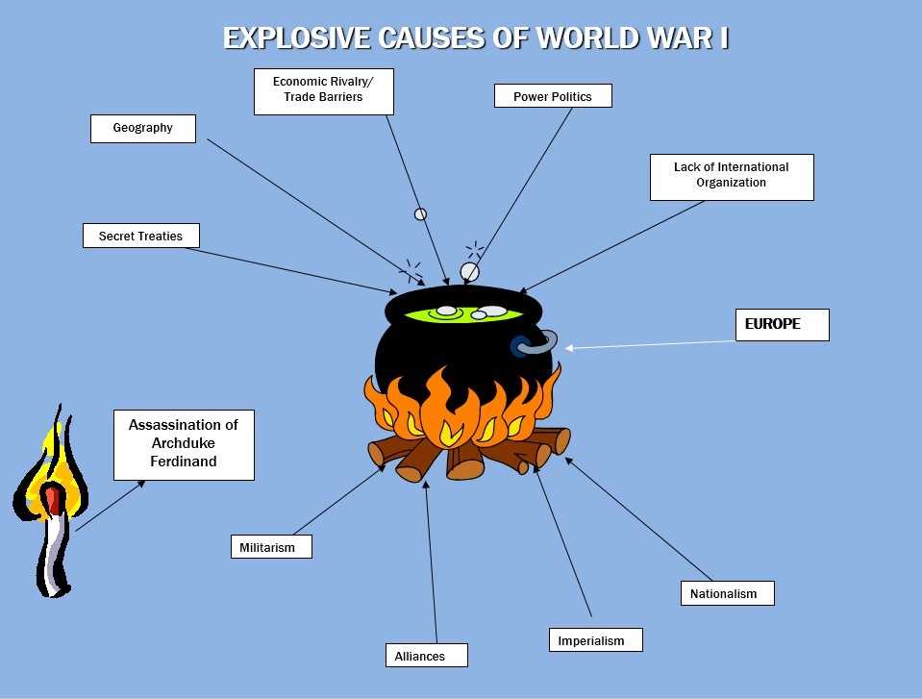
WILSON AND NEUTRALITY

- WEAPONS OF WWI

- TRENCH WARFARE
  - _________________________________ - the area between opposing trenches
  - Between 200 to 1000 meters between trenches

- TRENCH WARFARE
  - Germany and France dug trenches on Western Front. Millions died in “no-man’s-land” between trenches.

- U-BOATS
  - ______________________________________________________
  - Abbreviation for the German phrase for “undersea boat”

- STALEMATE
  - A situation where neither side can _____________________________________

- MONEY TALKS
  - By April 1917, the US had $2.6 billion in war bonds ($27 million German bonds)
  - American ships also carried war supplies to Europe

- UNRESTRICTED SUBMARINE WARFARE
  - Germany’s policy of sinking any ship, ______________________________________

- GERMAN AGGRESSION
  - May 1915 sinking of the Lusitania off coast of Ireland- 1200 killed (128 Americans)
  - 1 year later- Sussex sunk
  - Led to Sussex Pledge- Germany promises not to ______________________________
______________________________ and saving human lives.

- WILSON
  - Wins reelection in 1916- “He kept us out of War”
  - “__________________________________________________________”

- EVENTS THAT CAUSED THE U.S. TO JOIN WWI
  - Sinking of the Lusitania
  - ________________________________________ - proposed alliance between Mexico and Germany
    - Mexico would get land back from the US

- U.S. DECLARES WAR
  - On April 6, 1917 US declares war on Germany
  - The start of the war was July 28, 1914
  - WWI- 1914-1918

THE U.S. ENTERS WWI AND THE WAR AT HOME

The War at Home - 19.2-19.3
THE U.S. ENTERS WWI
- MOBILIZATION
  - Preparing the U.S. for WWI would require a massive mobilization of:
    - Money
    - Men
    - Materials
    - Minds

- MONEY
  - __________________________________________________________.
  - William McAdoo, Secretary of Treasury: “Anyone who refused to buy bonds is a friend of Germany”
  - U.S. Raised $23 Billion

- MEN
- ___________________– required men between ages of 21-30 to register to be drafted into the armed forces.
- 3 million men would be drafted.
- Some saw draft as _____________________________________________________.

- MATERIALS: INDUSTRY
- ________________________, Bernard Baruch in charge.
- Allocated scarce resources.
- Established production priorities.
- ____________________________________.
- “No steel, copper, cement, rubber, or other basic materials could be used without WIB approval.”

- MATERIALS: FOOD
  - Food Administration, Herbert Hoover in charge.
  - “Food can win the war”
  - Promised high prices to get farmers to grow more crops.
  - Encouraged “wheatless Wednesdays,” “meatless Mondays”.
  - Suggested Americans plant “__________________________________”.

- MATERIALS: FUEL
  - Fuel Administration, Harry Garfield in charge.
  - Organized production, distribution, and conservation of coal.
  - Encouraged mines/miners to maximize production.
  - Prevented labor strikes.
  - Encouraged Heatless days.

- MINDS: PROPOGANDA
  - _________________________________________, George Creel in charge.
  - “Sell the war to Americans”
  - Pictured Germans as evil monsters.
  - Hollywood helps:
  - “The Kaiser, the Beast of Berlin,” “The Claws of the Hun.”

- MINDS: PROPOGANDA
  - Patriotic organizations targeted anyone who questioned government, any Germany Americans.
  - German books removed from shelves.
  - Schools stopped teaching German.
  - Sauerkraut – liberty cabbage
  - Hamburger – Salisbury steak
  - Dachshunds – liberty pups

- MINDS: LAWS
  - ____________________________– punished people for aiding the enemy or refusing military duty.
  - ____________________________– made it illegal for Americans to speak disloyally about the U.S. government, Constitution, or flag.
  - 1000 opponents of the war were jailed under these laws.

- WOMEN IN THE WAR
  - Many women served as interpreters, nurses, typists, telephone operators.
  - Volunteered for _______________________________________.
  - Filled important industrial jobs.

- AFRICAN-AMERICANS IN THE WAR
  - Originally served in __________________________________.
  - Served in segregated units.
  - Fought alongside French.
  - Some won Croix de Guerre, French award for bravery in military combat.
WWI COMES TO AN END

  - WWI COMES TO AN END (The Final Days of the War)

- CONSCIENTIOUS OBJECTORS
  - An individual who, on religious, moral or ethical grounds, ________________________________________
  - Would be given _______________________________ or they would face jail sentences

- ARMISTICE
- ________________________________________________________
- On the 11th hour, of the 11th day of the 11th month 1918, WWI officially ended

- CENTRAL POWER DEATHS
- Germany 1.7 million
- Austria-Hungary 1.25 million
- Italy 460,000

- ALLIED POWERS
- Russia- 1.75 million
- France- 1.4 million
- Great Britain- 760,000
- British Empire- 251,900
- USA- 114,000

- TOTAL DEATHS
- Total deaths are estimated between 8 and 10 million

- SPANISH INFLUENZA
- Estimated global mortality from the 1918-1919 pandemic at anywhere between 30 and 50 million.
- An estimated 675,000 Americans were among the dead.

- JUST IN TIME
- The American Expeditionary Force (AEF) arrived in France in June 1917. The Allies were in bad shape.
- ___________________________________________________

- RUSSIA QUITS
- Russian Revolution, November 1917.
- People calling themselves _______________overthrows government.
- Communists, led by V.I. Lenin.
- Take Russia out of war with ________________________________________.

- THE FIGHTING STOPS
- Rioters in Central Power countries calls for end of war.
- On the 11th hour, of the 11th day, of the 11th month the armistice ended the war.
- Armistice day (Nov 11^{th)} would be celebrated for years.
- ______________________________________________________________________.

- WILSON’S FOURTEEN POINTS
- Wilson was very idealistic, he wanted a “Peace without victory”, for the “war to end all wars”.
- He outlined his plan for peace in his famous Fourteen Points.
- These 14 basic ideals dealt with:
  - Specific nations and regions
  - Freedom of the seas
  - Tariffs
  - Self-determination – the right of a people to decide their own political status.
  - A League of Nations – settle international disputes peacefully.

- PARIS PEACE CONFERENCE
- Allies disagree, ___________________________________.
- “Big Four” meet at Palace of Versailles outside Paris.
  - Wilson – U.S.
  - David Lloyd George – Great Britain
  - Georges Clemenceau – France
  - Vittorio Orlando – Italy

- PEACE CONFERENCE
- No members of the Central Powers were invited
- Wilson and the other leaders clashed
- _______________________________________________________

- TREATY OF VERSAILLES
- Germany must accept full responsibility for starting war _______________________
- Germany must pay reparations – ________________________________________________________
____________________________________________________________________________($33 billion).
- Germany must give back Alsace-Lorraine to France (France received other German territory too).
- New nations created: Czechoslovakia, Yugoslavia, Poland, Estonia, Finland, Latvia, and Lithuania.
- Central Powers must give control of colonies to Allies.

- THE LEAGUE OF NATIONS
- ________________________would include representatives from all democratic countries.
- League was too weak to enforce rulings (no military).
- Also, ___________________.
- Following WWII, the United Nations would replace the League, and exists to this day.

- THE BATTLE IN CONGRESS
- Henry Cabot Lodge, Republican Senators would not ratify Treaty (2/3rds necessary).
- Felt Article 10 of the League Charter ___________________________________________.
- U.S. would be ____________________________________________.

- THE BATTLE IN CONGRESS
- Wilson takes issue to American people directly, heads out on train tour.
- Suffers stroke, never fully recovers.
- Refuses to compromise with Republicans, treaty never ratified.
- U.S. signed separate peace treaties with Austria, Germany, and Hungary.

