Name _____________________________ Soil Webquest Date ___________________
Before you start this web quest you have to type in and open http://www.soil-net.com and then click on Secondary.
Link 1: What is Soil?
A. What is Soil?

B. Define Lithosphere

C. List 4 things that make up soil.
1. __________________________________ 3. ________________________________
2. __________________________________ 4. ________________________________
D. List 4 uses of soil.
1. __________________________________ 3. ________________________________
2. __________________________________ 4. ________________________________
E. What does a farmer and engineer think about soil?

F. Take Quiz.
Score ___/8
Link #2 Function of Soil

A. List five functions of soil.
1.
2.
3.
4.
5.

Link #3 Recognizing Types of Soil (Horizons)
A. What does a soil horizon mean?

(Link 3 Continued)
B. What is in each horizon?
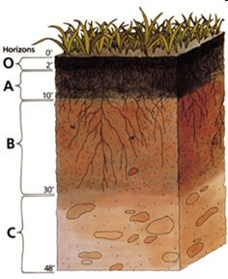
Horizon O (organic)

Horizon A (topsoil)

Horizon B (Subsoil)

Horizon C (Parent Material)

Horizon D (Bedrock) Not listed
C. What is a soil profile?

D. Take Quiz
Score ____/8

Link 4 Properties of Soil
A. What is soil texture?

B. List the 4 main components of soil texture
1.
2.
3.
4.

Link 5 Soil Under a Microscope
A. List soil fragments from largest to smallest
1.
2.
3.
4.

Link 6 Soil Character
A. List the two most important properties of soil and define each?

