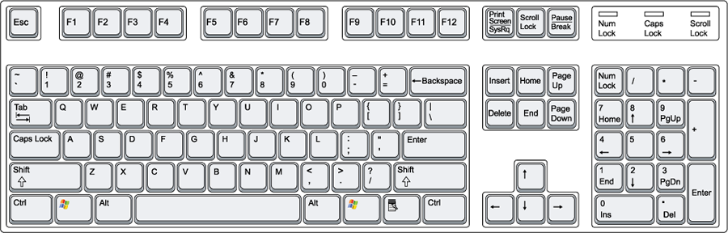

First Name: Last Name:

User Name:

Password: