Week 6
English I ---Mrs. Beery
September 19-23
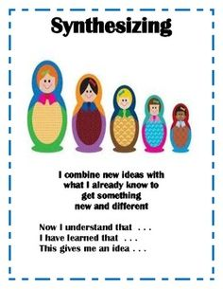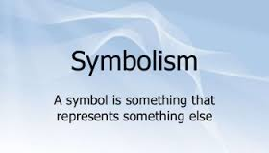

Practicing a learning goal, sharing that information with your peers, and applying it to a new work is the road to mastering a skill. This week we will revisit the familiar literary terms we focused on during the OMAM unit (characterization, setting, theme, and symbolism) and learn how to stretch our knowledge to show how one literary element propels others. In addition, we will also apply this information to a new work of reading. This is called synthesis. Synthesis is when a person combines information with new ideas to uncover new understandings. A good way to practice is in the picture above:
After reading OMAM…….Now I can understand (insert new idea)
After studying setting,characterization, theme and, symbol…I have learned that….
After this unit, This gives me a new idea about….

These higher level skills are important in this class and in life!!!!! Who is going to get his/her onion on this week? Prabesh already has his pic. Who is next?

M: Weekly Letter---onion picture ceremony for Prabesh
Independent Reading----return formatives, study guides, and handouts
Symbolism PPt and handout
HMWK: use handouts, study guide, notes, and PPt to study for test tomorrow. I have posted the PPt on my website

T: Objective Test for OMAM (20 questions multiple choice)
HMWK: Review literary terms ---setting, characterization,theme, and symbol---so you know how to apply to a text. In addition, review the requirements for an essay.

Expository Essay Format:
Introduction paragraph
Lead, Background information, thesis
Body paragraph
Topic sentence, TE, COMM, TE, COMM, CS (need 2 body paragraphs)
Conclusion paragraph
Restate/Reimagine thesis, summarize main points, conclude paragraph leaving audience interested and thinking about topic.
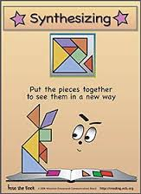

W: No school for students

TH: Test: Writing (one short answer, one extended response)

F: On-Demand Essay ----Homecoming Assembly Schedule TBA

