Week 7
English I---Mrs. Beery
September 26-30
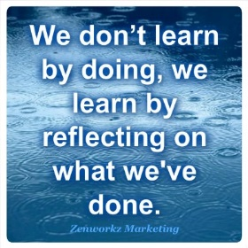
Welcome to week 7. This week is a week of reflection. Since we have now completed our first novel together, identified how setting, characterization, and symbols all build theme----We can understand that authors are using their writing tools to build a layered reading experience.
Have you been working independently?
Let’s start pulling back the layers and analyze. That’s what the super cool freshman do!!!!! This is lit!
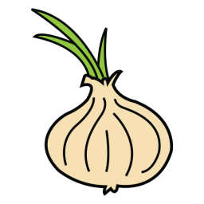
How have you been an advocate for your own learning?
What new skills have you learned?
How do you need to adjust to high school expectations?
If you didn’t master a concept in the last unit what do you do?

Mon Weekly Letter
Independent Reading
Reflection the objective test for OMAM and reading/testing strategies
Students will have an opportunity to make changes to incorrect answers if he/she can support and rationale.
HMWK: finish changes to test and turn in Tuesday

Tues Pre-Assessment Writing Test
Let’s reflect and review writing extended responses and essay
What are the four pillars of writing?
Why do we write?
What are the tools necessary for each type of writing?
HMWK: Reaction paper: One page, double-space, typed, Pick two different writing skills that are not mastered in your writing and write a reaction paper as to what is missing, how writing can improve, what help you need, and how you will ask for help.

Wed Independent Reading
Two different Lessons:
- Power Point & paragraph on “Carried Away” by Kevin Wilson
- Other students will get both “Carried Away” and “Wants” with no Power Point.
HMWK: finish writing Responses for flash fiction----label---what is present---what is missing? In the margins

Thurs Stall the teacher: United Way
Students will receive their paragraphs back from OMAM test and revise

Fri Independent Reading
Quiz on writing terms
Continue writing discussion on format and development
Read flash fiction: “Gifts” by Janet Gardner (p77) and write
HMWK: finish writing response for “Gifts”

