What item of trash did you bring in today?
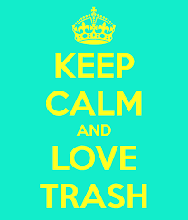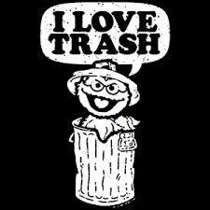

Analyze this Quote
…”The First Sign of Civilization is always trash”
Why do people discard things?
What would we find in your trash? The city’s? The Country’s
What statement does this make about our culture/civilation?

Journal:
- What object did you bring in? Why is it trash? How can it be treasure?
- Trash to Treasure: How do we change our perspective of things that are useless/discarded to things of respect and value?
- How can people change from trash to treasure?

Below are examples of art made from trash:
