Whitetail Deer
Odocoileus virginianus
Tracks and sign  Range: Most of U.S., except several Western states  Habitat: Woods, swamps, brushy areas, deserts, thickets  Size: 110-130 pounds, 5 feet long, 3.5 feet tall  Young: 2 fawns born in April - June  Tracks: Hoof with two toes, front track larger than hind  Scat: Pellets, dimple on one end, point on the other end  Stride: 30 inches  Diet: Plants, grasses, vegetation | Narrative  Whitetail deer are found in most of the U.S., except some western states.  Deer are crepuscular feeders, being active near dawn and dusk. They eat a variety of vegetation. Buds, twigs, leaves, nuts, even cactus, are eaten, depending on what vegetation grows where the deer lives.  Antlers of the whitetail deer branch from one main beam, rather than forking like those of mule deer. Antlers are shed annually in January through March. They grow new antlers in April and May.  Bucks begin the rut in September. Deer mate in October through December. Bucks in rut will sometimes attack plants and shrubs. I have found bushes with branches broken after a buck tore them up. When fawns are first born, they have spots, which help them with camouflage. These fade by their first winter. Lifespan of a wild deer is about 10 years.  Deer can move at speeds up to 30MPH. They use a gait called a pronk, or stot, where they spring up and all four feet are in the air at the same time. Deer are good swimmers and can swim in strong currents. I once watched a deer swim in a river near flood stage.  In winter snows, deer form "yards," where they stay together in their home range and use the same trails over and over, wearing trails into the snow.  Fawns use their natural fur coloration to camouflage themselves form predators. They remain still on the forest floor while their mothers forage nearby. Does will consume the droppings of the fawns to hide their scent from predators.  When surprised or disturbed, deer will snort, and sometimes bound away.

Whitetail Deer Tracks and Sign
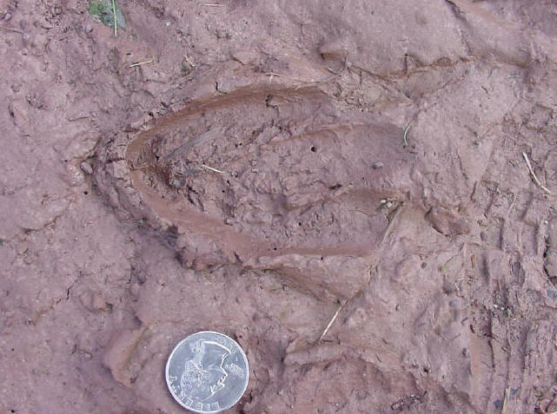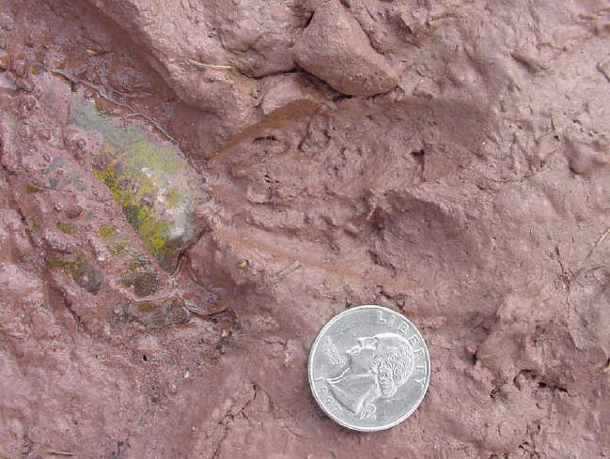
Pair of whitetail deer tracks
Whitetail deer track in mud
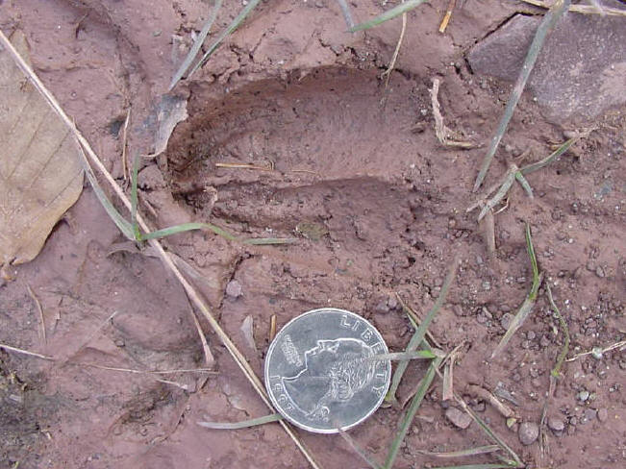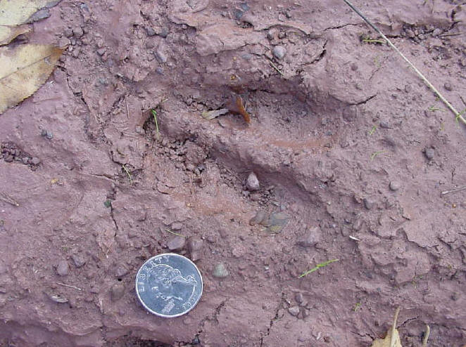

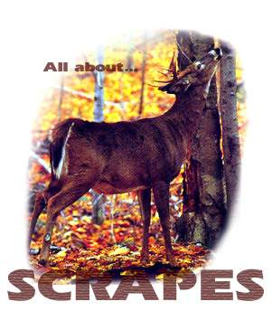

First: The Tools | 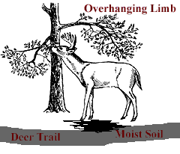
Overhanging Limb - 3.3 - 6.6 feet above the ground. The buck will typically hook this with his antler, often standing up on his hind legs to reach it. He will mouth it and pull the limb down, he releases the branch, letting it snap back across his glandular forehead. Often the buck then breaks or twists it - causing it to hang down above the scrape.
Deer Trail - A buck will rarely make a scrape away from a main deer trail. Typically the scrapes can be found where two trails intersect or in a funnel area. Mind you, a mature buck usually has his own trail which is downwind of, and parallel to, the main trail used by does and immature bucks.
Moist Soil - in dry, sandy conditions as those found in the Southwest and the Texas brush country, bucks will seek out darker, more secluded areas of a main deer trail to make a scrape. Moist soil seems to be a requirement of a buck unless there is none to be found.

Second: The Technique | 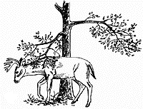
Working the Limb - The buck will seek out the right location along a main deer trail. Once he finds the overhanging branch, he hooks the branch and lets it rub along the frontal gland located in the forehead. The buck will often lick the branch and continue rubbing it a few times before, during or after he paws away the earth.
Pawing the ground - He will then proceed to paw away leaves and debris, exposing the moist dark earth with his front legs and occasionally his back legs. Once the spot is sufficiently cleaned of leaves and other debris, the buck steps forward until his two back legs are roughly centered into the scrape, puts his hooves together, arches his back and pees on his tarsal glands which are located inside the back legs. This technique is often called "scenting," or "rub urination." This ritual does not produce an intense stream of urine, but rather a trickling down the legs where the urine, mixed with the Tarsal scent, runs down the deer's legs and into the fresh earth where it leaves an odor. Rarely do bucks defecate on the scrape but I have seen it on a few occassions.
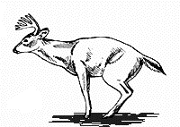 | Here is the characteristic pose of the whitetail urinating on his hock glands

Third: Timing | 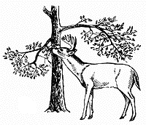

Timing - The timing of scrapes is directly related to the breeding cycle and the "state" of the buck. As the days grow shorter in late October and through November, the buck begins making scrapes, sometimes up to a hundred in a square mile area. As the does become receptive, scrapes begin to look old and unused.
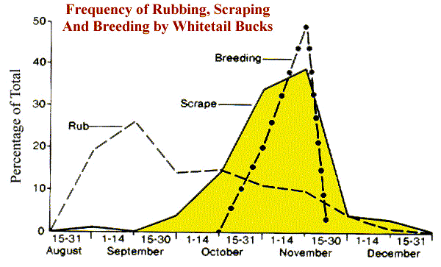

Fourth: Theories of why deer make scrapes | 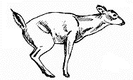
Mating - While nobody knows with certainty the reasons bucks create scrapes, it is a widely held belief that bucks use scrapes to "cold call" for receptive does. By leaving his scent and his mark on the ground, the hope is that a receptive doe will find it, then hang around the general area for him to return and breed her.
Data Profile of the Deer - Recent theories look for a more territorial explanation for scrapes rather than the common "calling card" one. Many biologists now believe that the scrape is more of a data profile of the buck. Telling clues about his health, his sexual readiness, and his dominance or lack thereof in the social structure of the deer herd. This is believed to be true since not all mature bucks leave scrapes during the rut, and there is growing evidence that alpha does create them as well - a behavior not limited to the breeding season.
Territory and Dominance - The final theory for scrapes is that bucks leave these signposts as a threat to other bucks - "this is my turf." This helps to suppress bucks both within the local deer herd, and meandering bucks that an area is off limits. Like posted signs - they keep out those who are not brave, or stupid enough to defy them.

