Camera Shots | Rules Assignment 2
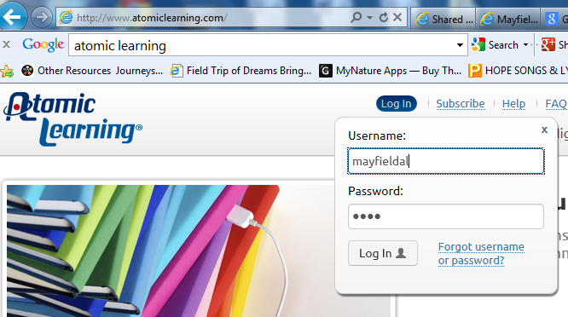
1. Open Atomic Learning

Username: mayfieldal
Password: ohio

2. Select Tools and Video Storytelling Guide

3. Select Shots | Rules

Rules of Thirds
Define:

Video example:

Your example:

Draw what it looks like

Headroom
Define:

Video example:

Your example:

Natural Cutoff lines
Define:

List the natural cutoff lines:

Watch the video and draw pictures of each of the Natural cut-off lines and label each picture. You can use stick figures.

Lead Space
Define:

Describe what the example showed you

Backgrounds (Define and describe (give an example) of each one below)

Distracting:

Merger:

Vector:

Depth of field:

