Biogeochemical cycle webquest—Ch 3, lessons 3 & 4 (Withgott) Name ________________ 10/12/2015
Carbon cycle (3.4)
- http://thecarboncycledio.weebly.com/the-carbon-cycle-steps.html
1 Carbon enters the atmosphere as ___________________ from respiration (_______________) and ____________ (burning).
2 Carbon dioxide is absorbed by pr______________________ (life forms that make their own food e.g. plants) to make ___________________ in _____________synthesis . These producers then put off the gas o_____________________.
3 Animals feed on the plants, thus passing the carbon compounds along the ______________. Most of the carbon these animals consume however is _________________ as carbon ___________ . This is through the process of breathing, also called _______________________ . Breathing serves the needs of all the body’s cells, because they produce carbon dioxide during cell r___________________. The animals and plants then eventually ________________.
4 The dead organisms (dead animals and plants) are eaten by ____________________ in the ground. The carbon that was in their bodies is then returned to the atmosphere as _______________________. In some circumstances the process of decomposition is prevented. The decomposed plants and animals may then be available as ______________________ in the future for burning, also known as _______________.

- http://footprints-science.co.uk/quizzes.php?module=54&section=1&type=The_carbon_cycle&quiz=drag&subjectarea=Biology%201&difficulty
Study the C cycle, then run key points at this website (on top bar), then try the quiz and drag and drop activities. When you’ve gotten every answer correct, you’ll be given a confirmation. Keep trying, then when you’re sure you know all the answers under “drag and drop”, fill in the blanks below.
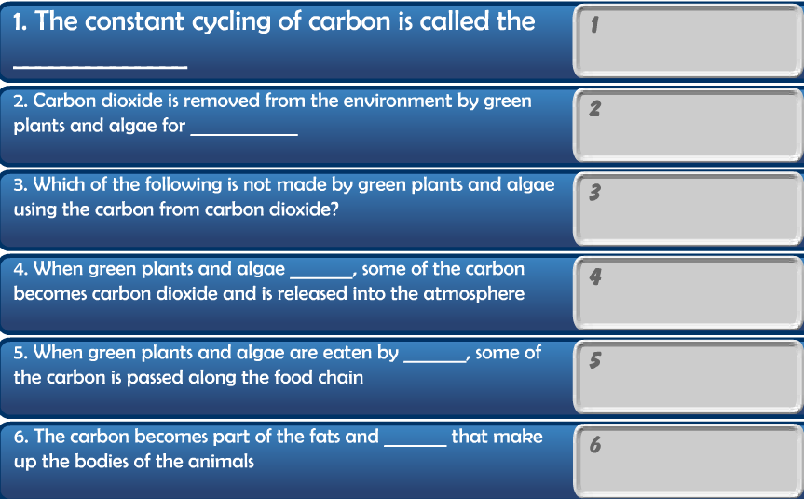
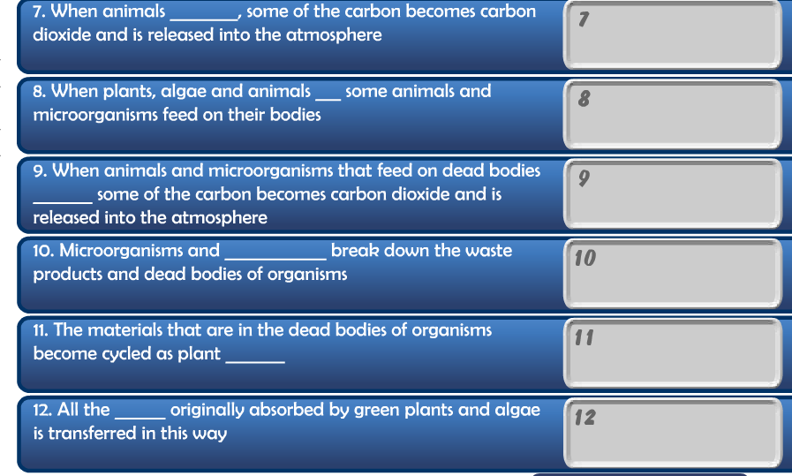
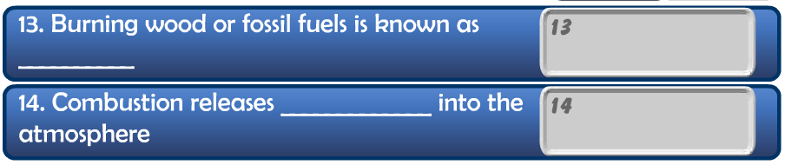
- http://serc.carleton.edu/eslabs/carbon/6a.html
Read through the information about the ability of the ocean to serve as a carbon sink, then answer the questions below.
- Which areas of the ocean are absorbing more CO₂ from the air? List all that apply
cold northern oceans
warm equatorial(tropical) waters
cold southern oceans
- Which general areas of the oceans have low amounts of CO₂ diffusing into sea surface waters? Check all that apply.
cold southern oceans
cold northern oceans
warm equatorial(tropical) water
- True or False. Check the statements below that are true.
More CO₂ diffuses and dissolves in colder sea surface water and less CO₂ diffuses and dissolves in warmer water
Sea surface waters have become slightly warmer as the climate warms. If this continues, you would expect concentrations of CO₂ in the atmosphere to decrease.

- http://www.sumanasinc.com/webcontent/animations/content/carboncycle.html
Watch/listen to this animation, then complete the questions below.
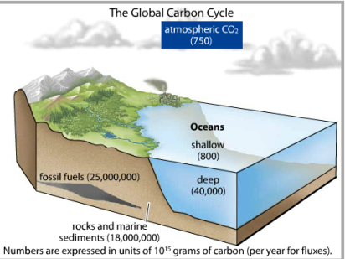 | 1. This figure shows that most of the earth’s carbon is found in ___________________ and in marine _______________ & __________________.  2. True or False. The majority of C on earth has not been actively cycling for over 200 million years when deposited as either fossil fuels or marine sediments.
3. Most actively cycling C in terrestrial (land) ecosystem is released from soil microbes and other organisms (biota) via cell r______________.  - 4. Two human activities resulting in the increasing concentrations of CO₂ are ___________________________ & ____________________________. Before the industrial revolution initiated burning of fossil fuels, the equilibrium concentration of carbon dioxide in the atmosphere was likely about _____________ parts per million. | 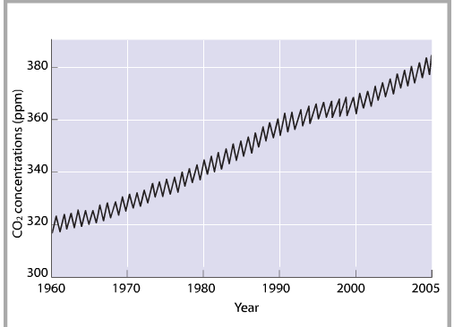  5 The line above is zig zagged because in winter, cell respiration’s replacement of carbon dioxide exceeds _______________ removal.  6 The reason climate scientists are concerned about increasing CO₂ concentrations is that the earth tends to (?increase, decrease?) ________________ as they rise. Hence, CO₂ is called a g_____________ gas.
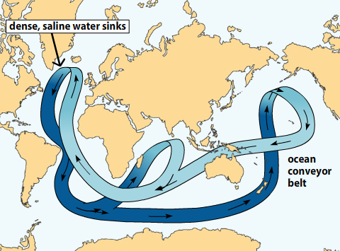  13  8  7 Climate scientists are concerned warming of oceans might upset the ocean conveyer belt that now allows the CO₂ removed by marine organisms like diatoms & foraminopherans to ___________________. | 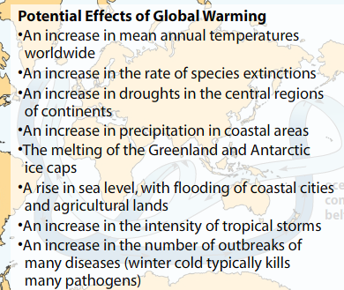  11  10  12  9  14
15 Increased CO2 warms the atmosphere, in turn inhibiting the ability of the North Atlantic to absorb CO2 & allow its sequestration into sediment, thus further raising CO2 concentrations and even further raising average global temperature. What type of feedback loop does this set of events demonstrate: Negative or positive? _________________

Nitrogen Cycle
- http://www.pbslearningmedia.org/asset/lsps07_int_nitrogen/
Run this animation to learn about the nitrogen cycle, then answer these questions.
________________ , ________ , & _______.
1
2
Nitrogen ___________________________.
3
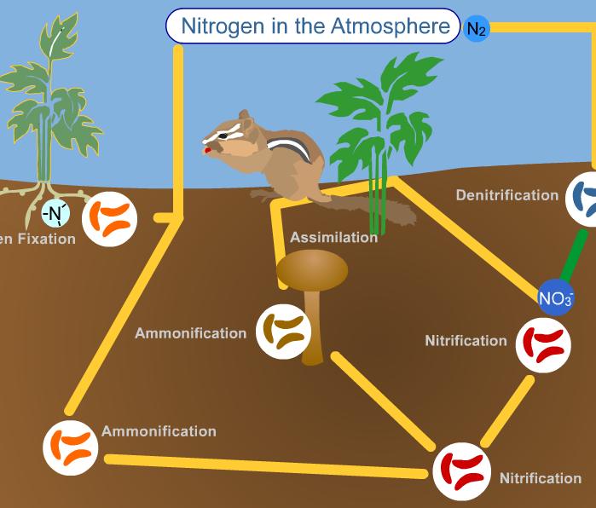
4 Humans farm the same soil repetitively, faster than nitrogen fixing bacteria can replace the nitrates required by plants. This requires the use of chemicals called f_________________ which are made artificially in chemical factories via an energy-expensive process called the Haber process. W/o fertilizer, yields of food per acre would be far lower.
iii __________________ by other soil bacteria converts nitrates back into N₂ gas.
ii Animals & decomposers ________________ N out of proteins, DNA, & RNA in foods. By metabolism, they break food down proteins, DNA, & RNA, then rebuild their own according to their own genetic instructions
i Bacteria in soil or legumes ____ N to a form other organisms can use. __________ are plants w/ roots contain Nitrogen fixing bacteria.

- https://www.classzone.com/books/ml_science_share/vis_sim/em05_pg20_nitrogen/em05_pg20_nitrogen.swf Run animation, then answer questions below.
- 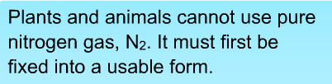
- 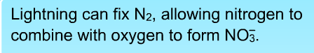
- 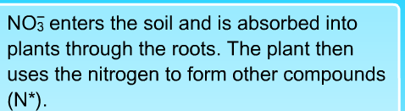
- 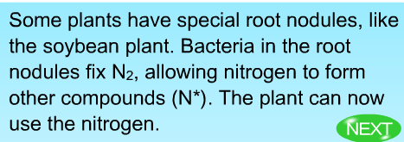
- 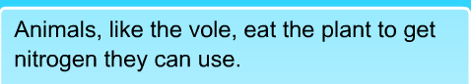
- 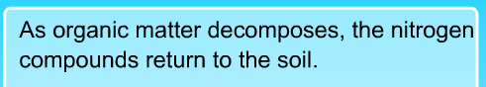
- 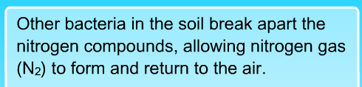
_________ via denitrification.

F. http://www.wignallandwales.co.nz/NDSWB/Sample-files/6G1b--Nitrogen-cycle-diagram.htm
Study the nitrogen cycle, then attempt to fill in the nitrogen cycle. When you’ve correctly identified answers, fill them into the chart below.
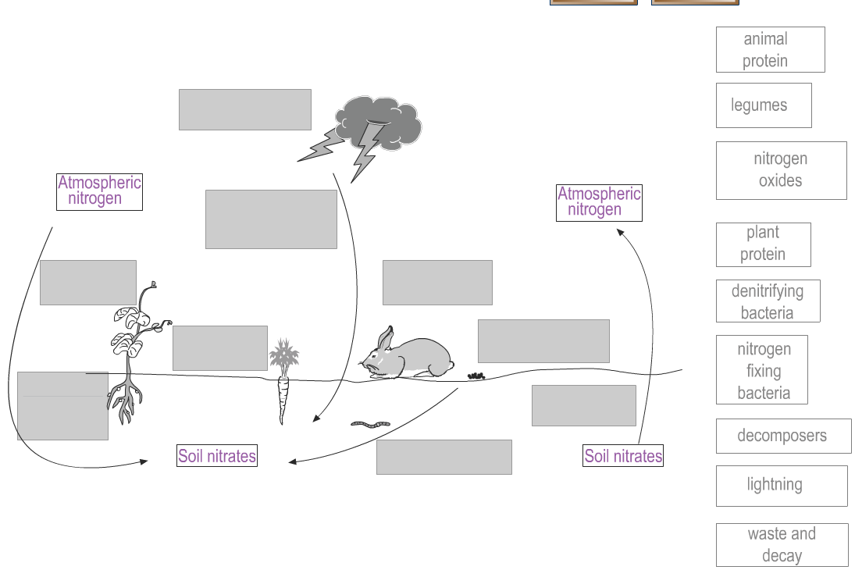
i
g
h
f
e
d
c
b
a
8
6
5
2a
3
7
2b
4
1
G. https://www.superteachertools.us/jeopardyx/jeopardy-review-game.php?gamefile=34443#.Vhvp2uxVhHw
1 The _________________ _____________ is the movement of nitrogen between the abiotic & biotic factors within the environment.
2 __________________ ________________ is a bacterial process that is able to change N2 gas into forms (ammonium and nitrate ions) that producers like photosynthetic bacteria, plants, and algae can use.
3 Plants take fixed N, in the form of nitrate ions, out of soil to make _______________, _______ & _______.
4 Animals get their fixed nitrogen out of their __________________, like plants they ate.
5 An abiotic source of fixed nitrogen is ___________________ during storms.
6 ____________________ of dead organisms returns fixed nitrogen to the soil for reuse by plants.
7What percent of Earth's atmosphere is nitrogen gas? ____________
8 __________________ in the roots of plants called legumes can fix nitrogen; other soil ___________________ carry out denitrification, returning N₂ gas to the atmosphere.

Phosphorous cycle

H. http://www.sumanasinc.com/webcontent/animations/content/phosphorouscycle.html
run the animation to learn about the phosphorous cycle
- Two locations of P in all cells is genetic material ______________ and the phosphate heads of the phospholipids in the cell membranes.
- The main reservoir (storage place) of P in the environment is in minerals that form ____________.
- P cycles through marine organisms for _________________ of years before settling into sediments at the bottom of the ocean, forming a rock called limestone.
- Weathering of rocks releases it for use by ____________________ which pass the P up to consumers, then decomposers, via the food web.
- True or False. ________ The P cycle is a sedimentary cycle that does not include an atmospheric phase.

I. https://www.lcmrschooldistrict.com/roth/PowerPoint_Lectures/chapter46/videos_animations/phos_anim.html
run to learn about the P cycle
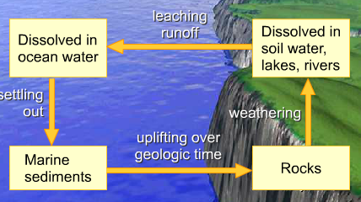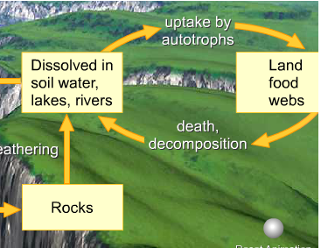
1
3
4
3
2

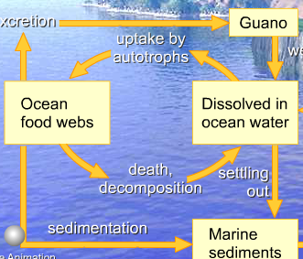
6
1
5
7. True or False. ________ Excessive runoff of P from fertilizer used by humans can damage ocean and fresh water ecosystems by causing algal blooms. This is because N and P, both found in fertilizer, are the limiting factor for producer growth in both aquatic and terrestrial ecosystem.

Water cycle
www.educationsoutheastwater.com.au/game/natural-water-cycle.htm
run to learn about the water cycle

http://www.discoverwater.org/blue-traveler/
run to learn about the water cycle

http://player.discoveryeducation.com/views/hhView.cfm?guidAssetId=087777c8-4ff0-45d2-878f-e7cd90f7ee19

