Digital Media on Brain Pop

Path to Brain Pop:
• http://www.mayfieldschools.org/
• Hover over “Student” tab
• Click “Library Media Centers”
• Hover over “Mayfield Middle School” (left side)
• Click “Research Databases”
• Click “Brain Pop” (in top row)
• Choose Arts & Music square (at bottom)
• Choose Art Concepts square (top left)

User name: mayfieldbp
Password: brainpop

You may watch any of the related topics. You will get credit for the number of correct answers submitted to me by e-mail.

Watch as many as possible. Your grade will be determined by the total number of correct quiz answers you submit.

Grades will be determined based on the average number of correct answers submitted by all three of my classes.

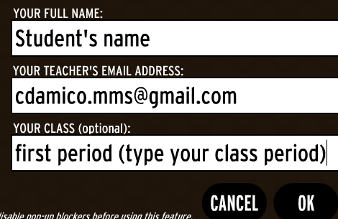
Select Quiz to take the quiz
Select Graded Quiz
E-mail your results (cdamico.mms@gmail.com)

