Creating Videos That Communicate
- Open the Creating Videos That Communicate series.
- Click on the link below to access INFOhio’s Digital Video Collection.
http://dvc.infohio.org/index.php?option=com_content&view=article&id=3&Itemid=6&selectedcategory=111269
OR if you are on a Mac
- Go to the Mayfield Middle School Website
- Library Media Center
- INFOhio
  - Username: Learn
  - Password: infohio
- Video Titles
- Scroll down to “Creating Videos That Communicate”

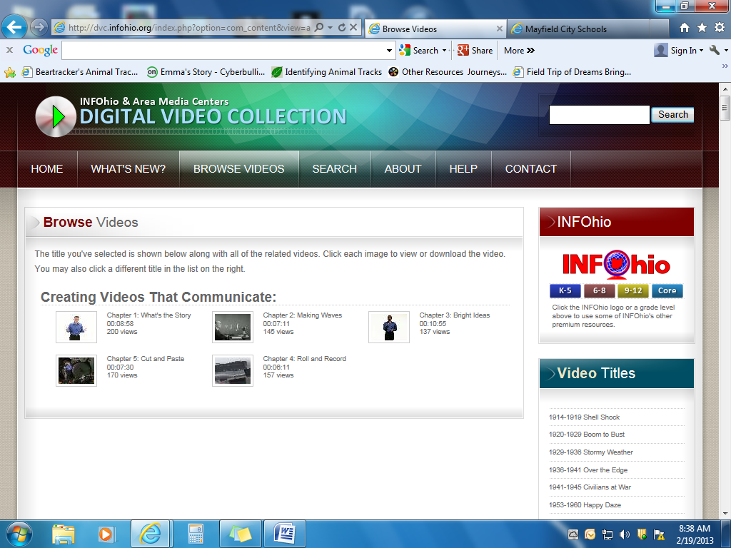
- Watch the Creating Videos That Communicate series.
- Take notes in Microsoft Word or Google Docs
- PC users click on the very bottom toolbar and select “show windows side by side.” This will place the video on one side of your screen and your notes on the other side.

