# Weather Forecasting lab

**Purpose:**

The purpose of this lab is for you to learn what data and observations of the atmosphere are used to make weather forecasts.

**Overview:**

You and a partner will work together to make daily forecasts of a city of your choice based upon weather data that you collect. After you make your daily forecast you will work through a series of activities designed to improve your knowledge and skill regarding weather forecasting.

**Procedure**:

1. Each day you will start by first checking your forecast and then making a new forecast. This should take no more than 10 to 15 minutes.
2. Then you should make an entry in your forecasting log reflecting on the accuracy of your forecast. 5 minutes maximum
3. Work on forecasting activities. 35 to 40 minutes.

**Daily Forecast/ Forecast Log:**

Record the data from the previous day in the appropriate places on the table. Look at current weather data on the University of Illinois web site. Use that data to make a forecast for the next two days.Compare actual weather with your forecast. Record the differences in temperature and precipitation.

**Forecasting activities/notes:**

Each of the forecasting activities is located on the following website:

<http://ww2010.atmos.uiuc.edu/(Gh)/guides/crclm/act/home.rxml>

You are to record all of your answers in your packet.

Activities:

1. Interpreting surface Observation Symbols and Interpreting weather symbols
2. Pressure
3. Air Masses
4. Precipitation along fronts
5. Forecasting temperature and precipitation

Grading:

Each person will be graded individually based upon the completion of each of the activities, completion of daily forecasts and the forecast log.

* Forecasting activities /notes 5 points each x 5 = 25 points
* Completion of daily forecasts 3 points each x 8 = 24 points

And forecast log

TOTAL 49 POINTS

**Activity #1 Interpreting Surface Observation Symbols**

**Introduction:**   
Routine surface meteorological observations are represented on weather maps by a standard notation of symbols and numbers. In order to correctly interpret the data, it is important to understand what types of data the different numbers and symbols represent. This skill is not only important for reporting weather conditions for a given station, but also for determining the positions of significant meteorological features like fronts, cyclones and anticyclones. The purpose of this activity is to introduce these reporting symbols and how to extract information about temperature, dew point temperature, wind speed and direction, cloud cover, pressure and current weather. Key words throughout this activity link directly to helper resources that provide useful information for answering the questions.

**Components of the Observation Symbol:**   
1) Fill in the blanks of the diagram to indicate what type of [meteorological data](http://ww2010.atmos.uiuc.edu/(Gh)/wwhlpr/sfcobs.rxml?hret=/guides/crclm/act/sfcobs.rxml) is represented by each location

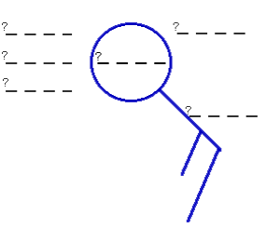

**Reporting on Weather Conditions:** Use the map to answer the following questions.

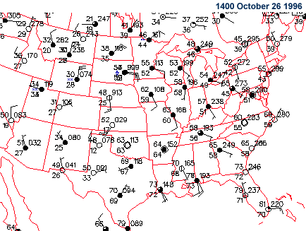

2) What is the [temperature](http://ww2010.atmos.uiuc.edu/(Gh)/wwhlpr/sfcobs_tmp.rxml?hret=/guides/crclm/act/sfcobs.rxml) in Des Moines, Iowa?

3) What is the [dew point temperature](http://ww2010.atmos.uiuc.edu/(Gh)/wwhlpr/sfcobs_dwp.rxml?hret=/guides/crclm/act/sfcobs.rxml) in Phoenix, Arizona?

4) What is the [pressure](http://ww2010.atmos.uiuc.edu/(Gh)/wwhlpr/sfcobs_prs.rxml?hret=/guides/crclm/act/sfcobs.rxml) in Dallas, Texas?

5) What is the report of [cloud cover](http://ww2010.atmos.uiuc.edu/(Gh)/wwhlpr/sfcobs_cld.rxml?hret=/guides/crclm/act/sfcobs.rxml) in Chicago, Illinois?

6) What is the report of [current weather](http://ww2010.atmos.uiuc.edu/(Gh)/wwhlpr/sfcobs_wx.rxml?hret=/guides/crclm/act/sfcobs.rxml) (weather symbol) in Casper, Wyoming?

7) What is the [speed](http://ww2010.atmos.uiuc.edu/(Gh)/wwhlpr/sfcobs_wnd_speed.rxml?hret=/guides/crclm/act/sfcobs.rxml) and [direction](http://ww2010.atmos.uiuc.edu/(Gh)/wwhlpr/sfcobs_wnd_direction.rxml?hret=/guides/crclm/act/sfcobs.rxml) of the wind in Miami, Florida?

**Activity #1 (continued) Interpreting Weather Symbols**

**Introduction:**   
In addition to temperature, dew point temperature, cloud cover, pressure and wind observations, a surface observation symbol also reports the current weather through the weather symbol. Conditions for clear skies, rain, snow and fog have appropriate symbols which are displayed as needed for each station report. The purpose of this activity is to introduce the most common weather symbols and how to interpret current weather conditions for cities on a map of surface observations. Key words throughout this activity link directly to helper resources that provide useful information for answering the questions.

**Location of Weather Symbol:**   
1) Fill in the blanks of the diagram to indicate what type of [meteorological data](http://ww2010.atmos.uiuc.edu/(Gh)/wwhlpr/sfcobs.rxml?hret=/guides/crclm/act/wx.rxml) is represented by each position. Then circle the position of the [weather symbol](http://ww2010.atmos.uiuc.edu/(Gh)/wwhlpr/sfcobs_wx.rxml?hret=/guides/crclm/act/wx.rxml).

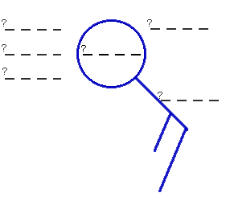

**Common Weather Symbols:**   
2) For the following table of [common weather symbols](http://ww2010.atmos.uiuc.edu/(Gh)/wwhlpr/common_wx_symbols.rxml?hret=/guides/crclm/act/wx.rxml), fill in the blanks labeled #1 through #7

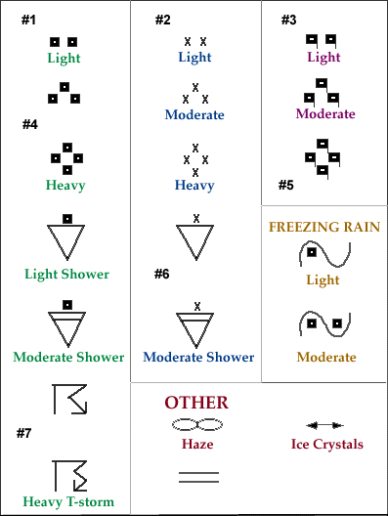

**Activity #2 Pressure Activity**

**Introduction:**   
Though you may not realize it, the air has weight. All the air molecules in the atmosphere exert a force, or pressure, on our bodies. Atmospheric pressure is the force exerted by the weight of the air above an object or surface. Variations in pressure generate winds, which play a significant role in day-to-day weather conditions. The purpose of this activity is to introduce characteristics of pressure, high and low pressure centers, and a brief analysis of an idealized pressure field. Key words throughout this activity link directly to helper resources that provide useful information for answering the questions.

**Characteristics of Pressure:**   
1) What are the different [units of pressure](http://ww2010.atmos.uiuc.edu/(Gh)/wwhlpr/pressure_units.rxml?hret=/guides/crclm/act/prs.rxml)? Which unit is used most by meteorologists?

2) Circle the correct response in the following sentence: Pressure (increases / decreases) [with height](http://ww2010.atmos.uiuc.edu/(Gh)/wwhlpr/pressure_height.rxml?hret=/guides/crclm/act/prs.rxml). Please explain why pressure changes this way with height.

**High and Low Pressure Centers:**   
3) Draw the symbol that represents a [high-pressure center](http://ww2010.atmos.uiuc.edu/(Gh)/wwhlpr/anticyclone.rxml?hret=/guides/crclm/act/prs.rxml) on a weather map. Do the same for a [low-pressure center](http://ww2010.atmos.uiuc.edu/(Gh)/wwhlpr/low_pressure_center.rxml?hret=/guides/crclm/act/prs.rxml).

4) Pictured below are two imaginary columns of air molecules exerting pressure on the surfaces below them. The left column contains fewer air molecules than the right column.

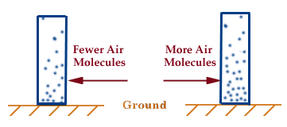

Which column is more representative of the atmosphere above a [high-pressure center](http://ww2010.atmos.uiuc.edu/(Gh)/wwhlpr/anticyclone.rxml?hret=/guides/crclm/act/prs.rxml)? Which one is more likely to be found over a [low pressure](http://ww2010.atmos.uiuc.edu/(Gh)/wwhlpr/low_pressure_center.rxml?hret=/guides/crclm/act/prs.rxml)? Using the correct symbols for labeling high and low pressure centers (see question #3), mark your answers beneath the appropriate columns in the diagram above.

**Analysis of a Pressure Field:**   
5) The diagram below is an idealized pressure field resembling those commonly found on surface weather maps. The numbers along each contour indicate the pressure value in millibars for that particular contour. Use the diagram below to answer the following questions.

* What are the [contours](http://ww2010.atmos.uiuc.edu/(Gh)/wwhlpr/isobars.rxml?hret=/guides/crclm/act/prs.rxml)? What do they represent?

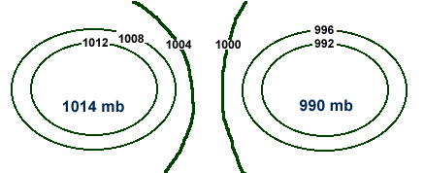

* Label the diagram above to indicate the positions of the [high](http://ww2010.atmos.uiuc.edu/(Gh)/wwhlpr/anticyclone.rxml?hret=/guides/crclm/act/prs.rxml) and [low](http://ww2010.atmos.uiuc.edu/(Gh)/wwhlpr/low_pressure_center.rxml?hret=/guides/crclm/act/prs.rxml) pressure centers. Please use the correct symbols (see question #3).
* Draw an arrow (on the diagram above) to indicate the direction in which the [pressure gradient force](http://ww2010.atmos.uiuc.edu/(Gh)/wwhlpr/pressure_gradient.rxml?hret=/guides/crclm/act/prs.rxml) is pointing.

.

**Activity #3 Air Masses**

**Introduction:**   
An air mass is a large body of air with similar temperature and moisture properties throughout. The best source regions for air masses are large flat areas where air can be stagnant long enough to take on the characteristics of the surface below. Air masses typically clash in the middle latitudes, producing some very interesting weather. The purpose of this activity is to introduce air masses that commonly influence the weather in the United States, characteristics of these air masses, and how to identify air masses on weather maps. Key words throughout this activity link directly to helper resources that provide useful information for answering the questions.   
**Characteristics of Air Masses:**   
1) The diagram below depicts two types of air masses that commonly influence weather in the United States. For each air mass, identify the following characteristics.

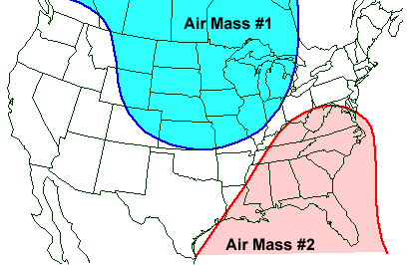

|  |  |  |
| --- | --- | --- |
|  | [**Air Mass #1**](http://ww2010.atmos.uiuc.edu/(Gh)/wwhlpr/arctic_airmass_def.rxml?hret=/guides/crclm/act/arms.rxml) | [**Air Mass #2**](http://ww2010.atmos.uiuc.edu/(Gh)/wwhlpr/tropical_airmass_def.rxml?hret=/guides/crclm/act/arms.rxml) |
| Type of Air Mass:  Source Region:  Relative Temperature:  Wind Direction:  Moisture Content: |  |  |

**Find the Air Masses:**   
2) One way of identifying a tropical air mass on the weather map below is to look for a region of higher [temperatures](http://ww2010.atmos.uiuc.edu/(Gh)/wwhlpr/sfcobs_tmp.rxml?hret=/guides/crclm/act/arms.rxml). To find a polar air mass, look for a region of colder temperatures. The image below is a map of [surface observations](http://ww2010.atmos.uiuc.edu/(Gh)/wwhlpr/sfcobs.rxml?hret=/guides/crclm/act/arms.rxml) and for this part of the activity, use the temperature field to draw two lines; a red line to outline the edge of a tropical air mass and a blue line to identify a polar air mass. Here is an [example](http://ww2010.atmos.uiuc.edu/(Gh)/wwhlpr/arctic_airmass_map.rxml?hret=/guides/crclm/act/arms.rxml).

3) Now examine the regions you have outlined. Look particularly close at the [wind barbs](http://ww2010.atmos.uiuc.edu/(Gh)/wwhlpr/sfcobs_wnd.rxml?hret=/guides/crclm/act/arms.rxml) for [wind direction](http://ww2010.atmos.uiuc.edu/(Gh)/wwhlpr/sfcobs_wnd_direction.rxml?hret=/guides/crclm/act/arms.rxml) and also examine the reports of [dew point temperature](http://ww2010.atmos.uiuc.edu/(Gh)/wwhlpr/sfcobs_dwp.rxml?hret=/guides/crclm/act/arms.rxml). In question #1, you determined typical wind direction and dew point temperatures associated with a [tropical air mass](http://ww2010.atmos.uiuc.edu/(Gh)/wwhlpr/tropical_airmass_map.rxml?hret=/guides/crclm/act/arms.rxml) and a [polar air mass](http://ww2010.atmos.uiuc.edu/(Gh)/wwhlpr/arctic_airmass_map.rxml?hret=/guides/crclm/act/arms.rxml). Use this additional information to again identify the tropical and the polar air masses in the diagram below. Label the edge of a tropical air mass with a red line and use a blue line to indicate the outer edge of a polar air mass.

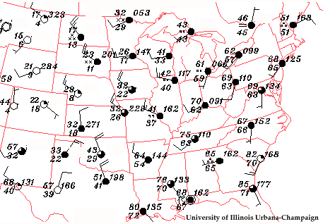

4) Are there any differences between your first analysis (temperature) and the second analysis(dew point)? Explain why they are different (if they indeed are).

**Activity #4 Precipitation Along Fronts**

**Introduction:**   
Precipitation develops from upward moving air. As the air rises, it cools and the water vapor condenses to form cloud droplets and eventually, precipitation. Upward motion typically occurs along frontal boundaries as air masses of different densities clash. A less dense air mass is lifted by a more dense air mass, leading to the development of precipitation.

The purpose of this activity is to introduce how precipitation develops along cold fronts and along warm fronts. Two animations have been constructed to visualize these distinctly different processes and students will use this information for comparison. Key words throughout this activity link directly to helper resources that provide useful information for answering the questions.

**Precipitation Along Cold Fronts:**   
1) The diagram below is a vertical cross-section through two air masses and the frontal boundary separating them. Fill in the [missing components](http://ww2010.atmos.uiuc.edu/(Gh)/wwhlpr/cold_front_prcpexp.rxml?hret=/guides/crclm/act/fpr.rxml) (the white boxes) of this diagram.

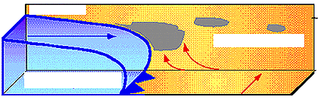

Using this [animation](http://ww2010.atmos.uiuc.edu/(Gh)/guides/crclm/act/gifs/fpr2.gif) for reference, write a description of how [precipitation develops along a cold front](http://ww2010.atmos.uiuc.edu/(Gh)/wwhlpr/cold_front_prcpexp.rxml?hret=/guides/crclm/act/fpr.rxml). Be sure to keep in mind the following points:

* the shape of the cold front (steep or not, tall or not etc.)
* strength of upward motions
* location and intensity of precipitation
* types of precipitation that commonly develop along cold fronts

Description : _______________________________________________________________________________ ________________________________________________________________________________________________________________________________________________________________________________________________________________________________________________________________________________________________________________________________________________________________________

**Precipitation Along Warm Fronts:**   
2) As in question #1, the diagram below is a vertical cross-section through two air masses and the frontal boundary separating them. Fill in the [missing components](http://ww2010.atmos.uiuc.edu/(Gh)/wwhlpr/warm_front_prcpexp.rxml?hret=/guides/crclm/act/fpr.rxml) (the white boxes) of this diagram.

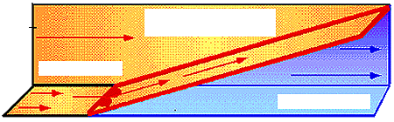

Using this [animation](http://ww2010.atmos.uiuc.edu/(Gh)/guides/crclm/act/gifs/fpr4.gif) for reference, write a description of how [precipitation develops along a warm front](http://ww2010.atmos.uiuc.edu/(Gh)/wwhlpr/warm_front_prcpexp.rxml?hret=/guides/crclm/act/fpr.rxml). Be sure to keep in mind the following points:

* the shape of the warm front (steep or not, tall or not etc.)
* strength of upward motions
* location and intensity of precipitation
* types of precipitation that commonly develop along warm fronts

Description : _______________________________________________________________________________ ________________________________________________________________________________________________________________________________________________________________________________________________________________________________________________________________________________________________________________________________________________________________________

**Comparing Warm Fronts and Cold Fronts:**   
3) Using your solutions from questions #1 and #2, write a paragraph comparing the development of precipitation along warm fronts with cold fronts. Some issues to keep in mind include:

* how the air is lifted
* strength of the upward motions
* type and intensity of precipitation that develops

Description : _______________________________________________________________________________ ______________________________________________________________________________________________________________________________________________________________________________________________________________________________________________________________________________________________________________________________________________________________________________________________________________________________________________________________________________________________________________________________________________________________________________________________________________________________________________________

**Activity #5 Forecasting Temperatures**

**Introduction:**   
Forecasting temperatures requires the consideration of many factors; day or night, clear or cloudy skies, windy or calm, or will there be any precipitation? An error in judgment on even one of these factors may cause your forecasted temperature to be off by as much as 20 degrees. The purpose of this activity is to explore these factors in greater detail and investigate their possible outcomes on forecasted temperatures. Key words throughout this activity link directly to helper resources that provide useful information for answering the questions.

**Forecasting Scenarios:**   
For each of the following weather scenarios, indicate what impact each component ([cloud cover](http://ww2010.atmos.uiuc.edu/(Gh)/wwhlpr/fcst_temps_cloud_cover.rxml?hret=/guides/crclm/act/ftmp.rxml) | [winds](http://ww2010.atmos.uiuc.edu/(Gh)/wwhlpr/fcst_temps_winds.rxml?hret=/guides/crclm/act/ftmp.rxml) | [advection](http://ww2010.atmos.uiuc.edu/(Gh)/wwhlpr/fcst_temps_advection.rxml?hret=/guides/crclm/act/ftmp.rxml) | [snow cover](http://ww2010.atmos.uiuc.edu/(Gh)/wwhlpr/fcst_temps_snow.rxml?hret=/guides/crclm/act/ftmp.rxml)) will have on forecasted temperatures. Indicate whether each weather condition will lead to lower (L) or higher (H) temperatures or indicate "None" if it is not a factor.

|  |  |  |  |  |  |  |
| --- | --- | --- | --- | --- | --- | --- |
| **Weather Scenario** |  | [**Cloud Cover**](http://ww2010.atmos.uiuc.edu/(Gh)/wwhlpr/fcst_temps_cloud_cover.rxml?hret=/guides/crclm/act/ftmp.rxml) | [**Winds**](http://ww2010.atmos.uiuc.edu/(Gh)/wwhlpr/fcst_temps_winds.rxml?hret=/guides/crclm/act/ftmp.rxml) | [**Temperature Advection**](http://ww2010.atmos.uiuc.edu/(Gh)/wwhlpr/fcst_temps_advection.rxml?hret=/guides/crclm/act/ftmp.rxml) | [**Snow  Cover**](http://ww2010.atmos.uiuc.edu/(Gh)/wwhlpr/fcst_temps_snow.rxml?hret=/guides/crclm/act/ftmp.rxml) | **Your Thoughts** |
| **Example Scenario:**  Night time forecast, cloud cover, no winds, no snow cover. |  | **H** | **L** | **None** | **None** | Cloud cover should keep temps warm. |
| **Scenario 1:**  Day time forecast, cloudy skies with calm winds, no significant temperature advection and no snow cover. |  |  |  |  |  |  |
| **Scenario 2:**  Night time forecast, snow cover, clear skies, no wind. |  |  |  |  |  |  |
| **Scenario 3:**  Night time forecast, cloudy skies, no snow cover, windy and warm advection. |  |  |  |  |  |  |
| **Scenario 4:**  Day time forecast, cloudy skies, windy, cold advection and no snow cover. |  |  |  |  |  |  |

**Activity #5 (continued) Forecasting Precipitation**

**Introduction:**   
Forecasting precipitation requires the consideration of many factors. Sometimes simple mathematics can be an effective tool for predicting when precipitation will occur, however, this method alone is always reliable. It is important to consider sources of moisture and lifting mechanisms in the development of precipitation. The purpose of this activity is to introduce some indicators that useful for predicting when and where precipitation is going to occur. Key words throughout this activity link directly to helper resources that provide useful information for answering the questions.   
1) What role do [fronts](http://ww2010.atmos.uiuc.edu/(Gh)/wwhlpr/fcst_precip_fronts.rxml?hret=/guides/crclm/act/fprcp.rxml) play in the development of precipitation?

2) Describe what happens as an [parcel of air rises upwards](http://ww2010.atmos.uiuc.edu/(Gh)/wwhlpr/precip_upw.rxml?hret=/guides/crclm/act/fprcp.rxml) through the atmosphere.

**Forecasting Scenarios:**   
3) For the following weather scenarios, indicate if precipitation is "likely" or "unlikely" to occur given the conditions described in each scenario. Explain why.

|  |  |  |
| --- | --- | --- |
| **Weather Scenario** |  | **Precipitation?** |
| **Example Scenario:**  Boulder, CO, a city on the east side of the Rockies. Downslope winds are expected. | **Unlikely** | Downslope winds (or wind blowing down the mountain) tend to be very dry, warming as it descends, creating an unfavorable environment for the development of precipitation (since rising air in the presence of downslope winds is unlikely). |
| **Scenario 1:**  A cold front is approaching from the west, but the air both ahead of and behind the front is very dry. |  |  |
| **Scenario 2:**  A warm front is approaching and the air behind and ahead of the front is very moist. |  |  |
| **Scenario 3:**  Upslope winds are expected in Boulder, CO and the air has been very moist for the past couple of days. |  |  |
| **Scenario 4:** The [trend for the latest batch of precipitation](http://ww2010.atmos.uiuc.edu/(Gh)/wwhlpr/fcst_trends.rxml?hret=/guides/crclm/act/fprcp.rxml) is a steady eastward movement of 30 miles/hour. The latest position is roughly 700 west of here. Will precipitation arrive within 24 hours? |  |  |