Epithelium Review
Name/Type Description Picture Function/Location

Simple Squamous | Single layer of flattened  Cells. Pancake like. Oval disc shaped nuclei. | 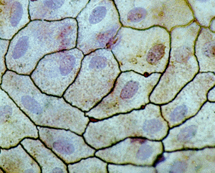 | Filtration: Kidneys  Diffusion: Air Sacs in Lungs and walls of capillaries which are known as endothelium. Simple squamous allows substances to move in and out quickly.
Simple Cuboidal | Single layer of cube like cells. Round, sphere shaped nuclei usually located in center of the cell. | 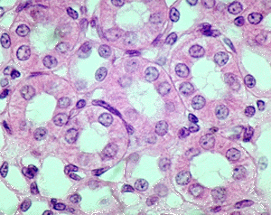 | Secretion and Absorption Both functions are performed in the kidneys to maintain water and salt balances.  Secretion in many small various glands throughout the body.
Simple Columnar | Single layer of rectangular, column-like cells. Length greater than width. Round or oval shaped nuclei located closer to the basement membrane.  Sometimes can be ciliated.  Sometimes have goblet cells which produce mucus. | 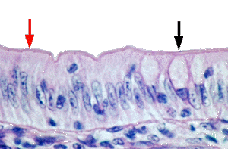 | Lines most of digestive tract from stomach to colon.  Absorption of nutrients from digestive system.  Secretion of enzymes and mucus in digestive tract.  Also found in respiratory tract, uterus, and excretory ducts of some glands.

Epithelium Review
Name/Type Description Picture Function/Location

Stratified squamous  (keratinized)  (non-keratinized) | Thick layer of cells, more cuboidal near basal region and connective tissue, becoming increasingly flattened squamous near the apical surface.  Keratinized has keratin and as cells reach the apical surface they are dead, and slough off | 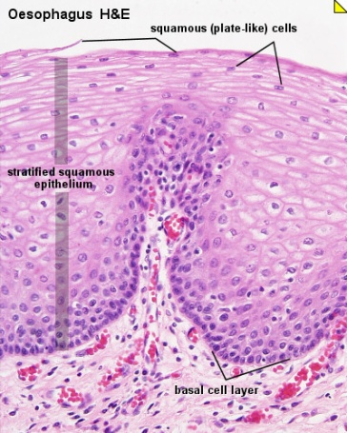 | Protection whether keratinized or non-keratinized. Also has nerve receptors associated with them.  Keratinized = outer skin  Non-keratinized = lines inside of oral cavity, esophagus and vagina.
Stratified cuboidal (rare) | Cuboidal shaped cells in multiple layers, typically 2 layers but sometimes a few more layers. | 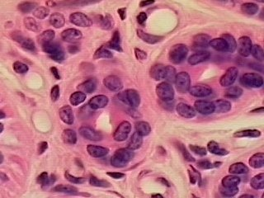 | Found in large glands like sweat and mammary glands. Protection  May also be involved in secretion of different substances.
Stratified columnar (rare) | Multiple layers of cells (typically 2-3) Cells on basement membrane are cuboidal, those at the apical/free surface are columnar shaped. | 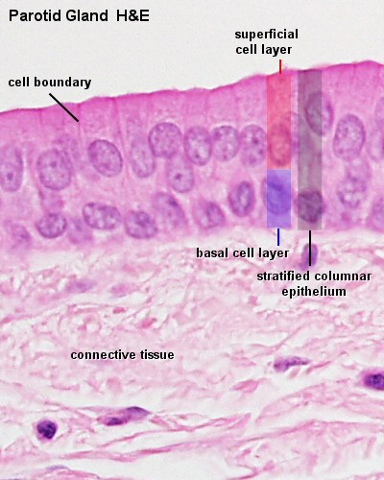 | Small amounts in pharynx, male urethra and some glandular ducts.  Protection  Secretion of different
Images from http://nte-serveur.univ-lyon1.fr/nte/EMBRYON/www.uoguelph.ca/zoology/devobio/210labs/epithelial1.html
http://www.stegen.k12.mo.us/tchrpges/sghs/ksulkowski/TissueSlides.htm
http://www.lab.anhb.uwa.edu.au/mb140/CorePages/Epithelia/epithel.htm
http://www.mhhe.com/biosci/ap/histology_mh/stratcuc.html

Epithelium Review
Name/Type Description Picture Function/Location

Pseudostratified | Appears layered due to nuclei found at different levels in the layer and different sizes of the cells.  Usually are ciliated.  Can have goblet cells. | 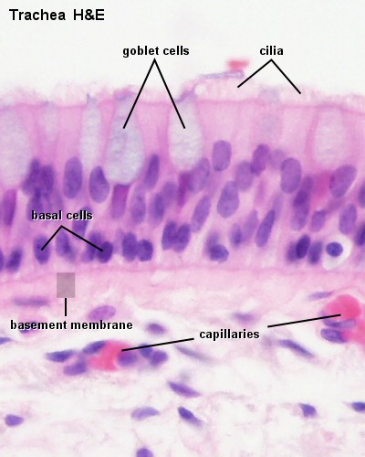 | Lines trachea and upper respiratory tract.  Non-ciliated type in male sperm carrying ducts and some glands.  Protect and secretion, especially mucus. Cilia move mucus up the respiratory tract helping trap particles etc. from entering the lower respiratory tract.
Transitional | Mutiple layers of cells, having both squamous and cuboidal appearance. Cells on free surface tend to be rounded and dome shape in appearance. | 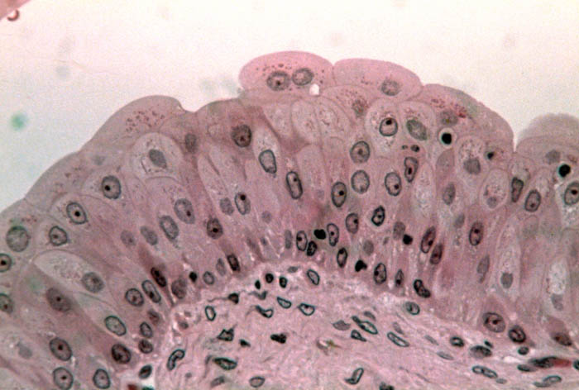 | Stretches and allows the urinary bladder to distend, thank goodness!  Found in the ureters and urinary bladder.  COUPLE MORE PHOTOS CONTINUE SCROLLING DOWN
Another picture of simple squamous Next window.  Second Window over is simple cuboidal. And pseudotratified down below farther. | 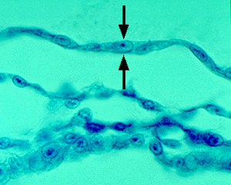 | 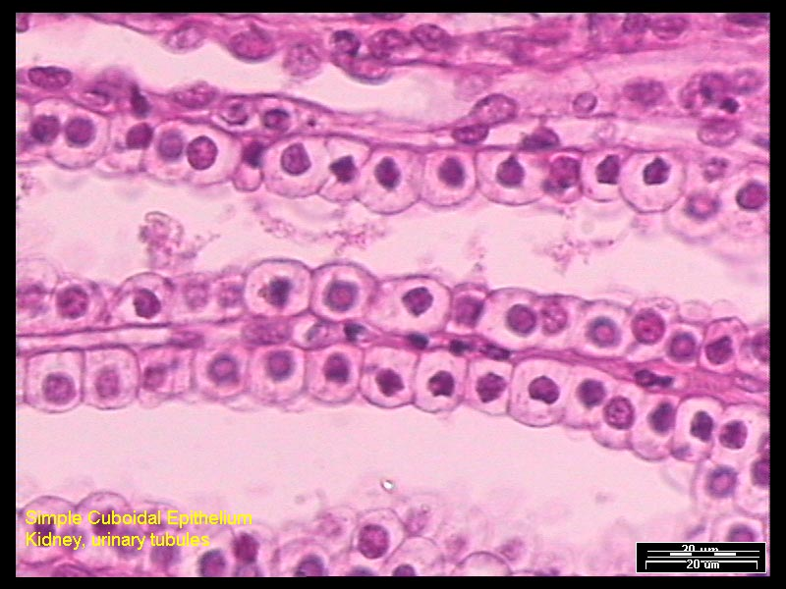
Pseudostratified to the right. |  | 