Final Review
The final is mostly multiple choices and a select number of essays.
Topics we discussed this year include that you should focus your studies on
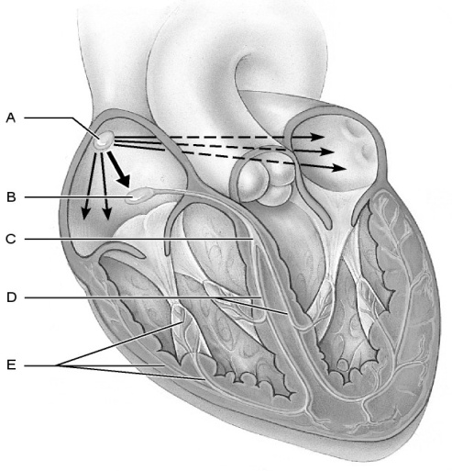
- The Heart
  - The pathway of blood
  - Anatomy
  - Electrical conduction do not forget EKGs!
  - Pathology heart attack
- The Eye
  - Anatomy
  - Vision
  - Cones and rods
  - Pathology
    - Cataracts, glaucoma, macular degeneration
- The Brain
  - Anatomy
  - Functions of different structures and regions
- The Nervous System
  - Properties of Neurons
  - Structure of Neuron
  - Nervous cell types
  - Divisions
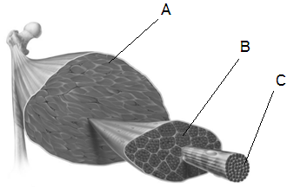
  - Action Potentials
- Muscle Contaction
  - Power Stroke!
  - Myofilaments
  - Sarcomere Structure
  - Myosin
  - Troponin
  - Actin
  - Tropomyosin
  - Calcium and ATP
- Muscle Anatomy
  - Fascicle, Fiber, Myofibril, Myofilament
  - Properties of Muscle Tissue

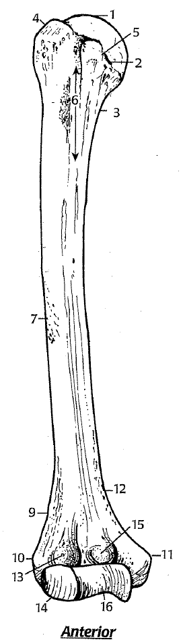
- Upper Limb and Pectoral Girdle - Processes and characteristics of
  - Humerus
  - Radius
  - Ulna
  - Scapula
  - Clavicle
  - Sternum
  - Carpals, Metacarpals, Phalanges
- Pelvic Girdle and Lower Limb - Processes and characteristics of
  - Ilium, Ischium, and Pubis
  - Femur, Tibia, Fibula, Tarsals, Metatarsals, Phalanges
- Male and Female Reproduction
