On Tuesday 2/27, N. Brown’s biology classes will report to a computer lab for OGT practice and for review with the www.newpathlearning.com website.
3rd period room 259
5th period room 113

Formative assessment:
Name _____________________________ February 26, 2014
You must write a complete sentence for each point! For example, if you use a punnett square, you must explain what it shows, as well as drawing it. One correct and explained idea 1 point.
- A plant’s dominant phenotype for flower color trait is Red, & its recessive phenotype is white. The trait obeys simple dominance. If a homozygous dominant plant is mated to a homozygous recessive plant, then:
- What is the probability that F1 offspring will be white? (1 pt) Explain how you know this (1 pt).
- What is the probability that an F2 offspring will be white? (1 pt) Explain how you know this (1pt)
____________________________________________________________________________________________________________________________________________________________________________________________________________________________________________________________________________________________________________________________________________________________________________________________________________________________________________________________________________________
For questions 2 –6, classify the inheritance pattern, then explain 2 reasons for your decision.
Choices:
- Autosomal dominant
- Autosomal recessive
- Sex-linked dominant
- Sex-linked recessive
2
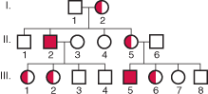

3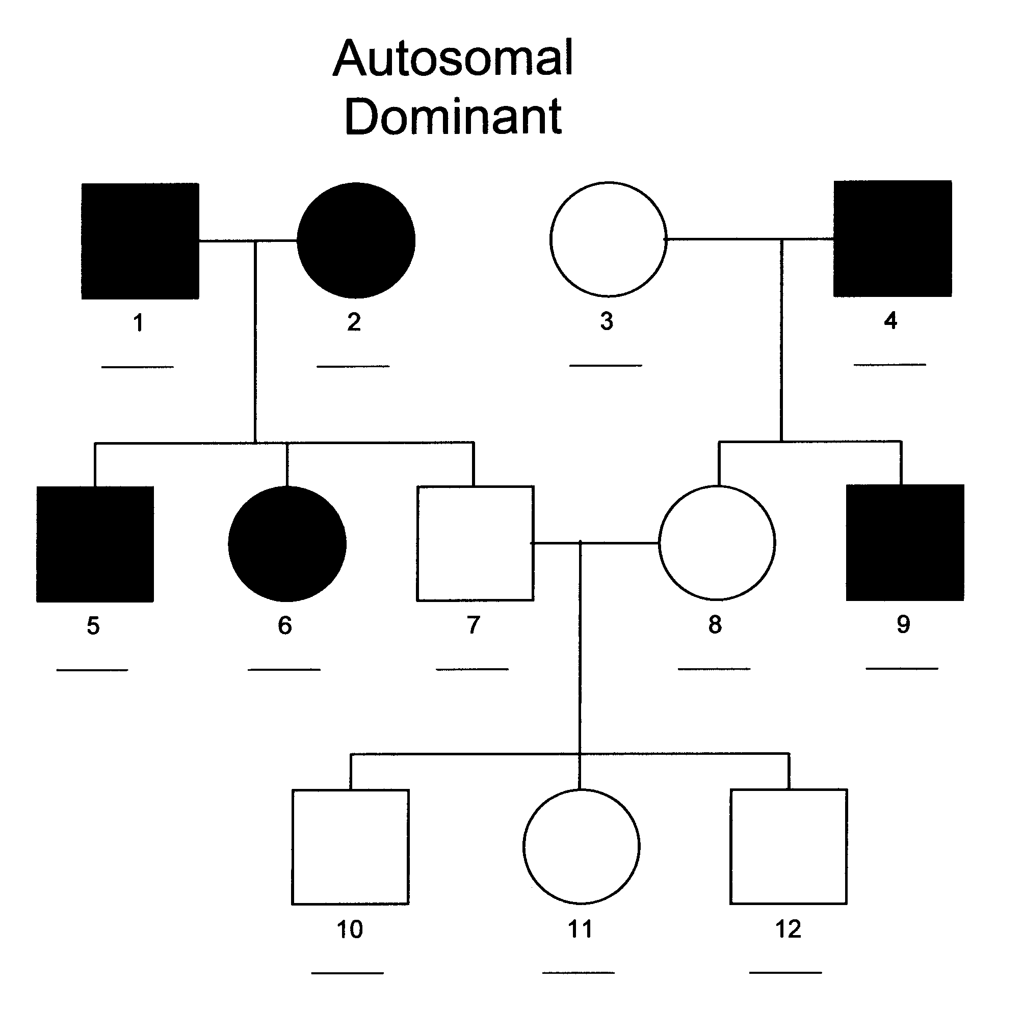

4