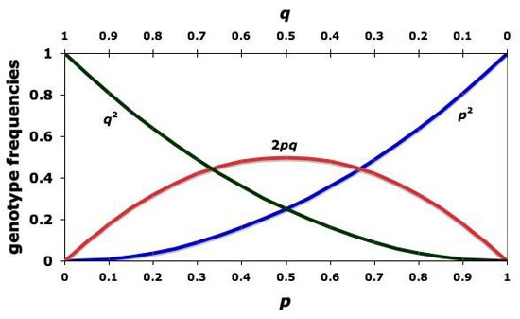

AP Biology
Mathematical Modeling of the Hardy-Weinberg Equilibrium

Evolution occurs in populations of organisms and involves variation, heredity, and differential survival. One way to study evolution is to study how the frequency of alleles in a population changes from one generation to the next. In other words, you can ask “What are the inheritance patterns of alleles, not just from two parental organisms, but in a population?” You can then explore how allele frequencies change in populations and how these changes might predict what will happen in the future.

This particular investigation provides a a problem designed to help you understand and develop the skill of modeling biological phenomena with computers. Mathematical models and computer simulations are tools used to explore the complexity of biological systems that might otherwise be difficult or impossible to study. It is easy to understand how microscopes opened up an entire new world of biological understanding. For some, it is not as easy to see the value of mathematics to the study of biology, but, like the microscope, math and computers provide tools to explore the complexity of biology and biological systems — providing deeper insights and understanding of what makes living systems work.

While there are dozens of computer models already built and available for free, the idea for this laboratory is for you to build your own from scratch and apply it to questions about evolution. To explore how allele frequencies change in populations of organisms, you will first build a computer spreadsheet that models the changes in a hypothetical gene pool from one generation to the next. This model will let you explore parameters that affect allele frequencies, such as selection, mutation, and migration. In the second part of the investigation asks you to generate your own questions regarding the evolution of allele frequencies in a population.

This investigation will provide you an opportunity for you to review concepts you might have studied previously, including evolution by natural selection, the relationships between genotype, phenotype and selective pressures, the fundamentals of classic Mendelian genetics, the mechanisms of population change, and the Hardy Weinberg equilibrium. To obtain the maximum benefit from this exercise, you should review any of these concepts that are foggy. As you build your own Hardy Weinberg model and explore it, you should develop a more thorough understanding of how genes behave in population.
Objectives

- To use a data set that reflects a change in the genetic makeup of a population over time and to apply mathematical methods and conceptual understandings to investigate the cause(s) and effect(s) of this change.

- To apply mathematical methods to data from a real or simulated population to predict what will happen to the population in the future.

- To evaluate data-based evidence that describes evolutionary changes in the genetic makeup of a population over time.

- To use data from mathematical models based on the Hardy-Weinberg equilibrium to analyze genetic drift and the effect of selection in the evolution of specific populations.

- To justify data from mathematical models based on the Hardy-Weinberg equilibrium to analyze genetic drift and the effects of selection in the evolution of specific populations.

- To describe a model that represents evolution within a population.

- To evaluate data sets that illustrate evolution as an ongoing process.

Introduction

Building a Simple Mathematical Model

The real world is infinitely complicated. To penetrate that complexity using model building, you must learn to make reasonable, simplifying assumptions about complex processes. For example, climate change models or weather forecasting models are simplifications of very complex processes — more than can be accounted for with even the most powerful computer. These models allow us to make predictions and test hypotheses about climate change and weather.

By definition, any model is a simplification of the real world. For that reason, you need to constantly evaluate the assumptions you make as you build a model, as well as evaluate the results of the model with a critical eye. This is actually one of the powerful benefits of a model — it forces you to think deeply about an idea.

Formulate the Question

Think about a recessive Mendelian trait such as cystic fibrosis. Why do recessive alleles like cystic fibrosis stay in the human population? Why don’t they gradually disappear?

Fingers on a single hand or toes on a foot) in humans. Polydactyly is a dominant trait, but it is not a common trait in most human populations. Why not?

How do inheritance patterns or allele frequencies change in a population? Our investigation begins with an exploration of answers to this simple questions.

Determine the Basic Ingredients

Let’s try to simplify the question: How do inheritance patterns or allele frequencies change in a population? To do this, we will need to start with some basic assumptions. For this model, assume that all the organisms in our hypothetical population are diploid. This organism has a gene locus with two alleles — A and B. (We could use A and a to represent the alleles, but A and B are easier to work with in the spreadsheet you’ll be developing.) So far, this imaginary population is much like any sexually reproducing population.

How else can you simplify the question? Consider that the population has an infinite gene pool (all the alleles in the population at this particular locus). Gametes for the next generation are selected totally at random. What does that mean? Focus on answering that question in your lab notebook for a moment — it is key to our model. For now let’s consider that our model is going to look only at how allele frequencies might change from generation to generation. To do that we need to describe the system.

Imagine for a minute the life cycle of our hypothetical organism. See if you can draw a diagram of the cycle; be sure to include the life stages of the organism. Your life cycle might look like Figure 1.

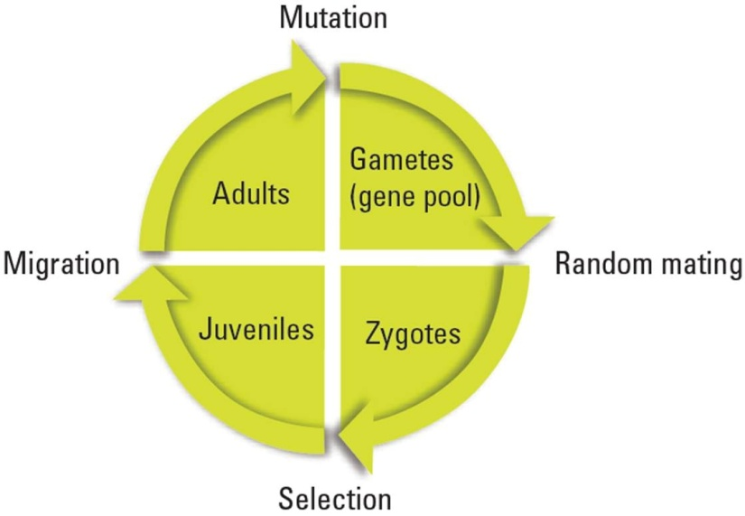

Figure 1: Life stages of a population of organisms.

To make this initial exploration into a model of inheritance patterns in a population, you need to make some important assumptions — all the gametes go into one infinite pool, and all have an equal chance of taking part in fertilization or formation of a zygote. For now, all zygotes live to be juveniles, all juveniles live to be adults, and no individuals enter or leave the population; there is also no mutation. Make sure to record these assumptions in your notebook; later, you will need to explore how your model responds as you change or modify these assumptions.

Spreadsheets are valuable tools that allow us to ask What if? questions. They can repeatedly make a calculation based on the results of another calculation. They can also model the randomness of everyday events. Our goal is to model how allele frequencies change through one life cycle of this imaginary population in the spreadsheet.

Part 1: Quantitatively Describing the Biological System

Procedures

- To begin your model, let’s define a couple of variables.

p = the frequency of the A allele
q = the frequency of the B allele

- Bring up an excel spreadsheet on your computer.

- In the upper left corner, in cell D2, enter a value for the frequency of the A allele. This value should be between 0 and 1.0.

- Enter a value for the B allele. Because all of the alleles in a population are either A or B for a given trait, the Hardy-Weinberg equation p + q = 1 applies. When making a model in a spreadsheet, it’s best to have the computer do as many of the calculations as possible. In cell D3, enter the formula to calculate the value of q.

= 1-D2

- Your spreadsheet should now look like something like Figure 2.

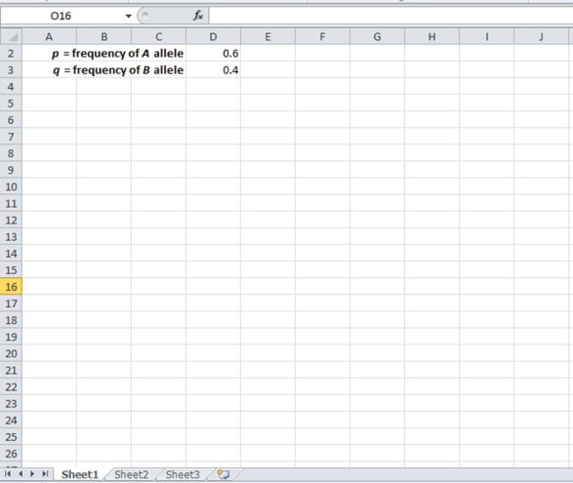

Figure 2:

- Let’s explore how one important spreadsheet function works before we incorporate it into our model. In a nearby empty cell, enter the function (we will remove it later).

=RAND()

Note that the parentheses in the equation above have nothing between them. After hitting return, what do you find in the cell? If you are on a PC, try hitting the F9 key several times to force recalculation. What happens to the value in the cell?
_____________________________________________________________________________
_____________________________________________________________________________

The RAND function returns random numbers between 0 and 1 in decimal format. This is a powerful feature of spreadsheets. It allows us to enter a sense of randomness to our calculations if it is appropriate — and here it is when we are “randomly” choosing gametes from a gene pool. Go ahead and delete the RAND function in the cell.

- Let’s select two gametes from the gene pool. In cell E5, let’s generate a random number, compare it to the value of p, and then place either an A gamete or a B gamete in the cell. We’ll need two functions to do this, The RAND function and the IF function. The function to be entered in cell E5 is

=IF(RAND()<=D$2,”A”,”B”)

Be sure to include the $ in front of the 2 in the cell address D2. It will save time later when you build onto this spreadsheet.

The formula in this cell basically says that if a random number between 0 and 1 is less than or equal to the value of p, then put an A gamete in this cell, or if it is not less than or equal to the value of p, put a B gamete in this cell. IF functions and RAND functions are very powerful tools when you try to build models for biology.

- Now create the same formula in cell F5, making sure that it is formatted in the exactly like E5. When you have this completed, press the recalculate key to force a recalculation of your spreadsheet. If you have entered the functions correctly in the two cells, you should see changing values in the two cells. (This is part of the testing and retesting that you have to do while model building.) Your spreadsheet should look like Figure 3.

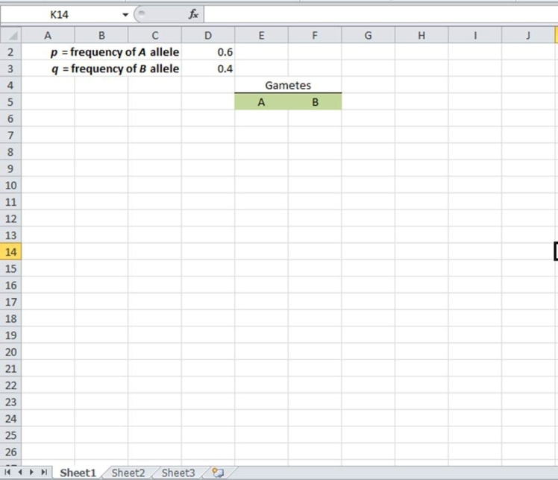

Figure 3:
- Try recalculating 10–20 times by pressing the F9 key. Record your results below.

 | Gametes |  |  |  | Gametes
Trial 1 | xxxxxxxxx | xxxxxxxxx |  | Trial 11 | xxxxxxxxx | xxxxxxxxx
Trial 2 |  |  |  | Trial 12
Trial 3 |  |  |  | Trial 13
Trial 4 |  |  |  | Trial 14
Trial 5 |  |  |  | Trial 15
Trial 6 |  |  |  | Trial 16
Trial 7 |  |  |  | Trial 17
Trial 8 |  |  |  | Trial 18
Trial 9 |  |  |  | Trial 19
Trial 10 |  |  |  | Trial 20

What are the p and q values that you entered in your spreadsheet? ______________________

How many A alleles came up in your recalculations? __________

How many B alleles came up in your recalculations? __________

Do both cells change to A and B in the ratios you’d expect from your p value?
_____________________________________________________________________________
_____________________________________________________________________________
_____________________________________________________________________________
_____________________________________________________________________________

- Try changing your p value to 0.8 or 0.9.

 | Gametes |  |  |  | Gametes
Trial 1 | xxxxxxxxx | xxxxxxxxx |  | Trial 11 | xxxxxxxxx | xxxxxxxxx
Trial 2 |  |  |  | Trial 12
Trial 3 |  |  |  | Trial 13
Trial 4 |  |  |  | Trial 14
Trial 5 |  |  |  | Trial 15
Trial 6 |  |  |  | Trial 16
Trial 7 |  |  |  | Trial 17
Trial 8 |  |  |  | Trial 18
Trial 9 |  |  |  | Trial 19
Trial 10 |  |  |  | Trial 20

What are the p and q values that you entered in your spreadsheet? ______________________

How many A alleles came up in your recalculations? __________

How many B alleles came up in your recalculations? __________

Do both cells change to A and B in the ratios you’d expect from your p value?
_____________________________________________________________________________
_____________________________________________________________________________
_____________________________________________________________________________
_____________________________________________________________________________

- Reset your p value to 0.5. Then copy these two formulas in E5 and F5 down for 20 rows to represent gametes that will form 20 offspring for the next generation. To copy the formulas, click on the bottom right-hand corner of the cell and, with your finger pressed down on the mouse, drag the cell downward. Your spreadsheet should look like Figure 4, although note that the sample shows only 16 generations.

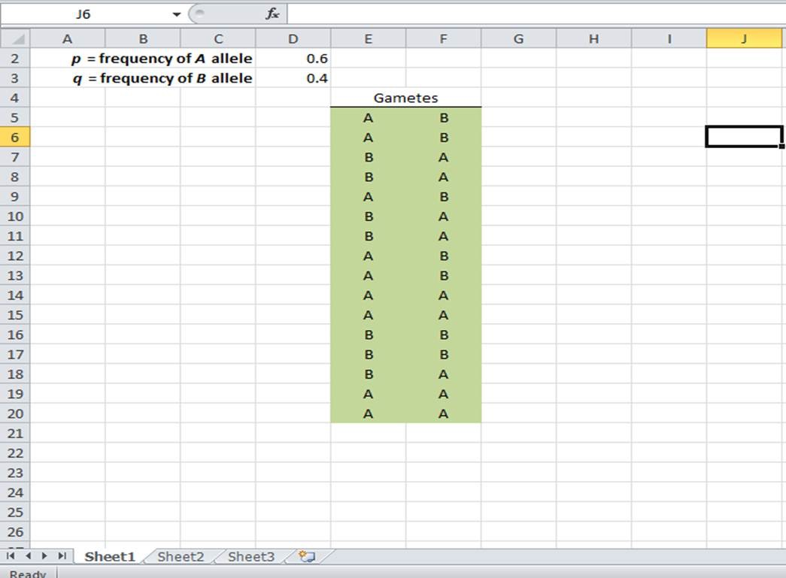

Figure 4:

- We’ll put the zygotes in cell G5. The zygote is a combination of the two randomly selected gametes. In the spreadsheet, you want to add the two gametes across the row. In spreadsheet vernacular, you want to concatenate the values in the two cells. In cell G5 enter the function

=CONCATENATE(E5,F5)

Copy this formula down as far down as you have gametes, as in Figure 5 on the next page.
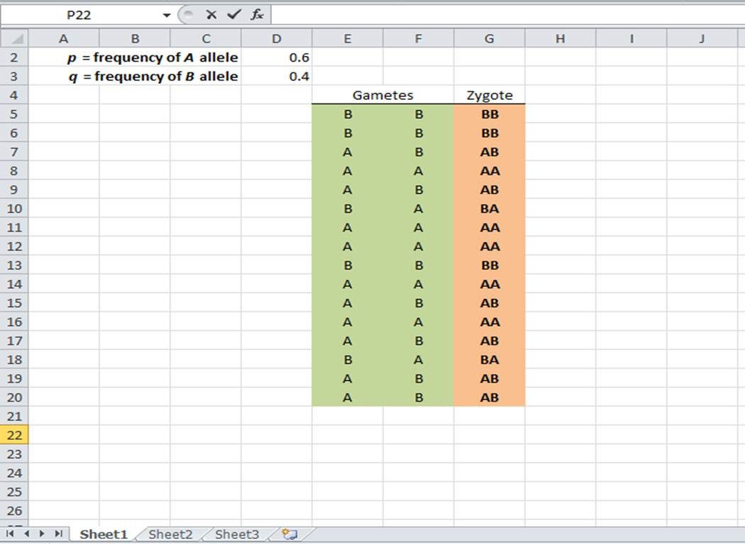

Figure 5:

- The next columns on the sheet, H, I, and J, are used for bookkeeping — that is, keeping track of the numbers of each zygote’s genotype. They are rather complex functions that use IF functions to help us count the different genotypes of the zygotes. The function in cell H5 is

=IF(G5=”AA”,1,0)

This basically means that if the value in cell G5 is AA, then put a “1” in the cell; if not, then put a “0”.

- Enter the following very similar function in cell J5.

=IF(G5=”BB”,1,0)

Interpret this formula? What does it say in English?
_____________________________________________________________________________
_____________________________________________________________________________
_____________________________________________________________________________
_____________________________________________________________________________

- Now let’s tackle the nested IF function. This is needed to test for either AB or BA. In cell I5 enter the nested function.

=IF(G5=”AB”,1,(IF(G5=”BA”,1,0)))

This example requires an extra set of parentheses, which is necessary to nest functions. This function basically says that if the value in cell G5 is exactly equal to AB, then put a 1; if not, then if the value in cell G5 is exactly BA, put a 1; if it is neither, then put a 0 in this cell. Copy these three formulas down for all the rows in which you have produced gametes.
- Enter the labels for the columns you’ve been working on — gametes in cell E4, zygote in cell G5, AA in cell H4, AB in cell I4, and BB in cell J4, as shown in Figure 6 on the next page.

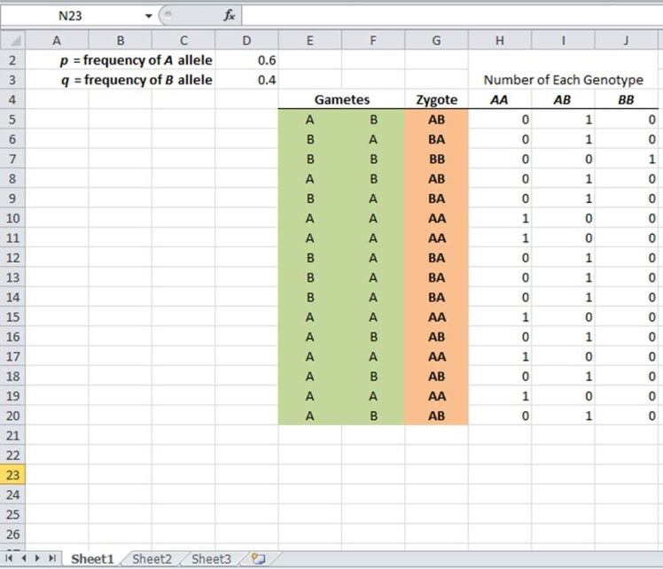

Figure 6:

- As before, try recalculating a number of times to make sure everything is working as expected.

- Calculate the sum of the AA genotypes in column H by entering the following formula in cell H25

=SUM(H5:H24)

Calculate the sum of the AB and BB genotypes in columns I and J using the same formula in cells I25 and J25, respectively. Enter the label for the calculations you’ve been working on, as in Figure 7.

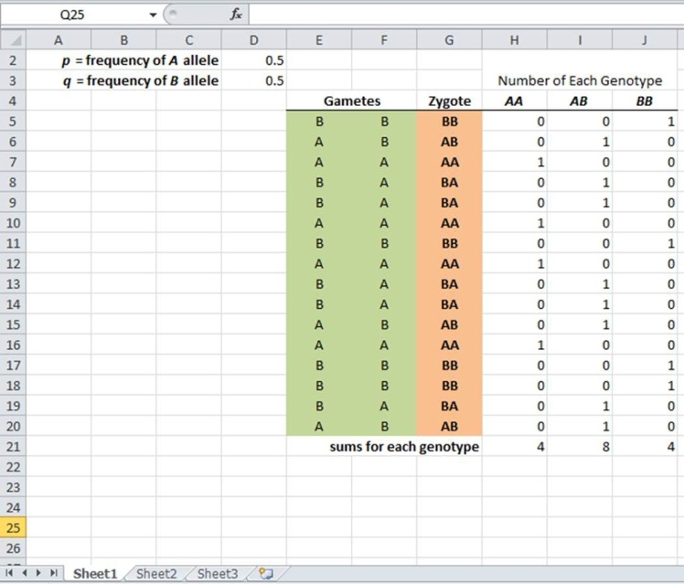

Figure 7:
- Calculate the number of each allele A and B in cells H28 and I28, respectively. Because each homozygous AA individual has two A alleles, and each heterozygous AB individual has only one A allele, use the following equation

=SUM(2*(H25),I25)

- Calculate the allele frequency of the A allele by dividing the number of A alleles by the total number of alleles in the population. Because your simulation generated 20 offspring, and each offspring is diploid, there are 40 alleles total. The equation below calculates the frequency of each allele

=(H28/40)

Your spreadsheet should now look like Figure 8.

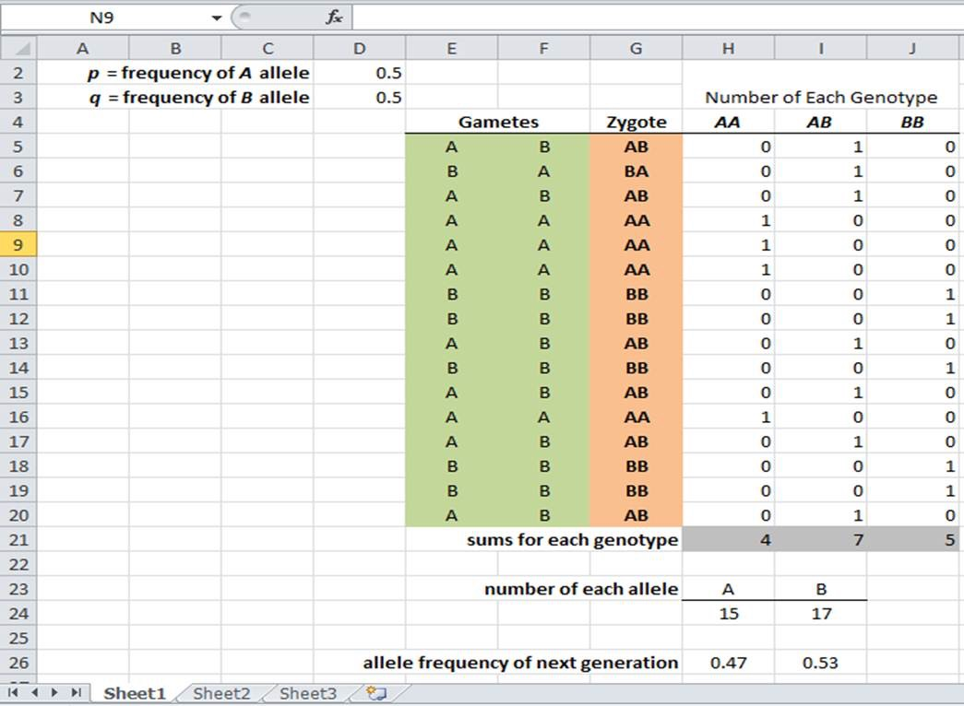

Figure 8:

- Given the number of each genotype calculated in your spreadsheet model, use the Hardy Weinberg equations below to calculate the frequency of the p and q alleles to support the accuracy of your computer model. Record your calculations in the space provided below.

Frequency of the p allele: __________ Frequency of the q allele: __________
- Make a bar graph of the genotypes using the chart tool. Your spreadsheet should resemble Figure 9.

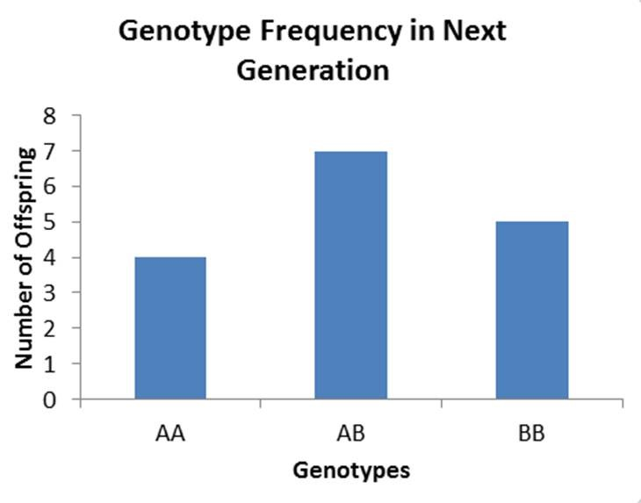

Figure 9:

- Name one problem in this model,
________________________________________________________________________________
________________________________________________________________________________
________________________________________________________________________________
________________________________________________________________________________

Part 2: Testing Your Mathematical Model

You now have a model with which you can explore how allele frequencies behave and change from generation to generation. Working with a partner, develop a plan to answer this general question: How do inheritance patterns or allele frequencies change in a population over one generation? As you work, think about the following more specific questions.

What can you change in your model? If you change something, what does the change tell you about how alleles behave?
_____________________________________________________________________________________
_____________________________________________________________________________________
_____________________________________________________________________________________
_____________________________________________________________________________________

Use your mathematical model to test out each of the following scenarios.

- Answer the following question: How do alleles behave at extreme frequencies?

  - How will you use your spreadsheet to model an extreme p value?
___________________________________________________________________________
___________________________________________________________________________
___________________________________________________________________________
___________________________________________________________________________

  - Increase the frequency of the A allele to 0.9. Run your simulation 20 times and record your results below, then answer the following questions.

 | Frequency of Each Genotype |  |  |  |  | Frequency of Each Genotype
 | AA | AB | BB |  |  | AA | AB | BB
Trial 1 | xxxxxxx | xxxxxxx | xxxxxxx |  | Trial 11 | xxxxxxx | xxxxxxx | xxxxxxx
Trial 2 |  |  |  |  | Trial 12
Trial 3 |  |  |  |  | Trial 13
Trial 4 |  |  |  |  | Trial 14
Trial 5 |  |  |  |  | Trial 15
Trial 6 |  |  |  |  | Trial 16
Trial 7 |  |  |  |  | Trial 17
Trial 8 |  |  |  |  | Trial 18
Trial 9 |  |  |  |  | Trial 19
Trial 10 |  |  |  |  | Trial 20

Frequency of AA genotype: __________  Frequency of AB genotype: __________  Frequency of BB genotype: __________  p = frequency of A allele: ____________  q = frequency of B allele: ____________ | Show your work:

  - Describe the patterns that you see after running your simulation 20 times for a population size of 50 offspring.
___________________________________________________________________________
___________________________________________________________________________
___________________________________________________________________________
___________________________________________________________________________

  - Predict what will happen to the frequency of the A allele after 500 generations, by sketching the anticipated frequency of the A allele in the graph below.

Frequency of the A Allele

Generation

  - Explain your prediction, below.
___________________________________________________________________________
___________________________________________________________________________
___________________________________________________________________________
___________________________________________________________________________

- Answer the following question: How do alleles behave when the population size is increased?

  - How will you use your spreadsheet to model an increase in population size?
___________________________________________________________________________
___________________________________________________________________________
___________________________________________________________________________
___________________________________________________________________________

  - Increase the population size to 250. Run your simulation 20 times with an allele frequency of 0.5 for p. Record your results below, then answer the following questions. Record your results below.

p = __________

 | Frequency of Each Genotype |  |  |  |  | Frequency of Each Genotype
 | AA | AB | BB |  |  | AA | AB | BB
Trial 1 | xxxxxxx | xxxxxxx | xxxxxxx |  | Trial 11 | xxxxxxx | xxxxxxx | xxxxxxx
Trial 2 |  |  |  |  | Trial 12
Trial 3 |  |  |  |  | Trial 13
Trial 4 |  |  |  |  | Trial 14
Trial 5 |  |  |  |  | Trial 15
Trial 6 |  |  |  |  | Trial 16
Trial 7 |  |  |  |  | Trial 17
Trial 8 |  |  |  |  | Trial 18
Trial 9 |  |  |  |  | Trial 19
Trial 10 |  |  |  |  | Trial 20

Frequency of AA genotype: __________  Frequency of AB genotype: __________  Frequency of BB genotype: __________  p = frequency of A allele: ____________  q = frequency of B allele: ____________ | Show your work:

  - Describe the patterns that you see after running your simulation 20 times for a population size of 50 offspring.
___________________________________________________________________________
___________________________________________________________________________
___________________________________________________________________________
___________________________________________________________________________

  - Predict what will happen to the frequency of the A allele after 500 generations, by sketching the anticipated frequency of the A allele in the graph below.

Frequency of the A Allele

Generation

  - Explain your prediction, below.
___________________________________________________________________________
___________________________________________________________________________
___________________________________________________________________________
___________________________________________________________________________

- Answer the following question: How do allele frequencies change over many generations?

  - How will you use your spreadsheet to model the changes in allele frequency after multiple generations?
___________________________________________________________________________
___________________________________________________________________________
___________________________________________________________________________
___________________________________________________________________________

  - Run your simulation for 20 generations with your population size of 250 and a p value of 0.5. Record your results below, then answer the following questions.

p = __________

 | Frequency of Each Genotype |  |  |  |  |  | Frequency of Each Genotype
 | AA | AB | BB |  |  |  | AA | AB | BB
Generation 1 | xxxxxxx | xxxxxxx | xxxxxxx |  |  | Generation 11 | xxxxxxx | xxxxxxx | xxxxxxx
Generation 2 |  |  |  |  |  | Generation 12
Generation 3 |  |  |  |  |  | Generation 13
Generation 4 |  |  |  |  |  | Generation 14
Generation 5 |  |  |  |  |  | Generation 15
Generation 6 |  |  |  |  |  | Generation 16
Generation 7 |  |  |  |  |  | Generation 17
Generation 8 |  |  |  |  |  | Generation 18
Generation 9 |  |  |  |  |  | Generation 19
Generation 10 |  |  |  |  |  | Generation 20
Frequency of AA genotype: __________  Frequency of AB genotype: __________  Frequency of BB genotype: __________  p = frequency of A allele: ____________  q = frequency of B allele: ____________ |  |  |  |  | Show your work:

  - Describe the patterns that you see after adding 20 generations to your model with a p value of 0.5.
___________________________________________________________________________
___________________________________________________________________________
___________________________________________________________________________
___________________________________________________________________________

  - Predict what will happen to the frequency of the A allele after 500 generations, by sketching the anticipated frequency of the A allele in the graph below.

Frequency of the A Allele

Generation

  - Explain your prediction, below.
___________________________________________________________________________
___________________________________________________________________________
___________________________________________________________________________
___________________________________________________________________________

- Run your simulation for 20 generations with your population size of 250 and a p value of 0.8. Record your results below, then answer the following questions.

p = __________

 | Frequency of Each Genotype |  |  |  |  | Frequency of Each Genotype
 | AA | AB | BB |  |  | AA | AB | BB
Generation 1 | xxxxxxx | xxxxxxx | xxxxxxx |  | Generation 11 | xxxxxxx | xxxxxxx | xxxxxxx
Generation 2 |  |  |  |  | Generation 12
Generation 3 |  |  |  |  | Generation 13
Generation 4 |  |  |  |  | Generation 14
Generation 5 |  |  |  |  | Generation 15
Generation 6 |  |  |  |  | Generation 16
Generation 7 |  |  |  |  | Generation 17
Generation 8 |  |  |  |  | Generation 18
Generation 9 |  |  |  |  | Generation 19
Generation 10 |  |  |  |  | Generation 20
Frequency of AA genotype: __________  Frequency of AB genotype: __________  Frequency of BB genotype: __________  p = frequency of A allele: ____________  q = frequency of B allele: ____________ |  |  |  |  | Show your work:

  - Describe the patterns that you see after adding 20 generations to your model with a p value of 0.5.
___________________________________________________________________________
___________________________________________________________________________
___________________________________________________________________________
___________________________________________________________________________

  - Predict what will happen to the frequency of the A allele after 500 generations, by sketching the anticipated frequency of the A allele in the graph below.

Frequency of the A Allele

Generation

  - Explain your prediction, below.
___________________________________________________________________________
___________________________________________________________________________
___________________________________________________________________________
___________________________________________________________________________

AP Biology
Mathematical Modeling of the Hardy Weinberg Lab
Homework: Questions for Analysis

- What are the requirements for a population to be in Hardy Weinberg equilibrium?
- What would happen if there were no randomness in this mathematical model?
- In the absence of random events (an infinitely large population), are the allele frequencies of the original population expected to change from generation to generation?
- How does this compare to a population that has random gamete selection but is small? In other words, what happens to allele frequencies in such a population? Is it predictable?
- In a large population would it be possible to completely eliminate a deleterious recessive allele?
- Which will increase in frequency more rapidly when favored by selection : a rare recessive allele, or a rare dominant allele?
- Which rises to a frequency of 1.0 more rapidly under selection: a common recessive allele or a common dominant allele? Why?

