UNIT 8: MOTIVATION AND EMOTION

8A: MOTIVATION
INSTINCTS

DRIVES AND INCENTIVES

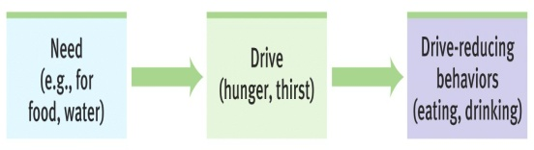
drive reduction theory

homeostasis

incentives

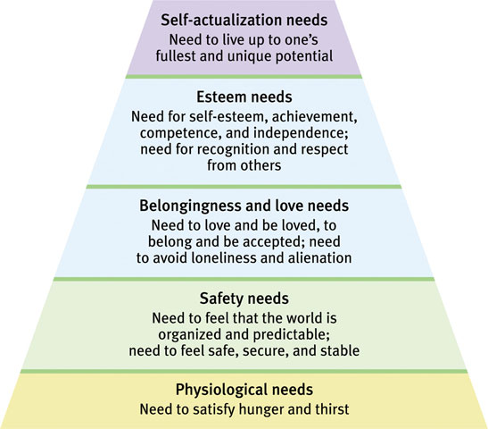

HIERARCHY OF NEEDS (MASLOW)

HUNGER AND THE HYPOTHALAMUS
HORMONE | TISSUE | RESPONSE
Orexin increase

Ghrelin increase

Insulin increase

Leptin increase

PPY increase

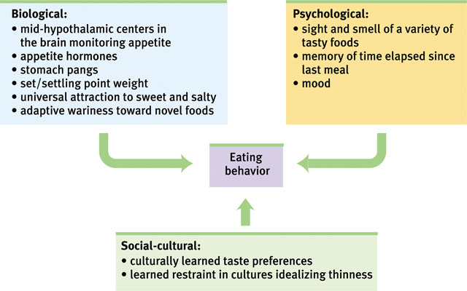

KEY QUESTIONS FROM 8A: MOTIVATION
1: From what perspectives do psychologists view motivated behavior?
- Instinct, drive-reduction, optimum arousal, hierarchy of needs

2: What physiological factors produce hunger?
- Hunger pangs, appetite hormones, hypothalamus, set point

3: What psychological and cultural factors influence hunger?
- Memory, taste preferences, culture

4: How do eating disorders demonstrate the influence of psychological forces on physiologically motivated behaviors?
- Bulimia, anorexia, binge eating disorder
- Body image & the media

5: What factors predispose some people to become and remain obese?
- Environment, twin and adoption studies

6: What stages mark the human sexual response cycle?
- Masters & Johnson (4 stages)
- Sexual disorders (problems)

7: Do hormones influence human sexual motivation?
- Estrogen and testosterone

8: How do internal and external stimuli influence sexual motivation?
- Erotic material & fantasies

9: What factors influence teen pregnancy and risk of sexually transmitted infections?
- Culture & media, Predictors of restraint

10: What has research taught us about sexual orientation?
- Biological influences

11: Is scientific research on sexual motivation value free?

12: What evidence points to our human need to belong?

8A: MULTIPLE CHOICE REVIEW QUESTIONS

- Motivation is best understood as a state that:
  - reduces a drive.
  - aims at satisfying a biological need.
  - energizes an organism to act.
  - energizes and directs behavior.

- Which of the following is a difference between a drive and a need?
  - Needs are learned; drives are inherited.
  - Needs are physiological states; drives are psychological states.
  - Drives are generally stronger than needs.
  - Needs are generally stronger than drives.

- One problem with the idea of motivation as drive reduction is that:
  - because some motivated behaviors do not seem to be based on physiological needs, they cannot be explained in terms of drive reduction.
  - it fails to explain any human motivation.
  - it cannot account for homeostasis.
  - it does not explain the hunger drive.

- Some scientific evidence makes a preliminary link between homosexuality and
  - late sexual maturation.
  - the age of an individual’s first erotic experience.
  - atypical prenatal hormones.
  - early problems in relationships with parents.

- Electrical stimulation of the lateral hypothalamus will cause an animal to:
  - begin eating.
  - stop eating.
  - become obese.
  - begin copulating.

- Instinct theory and drive-reduction theory both emphasize _________ factors in motivation.
  - environmental
  - cognitive
  - psychological
  - biological

- The correct order of the stages of Masters and Johnson’s sexual response cycle is:
  - plateau; excitement; orgasm; resolution.
  - excitement; plateau; orgasm; resolution.
  - excitement; orgasm; resolution; refractory.
  - plateau; excitement; orgasm; refractory.

- Bulimia nervosa involves:
  - binging.
  - purging.
  - dramatic weight loss.
  - a and b

- Castration of male rats results in:
  - reduced testosterone and sexual interest.
  - reduced testosterone, but no change in sexual interest.
  - reduced estrogen and sexual interest.
  - reduced estrogen, but no change in sexual interest.

- In his study of men on a semistarvation diet, Keys found that:
  - the metabolic rate of the subjects increased.
  - the subjects eventually lost interest in food.
  - the subjects became obsessed with food.
  - the subjects’ behavior directly contradicted predictions made by Maslow’s hierarchy of needs.

TRUE/FALSE ITEMS
_____ 1. When body weight rises above set point, hunger increases.
_____ 2. According to Masters and Johnson, only males experience a plateau period in the cycle of sexual arousal.
_____ 3. Testosterone affects the sexual arousal of the male only.
_____ 4. Unlike men, women tend not to be aroused by sexually explicit material.
_____ 5. All taste preferences are conditioned.
_____ 6. Married people are less at risk for depression than are unattached people.
_____ 7. An increase in insulin increases blood glucose levels and triggers hunger.
_____ 8. One’s sexual orientation is not voluntarily chosen.
UNIT 8B: EMOTION
James-Lange theory

Canon-Bard theory

two-factor theory

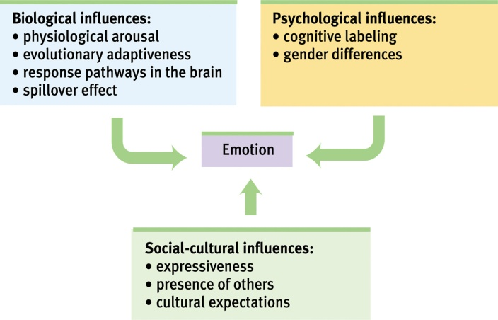
EMBODIED EMOTION
Autonomic nervous system

Physiological effects of emotions

The role of cognition

EXPRESSED EMOTION

Nonverbal communication

Detecting Emotion

Facial Expressions

EXPERIENCED EMOTION
Fear Anger Happiness

Adaptation and Comparison
KEY QUESTIONS FROM 8B: EMOTIONS, STRESS AND HEALTH
1: What are the components of an emotion?
- James-Lange, Cannon-Bard, Two-factor theories

2: What is the link between arousal and the autonomic nervous system?
3: Do different emotions activate different physiological and brain-pattern responses?
4: To experience emotions, must we consciously interpret and label them?
- Schachter & Singer, spillover effect

5: How do we communicate nonverbally?
- Universal nonverbal language, gender differences

6: Are nonverbal expressions of emotion universally understood?
7: Do our facial expressions influence our feelings?
8: What is the function of fear and how do we learn fears?
- Adaptive, prediagnosed vs. learned fears

9: What are the causes and consequences of anger?
- Catharsis, culture & gender differences

10: What are the causes and consequences of happiness?
- Feel-Good, Do-Good Phenomenon, Adaptation-Level Phenomenon, Relative Deprivation
- Predictors of happiness

11: What is stress?
- Adaptive vs. maladaptive

12: What events provoke stress responses?
13: Why are some of us more prone than others to coronary heart disease?
- Type A vs. Type B personality
- Chronic stress

14: How does stress make us more vulnerable to disease?
15: What factors affect our ability to cope with stress?
- Problem-focused coping, emotion-focused coping
- Perceived control, explanatory style

16: What tactics can we use to manage stress and reduce stress-related ailments?
- Aerobic exercise, relaxation, meditation
- Spirituality & faith

