Hydrophilic | Hydrophobic
Water is attracted  To these substances | These substances  Repel water
Charges in these substances attract  δ+ H and δ- O atoms  of water | These substances contain no charged  atoms, so water  is not attracted.
Ionic compounds with  + charged metal ions  & - charged nonmetal  Ions…like NaCl or KF | Nonpolar covalent compounds in which atoms with similar electronegativity share electrons equally.

Polar covalent compounds  in which atoms w/ low electronegativity share electrons unequally w/  atoms of high electronegativity | Hydrocarbons  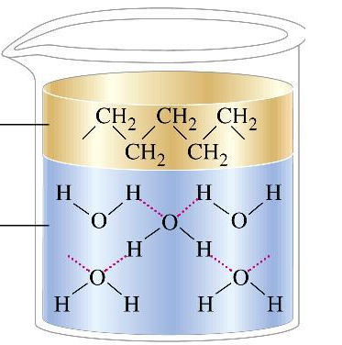
LiCl MgCl₂  NaF Na¹⁺  Cl¹⁻ Li¹⁺  F¹⁻ KI  K¹⁺ I¹⁻ | Phospholipid fatty  acid tails  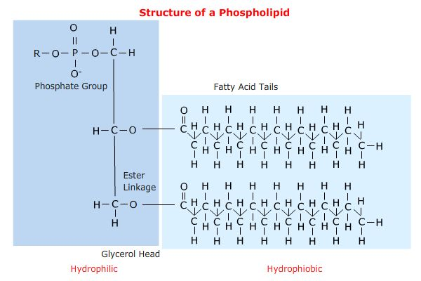
Phospholipid phosphate head groups | 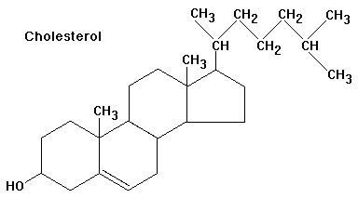
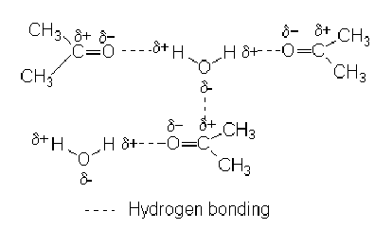 | 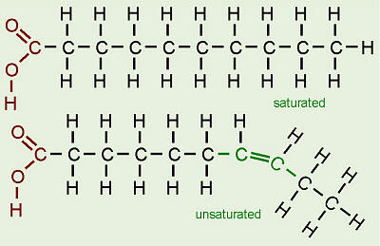

Water loving | Water fearing  Or  Water hating
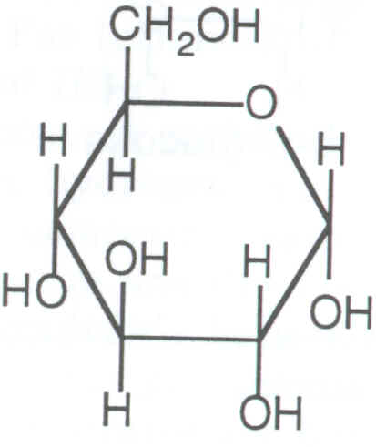 | 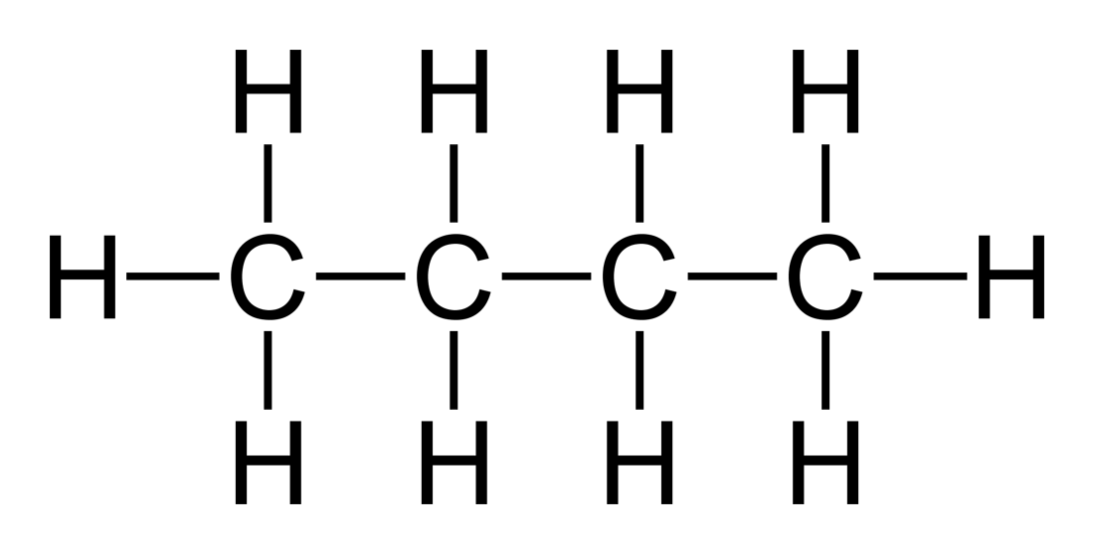
Outer cloth of a
rain coat or
plastic for a water
bottle

