English I : Intro to Lit and Comp
Mrs. Beery
Weekly Letter I

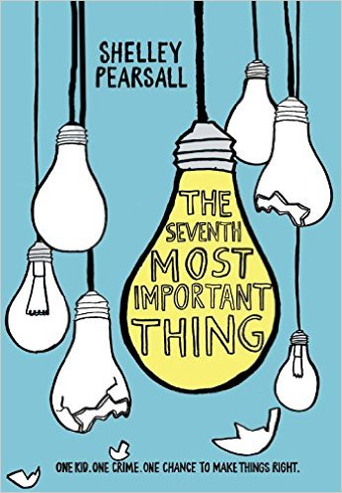
“This book in an ignition key to power and drive your love of reading!”
K. Rutigliano

Welcome to English I Honors, The Introduction to Literature and Composition, and more importantly, welcome to high school. Developing a healthy learning community is vital to our time together this year. As a result, we will send the majority of this week cultivating that learning community. Through writing, reading, and interacting we will share ideas, take risks, and get to know one another. I want you to feel safe and nurtured in this classroom. Think of this space as your place to explore, to ask questions, to think critically, to research, and to grow. Moreover, this week we will be preparing for our visit from Shelly Pearsall, the author of this year’s Wildcat Read. By aiding and honoring inquiry, passion, and awe, Mayfield hopes to inspire a love of reading, discovery, and narrative. As a community, we need to celebrate this commonality across disciplines. Don’t worry, this week and next week will also sprinkle in rules and expectations, supply lists and homework for this class. I am so honored to have you in my class this year. Let’s enjoy this journey together Here we go!!!!!......
Purchase the novella Of Mice and Men by John Steinbeck by Monday, August 25th
CCSS:
- I can determine how specific details in the text reveal and continually refine a central idea.
- I can determine the overall analysis, ideas, or events being conveyed by an author.
- I can analyze how a text unfolds and determine the impact that the order, development, and/or connections between points have on the reader.
- I can determine an author’s point of view and explain his/her purpose for writing the text.
- I can select a topic and identify and gather relevant information to share with my audience.
M: Teacher Work Day (no students)
T/W: Introduction game, (go around rehearse name & interesting fact) supply list
Discussion: What are the 7th most important things in your life?
HMWK: -Bring in a composition notebook for writing journal by Thursday
-pick out an independent reading book
-complete handout: what are the 7th most important things in the novel?
TH: 2nd period: Ninth grade class meeting in the auditorium

F Independent Reading: (10 minutes)---response log (IR and log are completed M,W, F)
Voluntary sharing; given “lightbulb” hand-out, have students begin listing the seven most important things from summer reading novel.
Journal: Pick one “most important thing” from your list on the handout and expand on how this thing is important to 1) Arthur 2) you 3) the world
Next, pick one other item and apply the ONION (5 whys)
Pictures of trash and treasure; L. Camino’s picture of the “Throne” at the Smithsonian;
Defining and setting distinctions on what makes trash and what makes treasure-Class discussion

HMWK: Bring in an item that looks like trash, but could hold beauty if looked at from a different perspective. This must be an item that you can give away. We will be using it for a project. Take some time to pick an item----it can be something old that you do not use anymore, cardboard, broken lamp, clothes, toys, bike, athletic equipment, etc…..(cannot be perishable) BRING IN OMAM ON MONDAY******

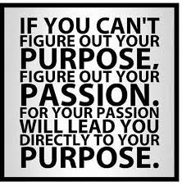

What is your passion?
______________________________________________________________________________________________________________________________________________________________________________________________________________________________________________________________

