Week 1
Creative Writing I
Writing Community
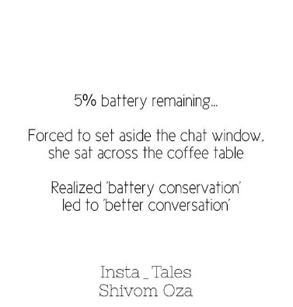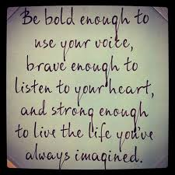
- The spiritual path is not a solo endeavor. In fact, the very notion of a self who is trying to free her/himself is a delusion. We are in it together and the company of spiritual friends helps us realize our interconnectedness.
Tara Brach
M: Teacher work Day
T: Welcome to Class. I am so glad you are here. ------Why do you write?
Google Classroom, Syllabus/contract, weekly letter
HWMK: make an observation today or tonight and write about it

W: The Adventure Awaits you! Give yourself time in your day to create
Writing: 15 minutes—write about your observation from last night or use the time to fine tune your writing for spotlight.
Spotlight your piece or a portion of your writing to build writing community support

TH: Building Community:
Print Contracts--------------take home and have them signed by parent if you are under 18
Writing from experience---making experiece happen
Street art, family and friends, selfies, concerts, a painting in a museum, funny signage. Many of us use our cell phones to capture photos and videos depicting everything from special occasions to the random striking visual encountered on a daily commute. Look through the photos on your cell phone and decide on a common theme, mood, or sentiment you’d like to convey in a poem or flash fiction. Are there photos you took by accident or ones you didn’t even know existed until browsing through? Write a poem consisting solely of descriptions of a selection of your photos. Which everyday objects, places, activities, or resonating visuals can you use to communicate a message?
HMWK: polish for homework

F: Signing day for contract
Spotlight poem or flashfiction

