English I Honors
Week 23
January 16-20

Bonus Opportunity: Attend or Perform at Open Mic Night
Friday, February 3rd at ---
($5 admission)

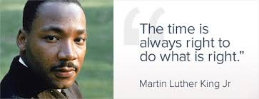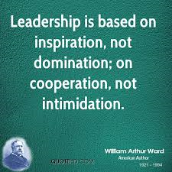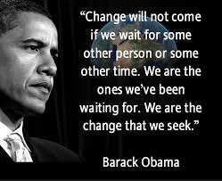
Word Origin and History for leader:
Old English lædere "one who leads," agent noun from lædan (see lead (v.)). As a title for the head of an authoritarian state, from 1918 (translating führer, Duce, caudillo, etc.). Meaning "writing or statement meant to begin a discussion or debate" is late 13c.; in modern use often short for leading article (1807) "opinion piece in a British newspaper" ( leader in this sense attested from 1837).
Who are your leaders?
What has Macbeth done in Act I to show leadership? How might he falter?

M No School----MLK Day

T Weekly Letter (sub)
On Demand Argument Essay
HMWK: Read Spark notes for Act II to prepare for acting on Wednesday
Assign roles for Act II on Wednesday

W 3 reasons in parallel structure------EDIT THIS CLAIM FROM ACT I:
Macbeth takes a dark turn mainly because of his (1) wife’s ambition ,(3)the prophecy , and (2) his own ambition for the throne.
Distribute Act II SG
Go over Act I SG questions, read claims with partners
Perform Act II
Homework: Complete Act II & SG Questions. With the information you learned about writing a claim: (acknowledging opposition, taking a position, stating 3 reasons in parallel structure------
EDIT THIS CLAIM FROM ACT II:
***Duncan’s murder was caused largely because of his trust in friends, fate intervening and because of other’s ambitions.
TH Distribute Act III SG
Go over Act II SG questions
Perform Act III
Homework: Complete Act III & SG Questions ans study for Quiz tomorrow

F Quiz Over Poetic terms, dramatic terms, and Act I and II & III of Macbeth

