The 113th Congress is the most diverse in history
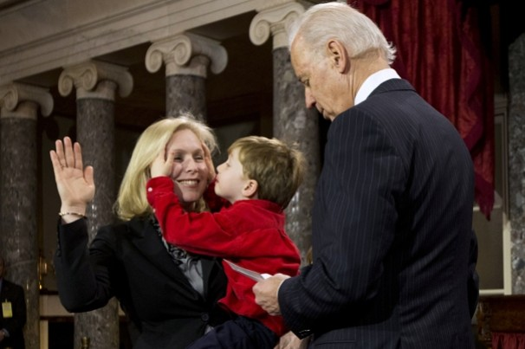
A record number of women and racial minorities were elected to the 113th Congress, which was sworn in Thursday. Among them was the first Buddhist to join the Senate, as well as the first Hindu and the first openly bisexual woman in the House.
House Democrats became the first caucus in the history of either chamber not to have a majority of white men. It was a watershed moment for the Democratic Party, which has adopted diversity as one of its chief selling points and has marketed itself as the party that looks more like a fast-changing United States.

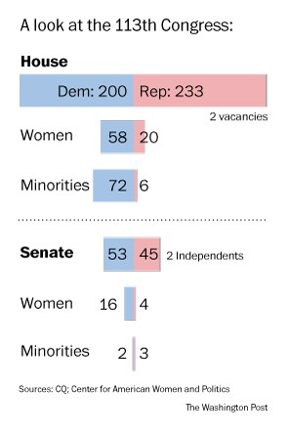
“It was a decision,” House Minority Leader Nancy Pelosi (D-Calif.) said in an interview about boosting the number of Democratic women in Congress. “We made a decision a long time ago that we were going to try to expand the number. We made a decision for women to help women, and also for the Democrats as a party to help recruit women and help fund campaigns.”
The overwhelming majority of lawmakers sworn in Thursday were white men. But the new Congress, while still lagging behind the nation as whole in diversity, reflects national demographic changes that hold significant implications for American politics.
Democrats think those changes give them a distinct political advantage in a nation in which whites make up a smaller part of the electorate. It also opens new avenues of fundraising to support their campaigns.
Republicans, too, see the value of diversity and have sought to highlight changes in the GOP. When Jim DeMint (S.C.) recently stepped down from the Senate, for instance, he was replaced by Tim Scott, giving Republicans a chance to claim the only African American in the Senate. Sen. Ted Cruz (Tex.), a Cuban American, also became an instant star among Republicans when he was elected.
Overall, though, Republicans have struggled to diversify their ranks, and the party was criticized after the presidential election for mainly appealing to an older, whiter coalition. Whether the GOP will adjust its positions to lure more votes from an increasingly diverse electorate is a key question likely to play out in the new Congress.
The Democratic diversity was on display Thursday during the vote for House speaker. Pelosi beamed as dozens of women and minorities called out her name as their choice over Speaker John A. Boehner (R-Ohio), who was narrowly elected by the Republican majority. Twice, her name was read aloud in Spanish.
For Pelosi, the moment probably paled in comparison to the day six years ago when she, in her words, “broke the marble ceiling” and was elected the nation’s first female speaker.
But for Pelosi, 72, who was one of 23 female lawmakers when she was first elected 25 years ago, Thursday had different rewards. Maybe no Democrat has been more central to the party’s diversity push than she has.
The House has 81 women, 61 of them Democrats. The Senate includes 20 women — still just a fifth of the chamber but an achievement striking enough that ABC News gathered the group together for a joint interview that aired on Thursday night.
The contrast between the two parties has been stark in recent weeks.
When Republicans first circulated a list of their committee chairmen for the 113th Congress, showing that every committee would be headed by a white man, Pelosi’s office quickly followed up with a flier with photos of the ranking Democrats on the panels.
Half of top Democrats on committees are minorities or women. In the debate that followed, Boehner named Rep. Candice Miller (R-Mich.) to chair the House Administration Committee, a panel on which she had not served.
“The more diversity of opinion at the table, the more consensus you can build, the more sustainability of the solutions, and the more respect it commands,” Pelosi said of her efforts to advance women and minorities into leadership.
There will be now be 42 African Americans in the House and one in the Senate — Scott, the first black Republican in the Senate since 1979.
Two of the Senate’s three Hispanics will be Republicans (Cruz and Sen. Marco Rubio of Florida). Sen. Robert Menendez (N.J.) is a Democrat.
But of the 29 Latinos in the House, 24 are Democrats. In opening-day speeches to the House by Pelosi and Boehner, only the Democratic leader mentioned the need for comprehensive immigration reform, to a standing ovation from Democrats and temperate applause from a handful of Republicans.
Democrats see tangible political advantages in their diversity.
“Part of our happiness is that we know the wind’s behind us,” said Rep. Raul M. Grijalva (Ariz.), explaining enthusiasm from Democrats on Thursday. “Obama’s victory is owed to that demographic, and you see more of that happening here, especially in our party. And you’re going to see more of it going forward.”
Meanwhile, the spirit among Republicans — who are still smarting from a divisive vote late Tuesday for legislation that will allow taxes to rise for the wealthiest Americans — was more muted.
For Pelosi, the growing number of female lawmakers has been a source of particular pride. The gains came in a year when Democrats campaigned aggressively on women’s issues.
“We’re a little past the time where people are pioneers,” Pelosi said. “We’re not just going out there and saying we want women to vote for us. We’re saying we want to give women a seat at the table, and you know what? A seat at the head of the table.”
Half of the Democratic Congressional Campaign Committee’s “red to blue” candidates, recruited to run in competitive districts that Republicans held, were women. Pelosi hosted women’s fundraising lunches nationwide and ultimately saw the number of Democratic women expand, even in a year when Republican numbers dropped from 24 to 20.
“She was tireless. She would do four events in a day,” said newly elected Rep. Tammy Duckworth (D-Ill.), an Iraq war veteran who took a position of honor next to Pelosi during a class photo of Democratic women taken on the Capitol steps on Thursday. “We were working hard. But she was working just as hard around the country for us.”
The women say their increased numbers could inject civility into a bitter and gridlocked process.
“By and large, they understand that extremism — whether it’s on women’s issues or fiscal issues — we’re not going to make progress if they’re on the far ends, the fringe,” said Sen. Claire McCaskill (D-Mo.), who was reelected in November after her Republican opponent claimed that pregnancies rarely result from “legitimate rape.”
“We’ve got to find that middle where we can all be a little unhappy, but we can actually get something done,” she said.

