Math 3 Name:
2-5 Additional Practice

Directions: Without a calculator, give the name of the parent function, give the equation of the parent function, graph the given function and the parent function, and describe the transformation of the parent function to the given function.

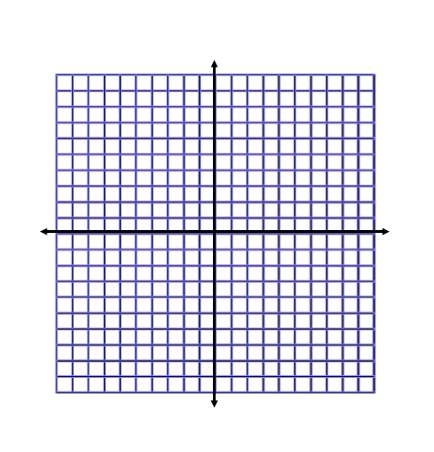
1. g(x) = -(x+3)² – 1 Name of Parent Function: _______________________
Equation of Parent Function: ____________________
Graph:

Transformation:________________________________

2. g(x) = Name of Parent Function: _______________________
Equation of Parent Function: ____________________
Graph:

Transformation:________________________________
3. h(x) = Name of Parent Function: _______________________
Equation of Parent Function: ____________________
Graph:

Transformation:________________________________

4. g(x) = Name of Parent Function: _______________________
Equation of Parent Function: ____________________
Graph:

Transformation:________________________________

Directions: Identify the domain and range of the function using interval notation (you may want to sketch a graph). Describe the transformation of the given function from its parent function.

5. g(x) = Domain : _____________________ Range : ___________________
Transformation:_____________________________________________

6. h(x) = - x² + 1 Domain : _____________________ Range : ___________________
Transformation:_____________________________________________

7. h(x) = Domain : _____________________ Range : ___________________
Transformation:_____________________________________________

8. f(x) = Domain : ________________ Range : ___________________
Transformation:_____________________________________________

9. h(x) = - (x + 9) ² Domain : _____________________ Range : ___________________
Transformation:_____________________________________________

Directions: Given the parent function and a description of the transformation, write the equation of the transformed function, f(x).

10. Absolute value—vertical shift up 5, horizontal shift right 3.

____________________

- Square Root— Reflection over the x-axis, horizontal shift left 2.

_____________________

- Inverse Variation (odd power) —Reflection over the x-axis, horizontal shift left 8, vertical translation down 3.

____________________

