Investigating the Effects of Temperature on Enzyme Activity

In this lab exercise, you will investigate enzyme function. Enzymes are large protein molecules (i.e. macromolecules) that act as catalysts in the biochemical reactions that occur in living things. A catalyst is a specific type of protein that increases the rate of a chemical reaction that would otherwise occur too slowly. How do enzymes increase the rate of a reaction? They lower the amount of activation energy that is needed to get the reaction started.
In an enzyme-catalyzed reaction, the substance that the enzyme acts upon is known as the substrate. Each enzyme is highly specific for a particular substrate because the enzyme has a special area the active site. The active site has a unique shape, and like pieces of a puzzle, the enzyme’s active site can only bind to a substrate with a complimentary shape. When the correct substrate binds, it forms a union known as the enzyme-substrate complex, in which the enzyme begins to change the substrate from its original form. After a short period of time, the substrate is turned into a new product; the enzyme will be recycled to find a new substrate. This process is summarized below:
Enzyme + Sustrate Enzyme-Substrate complex Enzyme + Product
Thus, it is the highly specific three-dimensional structure of an enzyme that will determine its ability to function properly. However, there are environmental conditions that can change the shape of an enzyme. When this happens, we say that the enzyme has become denatured, and its activity decreases or possibly completely stops. There are two factors that can alter the shape of (i.e. denature) enzymes: pH and temperature. An enzyme’s optimal pH and temperature are present when it works most efficiently. For most human enzymes, an optimal pH is 7.4 (i.e. neutral conditions) and an optimal temperature is 37ºC. Most human enzymes become denatured at extremely low/high pH levels (i.e. acidic conditions, pH 0-3, and basic conditions, pH 12-14). Temperatures around 40-50ºC will denature some human enzymes, but others won’t denature until they reach 70-80ºC; almost all enzyme activity will cease at100ºC (i.e. boiling).
The enzyme you will investigate is this lab is called catalase. Catalase is found in the tissues of many organisms (both plants and animals) because it plays a very important role in protecting cells from a harmful chemical called hydrogen peroxide (H₂O₂). Hydrogen peroxide is a normal by-product of cellular metabolism; however, it quickly becomes a poisonous toxin if it builds up in the cell. The enzyme catalase is responsible for speeding up the breakdown of toxic hydrogen peroxide into two harmless substances, water and oxygen. This chemical reaction is represented by the following chemical equation:
2 H₂O₂ 2 H₂O + O₂
^{(catalase)}

Purpose: To investigate the effects of temperature on catalase activity

Objective: To determine the optimal temperature for maximum catalase efficiency.

Pre Lab Questions:

1. Why are we doing this lab?

This lab is being conducted to look at the effect of temperature on enzyme activity.

2. What does the word “catalyst” mean? A catalyst is something that speeds up a reaction.

3. What are enzymes? How do they work? Enzymes are biological molecules of protein which speed up chemical reactions in living things.

4. What is activation energy? Activation energy is the energy needed for a chemical reaction to start.

5. What is the most important characteristic of an enzyme? The most important aspect of an enzyme is the shape at the active site.

6. What does it mean to be denatured? Denaturing is when an enzyme’s shape changes. Specifically, when the shape of the active site changes. This causes the enzyme to no longer work because it doesn’t match its substrate.

7. What 2 environmental conditions can denature an enzyme?

pH extremes and temperature can alter the shape of an enzyme.

8. How does increasing temperature affect the rate of enzyme?

Enzymes need some energy to work so low temperatures can cause slow reaction rates. Higher temperatures can denature the enzyme and stop it from working altogether.

9. What is the enzyme in this lab and why is it important? Catalase is an enzyme found in most living cells. It breaks down hydrogen peroxide into water and oxygen.
10. What is a substrate? A substrate is the molecule or molecules on which an enzyme works.

11. What is the substrate and the product(s) in this chemical reaction: 2 H₂O₂ 2 H₂O + O₂?

Water and oxygen are the products of the catalase reaction.

12. How will enzyme activity be measured? Explain! The number of bubbles produced will be counted. This shows that the reaction is happening because the hydrogen peroxide is being converted into water and oxygen gas.

13. Would the chemical reaction: 2 H₂O₂ 2 H₂O + O₂ take place if catalase wasn’t present? Explain!

Catalase is needed to break the hydrogen peroxide into water and oxygen. If there were no catalase it would happen but would happen very slowly compared to the catalyzed reaction. Catalase lowers activation energy for the reaction.

*** Important Note: These questions are to help you begin thinking about the “background information” that
you will need to include in the INTRODUCTION section of your laboratory report. Remember to ask yourself,
what terms and concepts are needed in your introduction section to allow someone who is reading your lab
report to completely understand what the experiment was about. ***

13. Identify the following:

Independent Variable
Dependent Variable
Control Variables

14. What is your Hypothesis: [remember, if…(independent variable)…, then…(dependent variable)…]

____________________________________________________________________________________________________________

____________________________________________________________________________________________________________

MATERIALS
- 4 large test tubes

- Test tube rack
- Hot plate
- ice water bath
- transfer pipette
- 10 mL graduated cylinder

- Two 250 mL beakers
- 1 ml of liver solution that contains catalase
- H₂O₂ (Hydrogen Peroxide)
- test tube holders
- glass bends and rubber tubing

EXPERIMENTAL DESIGN:
Test Tube 1: CONTROL GROUP Test Tube 2: EXPERIMENTAL GROUP
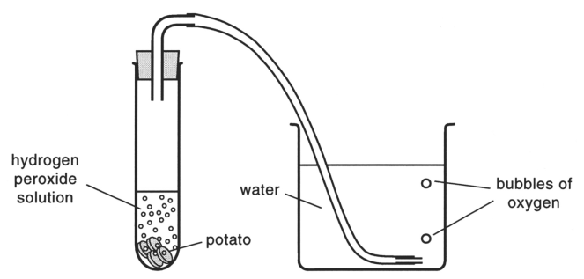
No liver
1 ml Liver

Procedure: Complete the following procedure at each of the three stations: Ice Water Bath, Room Temperature, and Hot Water Bath.

1. Place 10 mL of water into test tube 1 and test tube 2.
2. Place 1 mL of additional water into test tube 1(control).
3. Place 1 ml of liver solution into test tube 2 (experimental).
4. Obtain a rubber test tube stopper that has a glass bend and tubing attached.
5. Submerge the tubing in the 250 mL beaker containing water (at station).
6. Measure out 2 mL of hydrogen peroxide in a graduated cylinder.
7. Place 2 mL of hydrogen peroxide (H₂O₂) into the test tube 1, then immediately seal the test tube with the stopper that has the glass bend and rubber tubing attached.
8. Allow the reaction to proceed for three minutes. Count the bubbles that begin to form in the water over this period of time.
9. At the end of three minutes, record the total number of bubbles you counted in the correct data table.
10. Repeat steps 4-9 for test tube 2.
11. Empty and rinse both test tubes. Be sure station is clean and ready for the next group.

RESULTS:

Data Table: TEST TUBE 1 (CONTROL GROUP)
 | Temperature (ºC) | Number of Oxygen Bubbles  in 3 Minutes | Class Average: Number of Oxygen Bubbles  in 3 Minutes
Ice Water Bath
Room Temperature
Hot Water Bath

Data Table: TEST TUBE 2 (EXPERIMENTAL GROUP)
 | Temperature (ºC) | Number of Oxygen Bubbles in 3 Minutes | Class Average: Number of Oxygen Bubbles in 3 Minutes
Ice Water Bath
Room Temperature
Hot Water Bath

GRAPHING YOUR RESULTS:
Use Excel to plot oxygen bubbles produced versus temperature on a graph. Your graph will include one line for the control and one line for the experimental group. See handout and video on how to make graph in Excel!

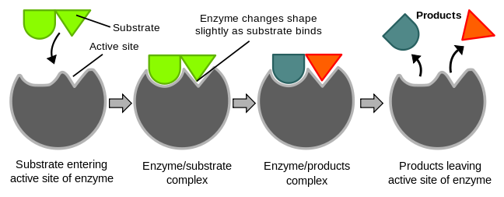You will make a graph of YOUR DATA. We will provide you with a graph of the class average data to include in your report in addition to the graph that you make.
Hydrogen Peroxide
Hydrogen Peroxide
Water
Oxygen
DISCUSSION Questions:
Use these questions (and their answers) to guide you as you write the DISCUSSION and CONCLUSION section of your lab report.
1. How did you know that the catalase was working?

The chemical reaction was occurring when oxygen bubbles were observed.

2. If catalase is working properly, what is the liquid substance that is left inside the test tube at the end
of the reaction time? Explain by analyzing the chemical equation of the reaction.

The resulting liquid should have been water because hydrogen peroxide breaks down into water and oxygen in the presence of catalase.

3. What effect does increasing the temperature have on catalase activity? Explain (don’t forget to
CITE SPECIFIC DATA to support any statements you make)
Catalase works differently at different temperatures. Catalase activity increases as the temperature goes from 0’C to around 30’C. Catalase activity decreases as temperature goes from around 30’C to 100’C.
4. Based on your results and your graph, what is the optimal temperature for maximum catalase
activity? Explain (don’t forget to CITE DATA to support your reasoning).

Optimal temperature for catalase activity is around 30’C because the highest amount of oxygen bubbles were observed at this temperature.

5. What happens to enzyme activity when the optimum temperature is exceeded? Give SCIENTIFIC
REASONING as to why this happens (hint: shape)
Catalase activity decreases after optimal temperature. This happens because the enzyme becomes denatured. Denaturing is when an enzyme loses its shape at the active site. The active site is where the enzyme and substrate meet. If they cannot match up (due to a denatured active site) then the reaction cannot take place.
6. In CONCLUSION, what is the importance of enzymes in living things and what do you know about how they function? How does temperature affect enzymes.
Enzymes are critical to life because they speed up chemical reactions that take place within our cells. Without enzymes, the reactions would take place too slowly to support life.

