Food Chains, Food Webs, and Energy Pyramid worksheet

- Using the following food chain, answer the questions below.
Grass → Rabbit → Fox

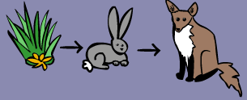
- What type of organism is the grass? _____________________________
- Which animal is a herbivore or primary consumer? ___________________________
- What would happen to the population of rabbits, if the population of foxes increased (got bigger)? Why? ____________________________________________________________________________________________________________________________________________________________________________

- Construct a food chain. Label the producer, primary consumer, secondary consumer, and tertiary consumer.

An owl eats a snake, the snake eats a squirrel, the squirrel ate a nut.

- Using the food chain from question 2, construct an energy pyramid.

  - Which animal has the most amount of available energy? ____________________

  - Which animal has the least amount of available energy? ____________________

- Use the food web below to answer the questions.

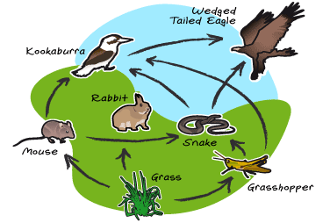

  - What is the producer? __________________________________________
  - What are the primary consumers? __________________________________________________________________
  - What are the secondary consumers? __________________________________
  - What are the tertiary consumers? ____________________________________________________________________________________________________________________________________
  - What is the top predator? ___________________________________________
  - Construct one food chain that you see on the food web.

g. Using your food chain above, construct an energy pyramid.
Energy Flow Through the Ecosystem Study Guide

Word | Description/Definition | Example/Picture
Producer

Consumer

Herbivore

Omnivore

Carnivore

Decomposer

Food Chain

Trophic Level

Food Web

Energy Pyramid

Directions: Label each level on the energy pyramid below. 130,000 kcal of energy is available at the producer level. Identify the amount of kcal available at each level.

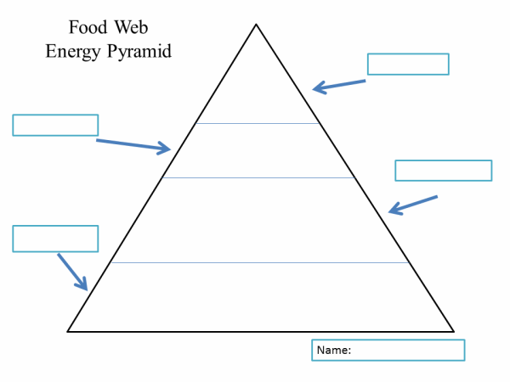

Name:______________________
Hour:___________________
Abiotic vs Biotic Factors

What is the definition of an abotic factor?
_____________________________________________________________________

What is the definition of a biotic factor?

____________________________________________________________________________

Enter the items from the following list into a Venn diagram.
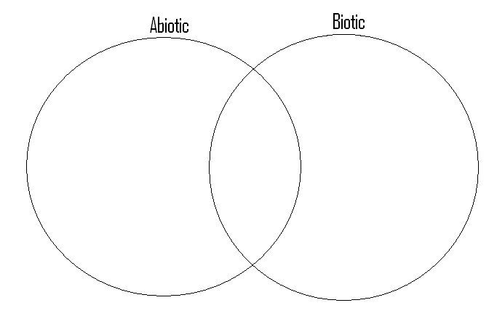
In the center place what contains both biotic and abiotic factors.
- Whale  - Mushroom  - Water  - Desert  - Paper  - Glass  - Temperature  - Coral  - Sand | - Clouds  - Snail  - Steak  - Athletes Foot  - Salad  - Mold  - Grass  - Hair | - Ocean  - Tree  - Rocks  - Dirt  - Gold  - Plastic  - Grapes  - Oxygen  - Tundra

Comprehending…
All biotic and abiotic factors are interrelated. In nature you will find that if one factor is changed or removed, it impacts the availability of other resources within the system. Knowing this, give an example of what might happen given the following situations.

In the open space place either an (A) for abiotic or (B) for biotic to identify the bolded object.

  - All of the rocks(___) are removed from a desert ecosystem, what would happen to the population of rock dwelling lizards (___) and in turn the animals which eat them. ______________________________________________________________________________________________________________________________

  - A ten mile area of trees (___) is removed from the tropical rainforest. How will this affect the amount of water (___) and the amount of oxygen (___) in the area?
________________________________________________________________________________________________________________________________

Essay: The essay question is going to deal with the Grey Wolf Population and the Kaibab Deer. Write a list containing 10 things you learned about controlling a population of organisms. Relate each statement to the Grey Wolf or Kaibab Deer activity.

